МИНОБРНАУКИ РОССИИ

Федеральное государственное бюджетное

образовательное учреждение высшего образования

«ЧЕРЕПОВЕЦКИЙ ГОСУДАРСТВЕННЫЙ УНИВЕРСИТЕТ»

Институт Информационных Технологий

Кафедра МПО ЭВМ

Дисциплина «Теория автоматов и формальных языков»

Лабораторная работа №7-8

«Построение дескрипторного кода. Построение регулярной грамматики»

Выполнил:

студент группы 1ПИб-02-2оп-22

Тихомиров Владислав Валерьевич

Проверил:

доцент, к.т.н.

Ганичева Оксана Георгиевна

Череповец, 2024 год

Задание

Написать часть/функцию лексического анализатора, обрабатывающую входную строку по конечному автомату на основе оператора выбора, формирование таблиц с классами лексем, (это часть с предыдущей работы) реализующую построение дескрипторного кода и псевдокода.

2. Формальное описание конечного автомата

А = {X, S, S0, F, δ}

X = {m, p, v, “, без_усл, ‘_’, ‘, s, w, i, t, c, h, a, e, b, r, k, f, o, d, u, l, n, g, . }

S = {S0, S1, S2, S3, S4, S5, S6, …, S119}

S0 = {S0}

F = {S1, S3, S6, S17, S21, S26, S28, S31, S38, S42, S53, S62, S66, S68, S72, S73, S78, S83, S88, S95, S96, S100, S103, S105, S108, S109, S112, S114, S119 }

Совмещенная таблица соответствия команды КА и правила РГ:

|  |  |
| --- | --- |
| **Команды КА** | **Правила РГ** |
| (S0, -) → S1 | S0 → - S1 |
| (S0, /) → S8 | S0 → / S8 |
| (S0, s) → S2 | S0 → s S2 |
| (S0, c) → S18 | S0 → c S18 |
| (S0, b) → S22 | S0 → b S22 |
| (S0, i) → S27 | S0 → i S27 |
| (S0, f) → S29 | S0 → f S29 |
| (S0, d) → S32 | S0 → d S32 |
| (S0, e) → S39 | S0 → e S39 |
| (S0, r) → S43 | S0 → r S43 |
| (S0, u) → S49 | S0 → u S49 |
| (S0, n) → S54 | S0 → n S54 |
| (S0, v) → S63 | S0 → v S63 |
| (S0, m) → S97 | S0 → m S97 |
| (S0, кавычки) → S109 | S0 → кавычки S109 |
| (S0, \) → S113 | S0 → \ S113 |
| (S0, Другой) → S0 | S0 → Другой S0 |
| (S1, Число) → S1 | S1 → Число S1 |
| (S1, ') → S3 | S1 → ' S3 |
| (S1, Пробел ; : ,) → S0 | S1 → Пробел ; : , S0 |
| (S1, Другой) → S7 | S1 → Другой S7 |
| (S2, w) → S13 | S2 → w S13 |
| (S2, t) → S79 | S2 → t S79 |
| (S2, y) → S115 | S2 → y S115 |
| (S2, Другой) → S0 | S2 → Другой S0 |
| (S3, Число) → S3 | S3 → Число S3 |
| (S3, Пробел : ; ,) → S0 | S3 → Пробел : ; , S0 |
| (S3, e/E) → S4 | S3 → e/E S4 |
| (S3, Другой) → S7 | S3 → Другой S7 |
| (S4, Число) → S6 | S4 → Число S6 |
| (S4, +/-) → S5 | S4 → +/- S5 |
| (S4, Другой) → S7 | S4 → Другой S7 |
| (S5, Число) → S6 | S5 → Число S6 |
| (S5, Другой) → S7 | S5 → Другой S7 |
| (S6, Другой) → S6 | S6 → Другой S6 |
| (S6, Пробел ; : ,) → S0 | S6 → Пробел ; : , S0 |
| (S6, Другой) → S7 | S6 → Другой S7 |
| (S7, Любой) → S0 | S7 → Любой S0 |
| (S8, /) → S9 | S8 → / S9 |
| (S8, *) → S10 | S8 → * S10 |
| (S9, \n) → S0 | S9 → \n S0 |
| (S9, Другой) → S9 | S9 → Другой S9 |
| (S10, *) → S11 | S10 → * S11 |
| (S10, Другой) → S10 | S10 → Другой S10 |
| (S11, /) → S12 | S11 → / S12 |
| (S11, Другой) → S10 | S11 → Другой S10 |
| (S12, Пробел) → S0 | S12 → Пробел S0 |
| (S12, Другой) → S0 | S12 → Другой S0 |
| (S13, i) → S14 | S13 → i S14 |
| (S13, Другой) → S0 | S13 → Другой S0 |
| (S14, t) → S15 | S14 → t S15 |
| (S14, Другой) → S0 | S14 → Другой S0 |
| (S15, c) → S16 | S15 → c S16 |
| (S15, Другой) → S0 | S15 → Другой S0 |
| (S16, h) → S17 | S16 → h S17 |
| (S16, Другой) → S0 | S16 → Другой S0 |
| (S17, Пробел () → S0 | S17 → Пробел ( S0 |
| (S17, Другой) → S0 | S17 → Другой S0 |
| (S18, a) → S19 | S18 → a S19 |
| (S18, o) → S101 | S18 → o S101 |
| (S18, i) → S104 | S18 → i S104 |
| (S18, h) → S110 | S18 → h S110 |
| (S18, Другой) → S0 | S18 → Другой S0 |
| (S19, s) → S20 | S19 → s S20 |
| (S19, Другой) → S0 | S19 → Другой S0 |
| (S20, e) → S21 | S20 → e S21 |
| (S20, Другой) → S0 | S20 → Другой S0 |
| (S21, Пробел :) → S0 | S21 → Пробел : S0 |
| (S21, Другой) → S0 | S21 → Другой S0 |
| (S22, r) → S23 | S22 → r S23 |
| (S22, Другой) → S0 | S22 → Другой S0 |
| (S23, e) → S24 | S23 → e S24 |
| (S23, Другой) → S0 | S23 → Другой S0 |
| (S24, a) → S25 | S24 → a S25 |
| (S24, Другой) → S0 | S24 → Другой S0 |
| (S25, k) → S26 | S25 → k S26 |
| (S25, Другой) → S0 | S25 → Другой S0 |
| (S26, Пробел ;) → S0 | S26 → Пробел ; S0 |
| (S26, Другой) → S0 | S26 → Другой S0 |
| (S27, f) → S28 | S27 → f S28 |
| (S27, n) → S67 | S27 → n S67 |
| (S27, o) → S89 | S27 → o S89 |
| (S27, Другой) → S0 | S27 → Другой S0 |
| (S28, Пробел () → S0 | S28 → Пробел ( S0 |
| (S28, Другой) → S0 | S28 → Другой S0 |
| (S29, o) → S30 | S29 → o S30 |
| (S29, l) → S69 | S29 → l S69 |
| (S29, Другой) → S0 | S29 → Другой S0 |
| (S30, r) → S31 | S30 → r S31 |
| (S30, Другой) → S0 | S30 → Другой S0 |
| (S31, Пробел () → S0 | S31 → Пробел ( S0 |
| (S31, Другой) → S0 | S31 → Другой S0 |
| (S32, e) → S33 | S32 → e S33 |
| (S32, o) → S74 | S32 → o S74 |
| (S32, Другой) → S0 | S32 → Другой S0 |
| (S33, f) → S34 | S33 → f S34 |
| (S33, Другой) → S0 | S33 → Другой S0 |
| (S34, a) → S35 | S34 → a S35 |
| (S34, Другой) → S0 | S34 → Другой S0 |
| (S35, u) → S36 | S35 → u S36 |
| (S35, Другой) → S0 | S35 → Другой S0 |
| (S36, l) → S37 | S36 → l S37 |
| (S36, Другой) → S0 | S36 → Другой S0 |
| (S37, t) → S38 | S37 → t S38 |
| (S37, Другой) → S0 | S37 → Другой S0 |
| (S38, Пробел :) → S0 | S38 → Пробел : S0 |
| (S38, Другой) → S0 | S38 → Другой S0 |
| (S39, l) → S40 | S39 → l S40 |
| (S39, n) → S106 | S39 → n S106 |
| (S39, Другой) → S0 | S39 → Другой S0 |
| (S40, s) → S41 | S40 → s S41 |
| (S40, Другой) → S0 | S40 → Другой S0 |
| (S41, e) → S42 | S41 → e S42 |
| (S41, Другой) → S0 | S41 → Другой S0 |
| (S42, Пробел {) → S0 | S42 → Пробел { S0 |
| (S42, Другой) → S0 | S42 → Другой S0 |
| (S43, e) → S44 | S43 → e S44 |
| (S43, Другой) → S0 | S43 → Другой S0 |
| (S44, t) → S45 | S44 → t S45 |
| (S44, Другой) → S0 | S44 → Другой S0 |
| (S45, u) → S46 | S45 → u S46 |
| (S45, Другой) → S0 | S45 → Другой S0 |
| (S46, n) → S47 | S46 → n S47 |
| (S46, Другой) → S0 | S46 → Другой S0 |
| (S47, n) → S48 | S47 → n S48 |
| (S47, Другой) → S0 | S47 → Другой S0 |
| (S48, Пробел ;) → S0 | S48 → Пробел ; S0 |
| (S48, Другой) → S0 | S48 → Другой S0 |
| (S49, s) → S50 | S49 → s S50 |
| (S49, Другой) → S0 | S49 → Другой S0 |
| (S50, i) → S51 | S50 → i S51 |
| (S50, Другой) → S0 | S50 → Другой S0 |
| (S51, n) → S52 | S51 → n S52 |
| (S51, Другой) → S0 | S51 → Другой S0 |
| (S52, g) → S53 | S52 → g S53 |
| (S52, Другой) → S0 | S52 → Другой S0 |
| (S53, Пробел) → S0 | S53 → Пробел S0 |
| (S53, Другой) → S0 | S53 → Другой S0 |
| (S54, a) → S55 | S54 → a S55 |
| (S54, Другой) → S0 | S54 → Другой S0 |
| (S55, m) → S56 | S55 → m S56 |
| (S55, Другой) → S0 | S55 → Другой S0 |
| (S56, e) → S57 | S56 → e S57 |
| (S56, Другой) → S0 | S56 → Другой S0 |
| (S57, s) → S58 | S57 → s S58 |
| (S57, Другой) → S0 | S57 → Другой S0 |
| (S58, p) → S59 | S58 → p S59 |
| (S58, Другой) → S0 | S58 → Другой S0 |
| (S59, a) → S60 | S59 → a S60 |
| (S59, Другой) → S0 | S59 → Другой S0 |
| (S60, c) → S61 | S60 → c S61 |
| (S60, Другой) → S0 | S60 → Другой S0 |
| (S61, e) → S62 | S61 → e S62 |
| (S61, Другой) → S0 | S61 → Другой S0 |
| (S62, Пробел) → S0 | S62 → Пробел S0 |
| (S62, Другой) → S0 | S62 → Другой S0 |
| (S63, o) → S64 | S63 → o S64 |
| (S63, Другой) → S0 | S63 → Другой S0 |
| (S64, i) → S65 | S64 → i S65 |
| (S64, Другой) → S0 | S64 → Другой S0 |
| (S65, d) → S66 | S65 → d S66 |
| (S65, Другой) → S0 | S65 → Другой S0 |
| (S66, Пробел) → S0 | S66 → Пробел S0 |
| (S66, Другой) → S0 | S66 → Другой S0 |
| (S67, t) → S68 | S67 → t S68 |
| (S67, c) → S84 | S67 → c S84 |
| (S67, Другой) → S0 | S67 → Другой S0 |
| (S68, Пробел) → S73 | S68 → Пробел S73 |
| (S68, Другой) → S0 | S68 → Другой S0 |
| (S69, o) → S70 | S69 → o S70 |
| (S69, Другой) → S0 | S69 → Другой S0 |
| (S70, a) → S71 | S70 → a S71 |
| (S70, Другой) → S0 | S70 → Другой S0 |
| (S71, t) → S72 | S71 → t S72 |
| (S71, Другой) → S0 | S71 → Другой S0 |
| (S72, Пробел) → S73 | S72 → Пробел S73 |
| (S72, Другой) → S0 | S72 → Другой S0 |
| (S73, Пробел ; =) → S0 | S73 → Пробел ; = S0 |
| (S73, Другой) → S73 | S73 → Другой S73 |
| (S74, u) → S75 | S74 → u S75 |
| (S74, Другой) → S0 | S74 → Другой S0 |
| (S75, b) → S76 | S75 → b S76 |
| (S75, Другой) → S0 | S75 → Другой S0 |
| (S76, l) → S77 | S76 → l S77 |
| (S76, Другой) → S0 | S76 → Другой S0 |
| (S77, e) → S78 | S77 → e S78 |
| (S77, Другой) → S0 | S77 → Другой S0 |
| (S78, Пробел) → S73 | S78 → Пробел S73 |
| (S78, Другой) → S0 | S78 → Другой S0 |
| (S79, r) → S80 | S79 → r S80 |
| (S79, d) → S96 | S79 → d S96 |
| (S79, Другой) → S0 | S79 → Другой S0 |
| (S80, i) → S81 | S80 → i S81 |
| (S80, Другой) → S0 | S80 → Другой S0 |
| (S81, n) → S82 | S81 → n S82 |
| (S81, Другой) → S0 | S81 → Другой S0 |
| (S82, g) → S83 | S82 → g S83 |
| (S82, Другой) → S0 | S82 → Другой S0 |
| (S83, Пробел) → S73 | S83 → Пробел S73 |
| (S83, Другой) → S0 | S83 → Другой S0 |
| (S84, l) → S85 | S84 → l S85 |
| (S84, Другой) → S0 | S84 → Другой S0 |
| (S85, u) → S86 | S85 → u S86 |
| (S85, Другой) → S0 | S85 → Другой S0 |
| (S86, d) → S87 | S86 → d S87 |
| (S86, Другой) → S0 | S86 → Другой S0 |
| (S87, e) → S88 | S87 → e S88 |
| (S87, Другой) → S0 | S87 → Другой S0 |
| (S88, Пробел) → S0 | S88 → Пробел S0 |
| (S88, Другой) → S0 | S88 → Другой S0 |
| (S89, s) → S90 | S89 → s S90 |
| (S89, Другой) → S0 | S89 → Другой S0 |
| (S90, t) → S91 | S90 → t S91 |
| (S90, Другой) → S0 | S90 → Другой S0 |
| (S91, r) → S92 | S91 → r S92 |
| (S91, Другой) → S0 | S91 → Другой S0 |
| (S92, e) → S93 | S92 → e S93 |
| (S92, Другой) → S0 | S92 → Другой S0 |
| (S93, a) → S94 | S93 → a S94 |
| (S93, Другой) → S0 | S93 → Другой S0 |
| (S94, m) → S95 | S94 → m S95 |
| (S94, Другой) → S0 | S94 → Другой S0 |
| (S95, Пробел >) → S0 | S95 → Пробел > S0 |
| (S95, Другой) → S0 | S95 → Другой S0 |
| (S96, Пробел ;) → S0 | S96 → Пробел ; S0 |
| (S96, Другой) → S0 | S96 → Другой S0 |
| (S97, a) → S98 | S97 → a S98 |
| (S97, Другой) → S0 | S97 → Другой S0 |
| (S98, i) → S99 | S98 → i S99 |
| (S98, Другой) → S0 | S98 → Другой S0 |
| (S99, n) → S100 | S99 → n S100 |
| (S99, Другой) → S0 | S99 → Другой S0 |
| (S100, Пробел () → S0 | S100 → Пробел ( S0 |
| (S100, Другой) → S0 | S100 → Другой S0 |
| (S101, u) → S102 | S101 → u S102 |
| (S101, Другой) → S0 | S101 → Другой S0 |
| (S102, t) → S103 | S102 → t S103 |
| (S102, Другой) → S0 | S102 → Другой S0 |
| (S103, Пробел <) → S0 | S103 → Пробел < S0 |
| (S103, Другой) → S0 | S103 → Другой S0 |
| (S104, n) → S105 | S104 → n S105 |
| (S104, Другой) → S0 | S104 → Другой S0 |
| (S105, Пробел >) → S0 | S105 → Пробел > S0 |
| (S105, Другой) → S0 | S105 → Другой S0 |
| (S106, l) → S107 | S106 → l S107 |
| (S106, Другой) → S0 | S106 → Другой S0 |
| (S107, l) → S108 | S107 → l S108 |
| (S107, Другой) → S0 | S107 → Другой S0 |
| (S108, Пробел ;) → S0 | S108 → Пробел ; S0 |
| (S108, Другой) → S0 | S108 → Другой S0 |
| (S109, кавычки) → S0 | S109 → кавычки S0 |
| (S109, Другой) → S109 | S109 → Другой S109 |
| (S110, a) → S111 | S110 → a S111 |
| (S110, Другой) → S0 | S110 → Другой S0 |
| (S111, r) → S112 | S111 → r S112 |
| (S111, Другой) → S0 | S111 → Другой S0 |
| (S112, Пробел) → S73 | S112 → Пробел S73 |
| (S112, Другой) → S0 | S112 → Другой S0 |
| (S113, Символ) → S114 | S113 → Символ S114 |
| (S114, ') → S0 | S114 → ' S0 |
| (S114, Другой) → S0 | S114 → Другой S0 |
| (S115, s) → S116 | S115 → s S116 |
| (S115, Другой) → S0 | S115 → Другой S0 |
| (S116, t) → S117 | S116 → t S117 |
| (S116, Другой) → S0 | S116 → Другой S0 |
| (S117, e) → S118 | S117 → e S118 |
| (S117, Другой) → S0 | S117 → Другой S0 |
| (S118, m) → S119 | S118 → m S119 |
| (S118, Другой) → S0 | S118 → Другой S0 |
| (S119, Пробел () → S0 | S119 → Пробел ( S0 |
| (S119, Другой) → S0 | S119 → Другой S0 |

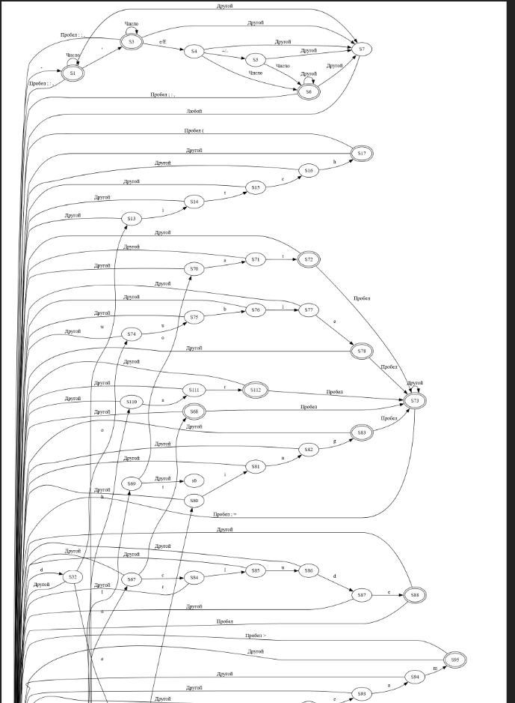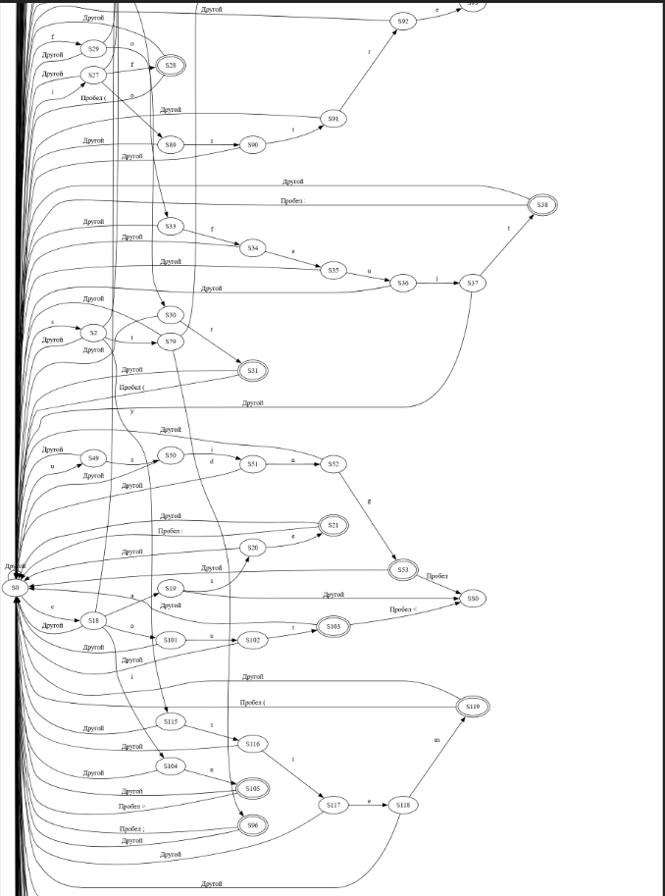

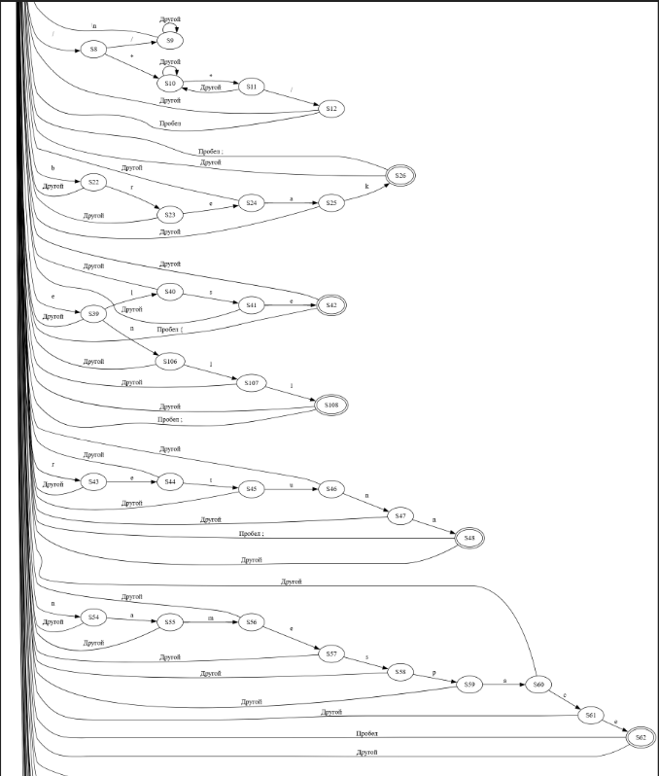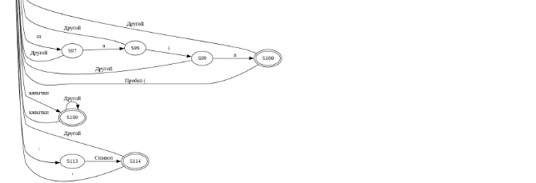

Рис. 1. Граф конечного автомата

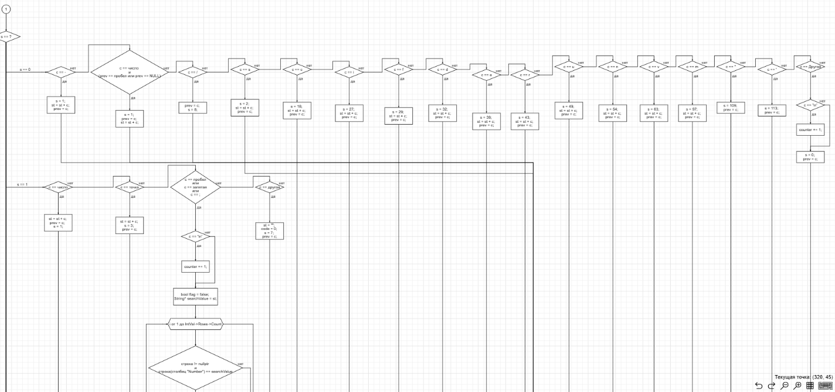

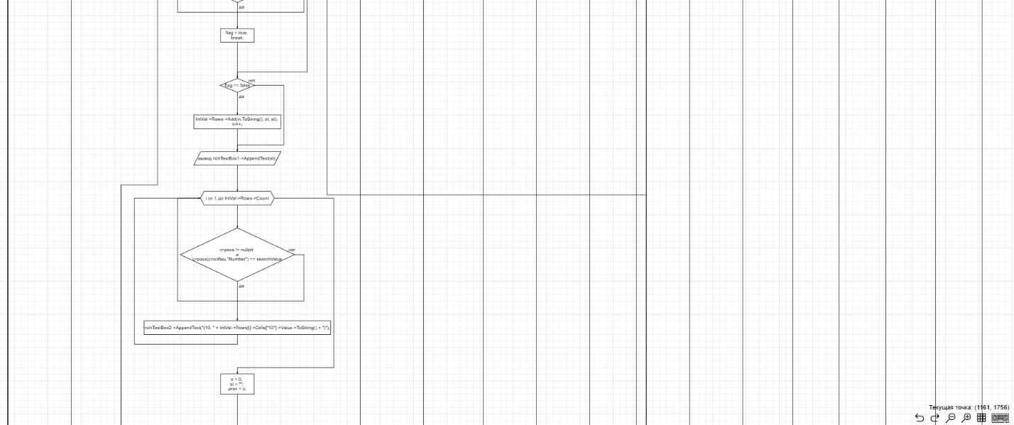

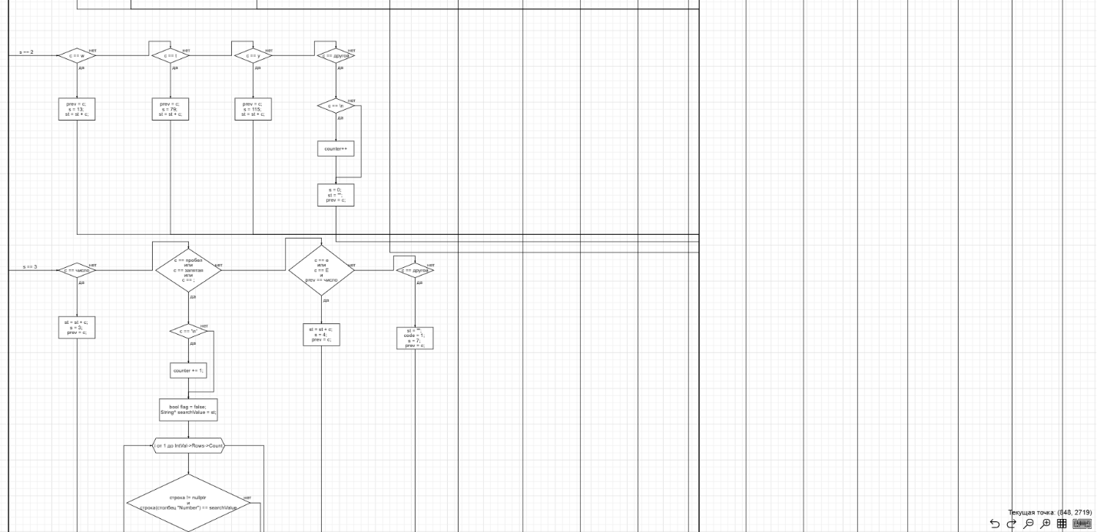

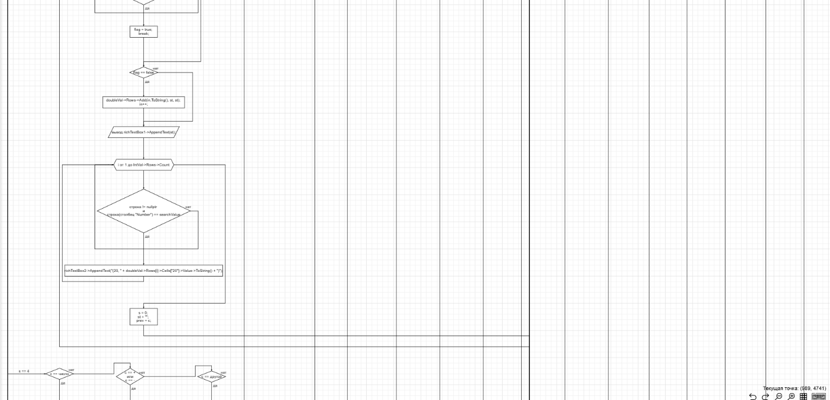

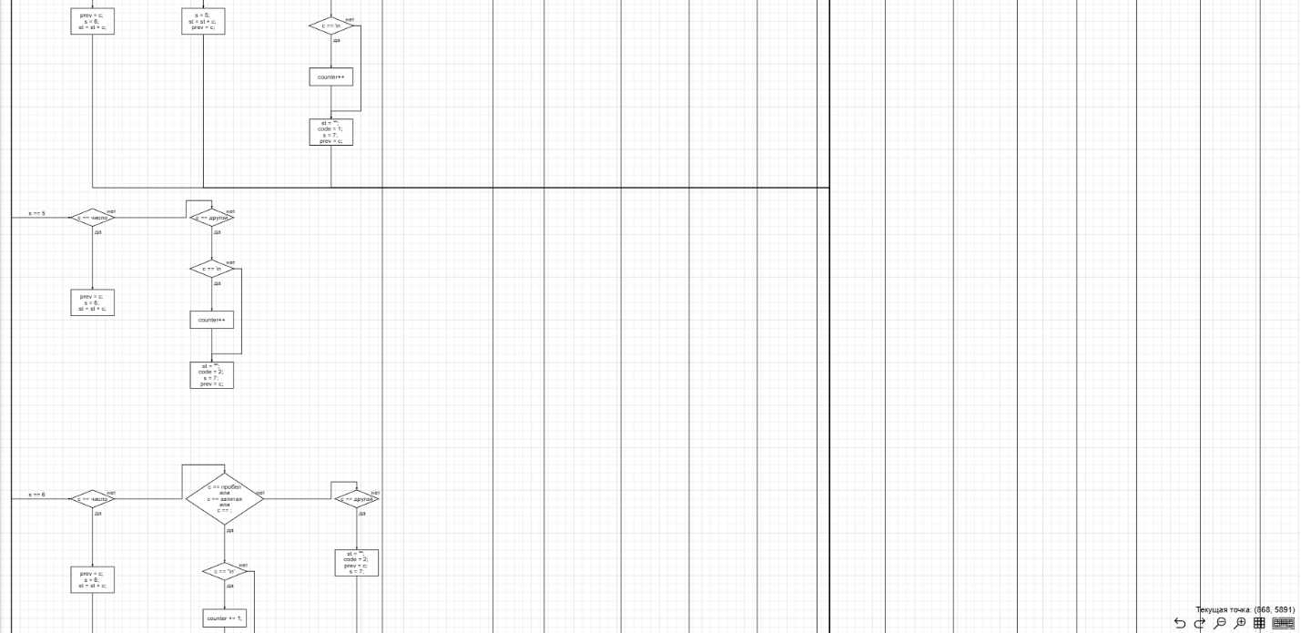

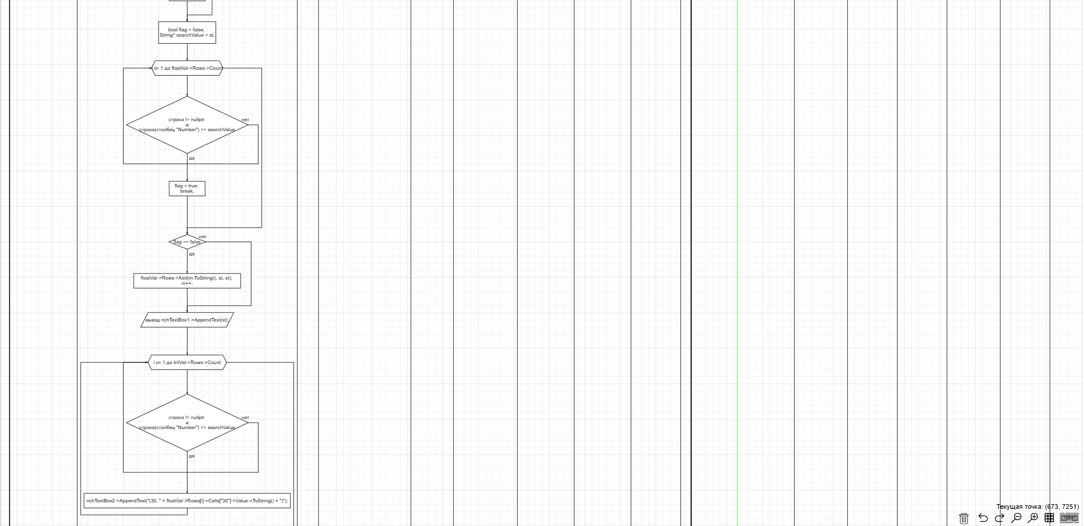

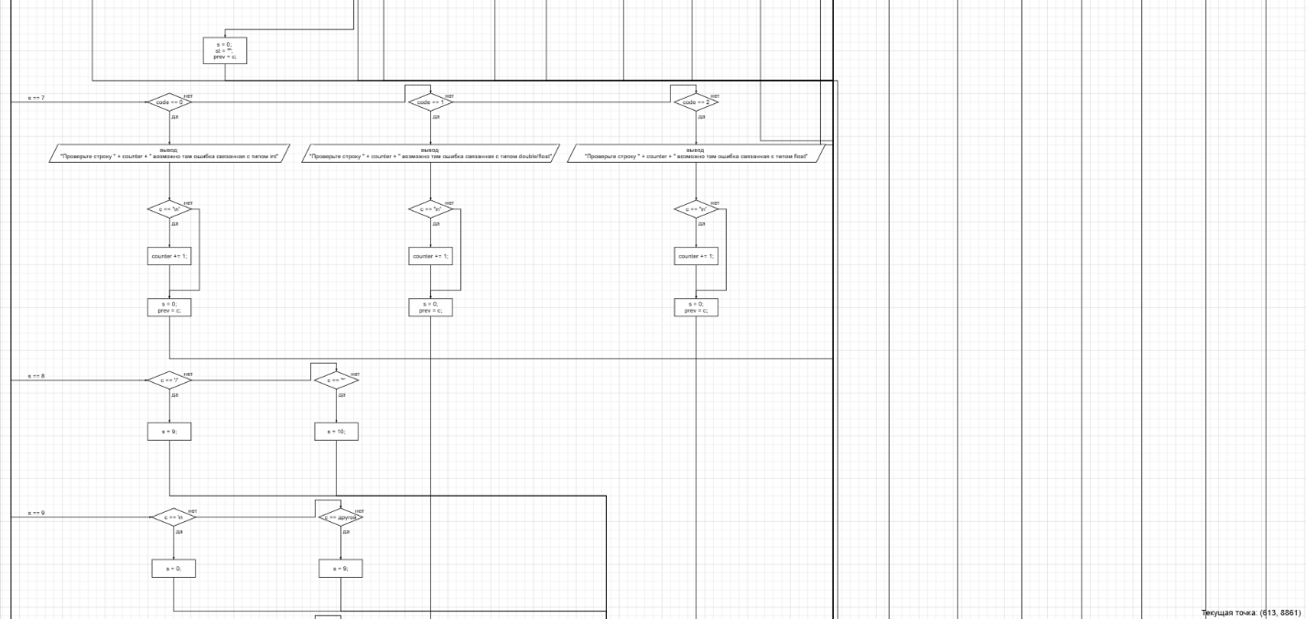

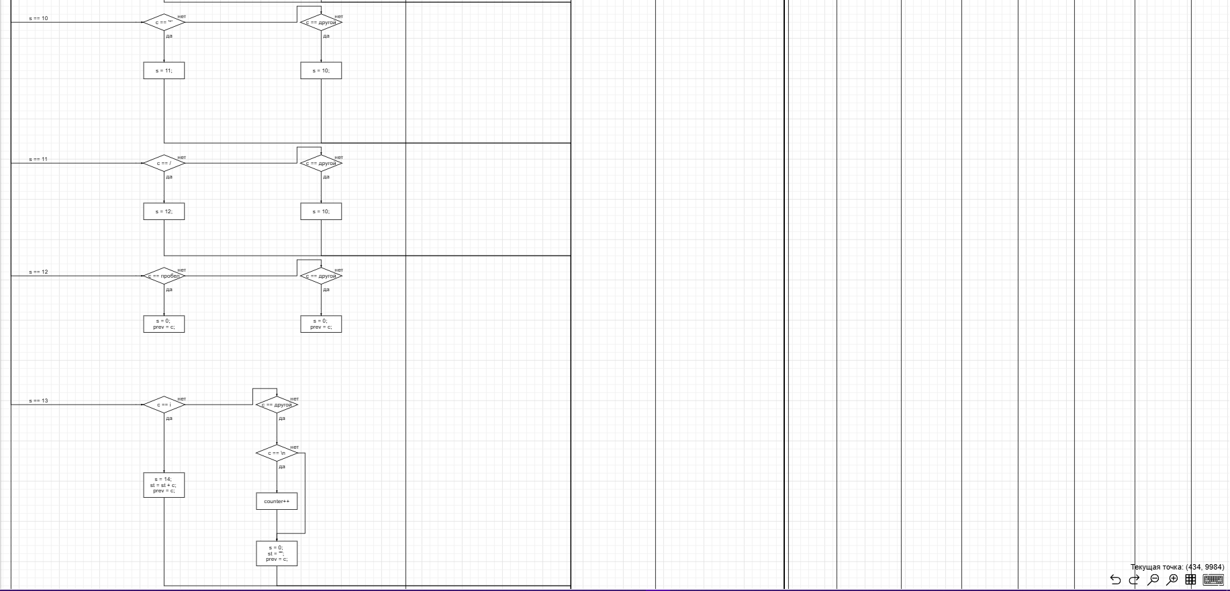

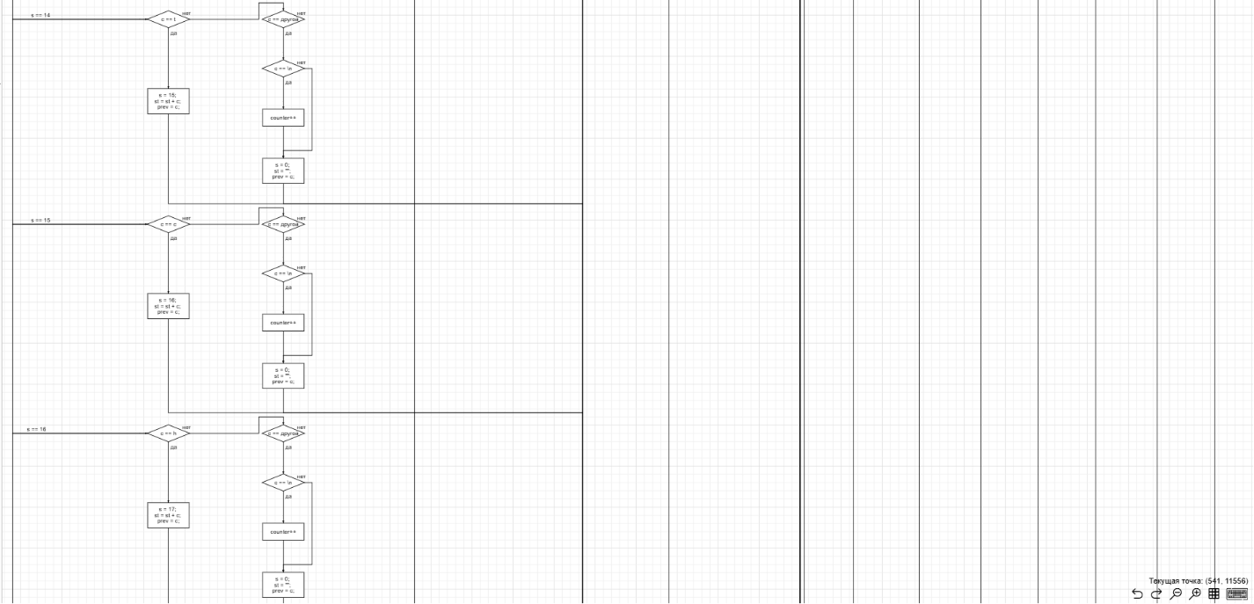

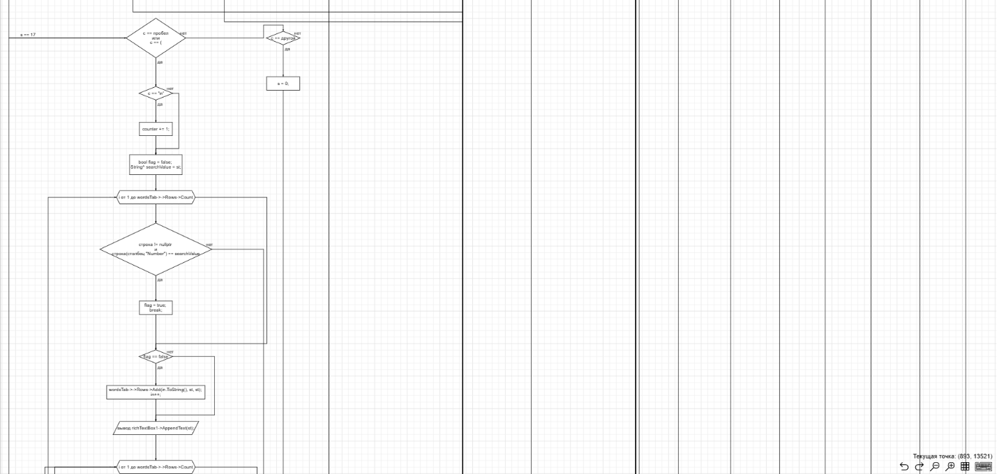

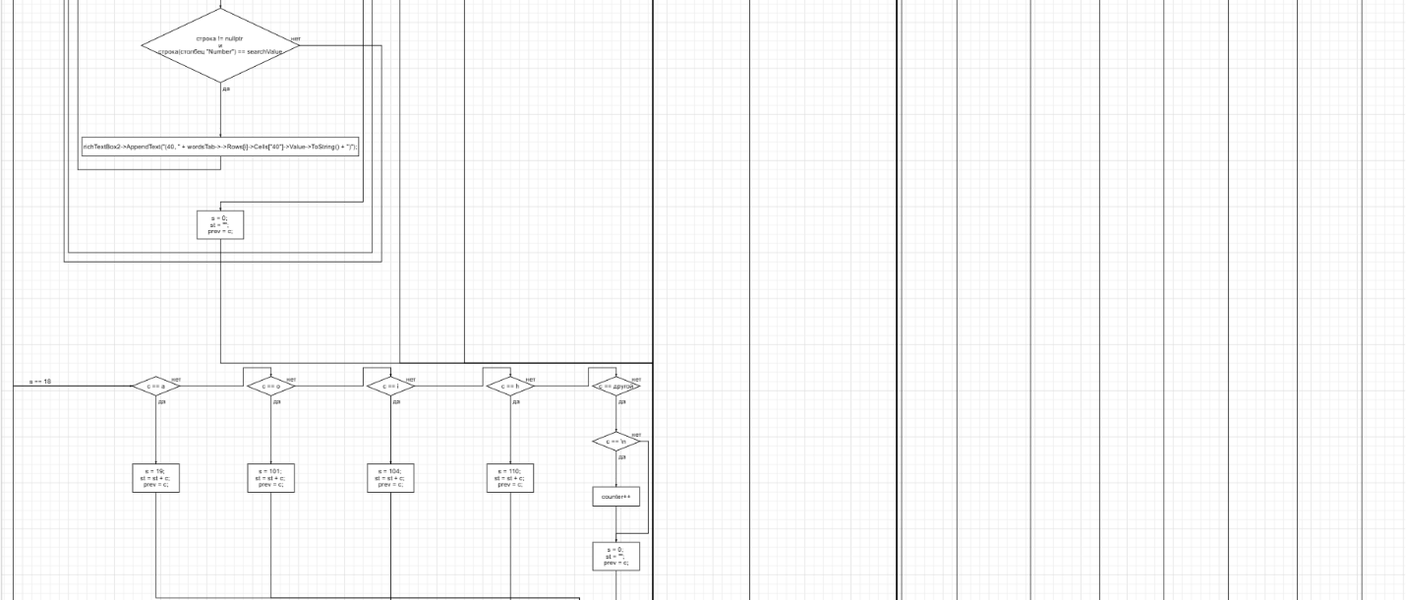

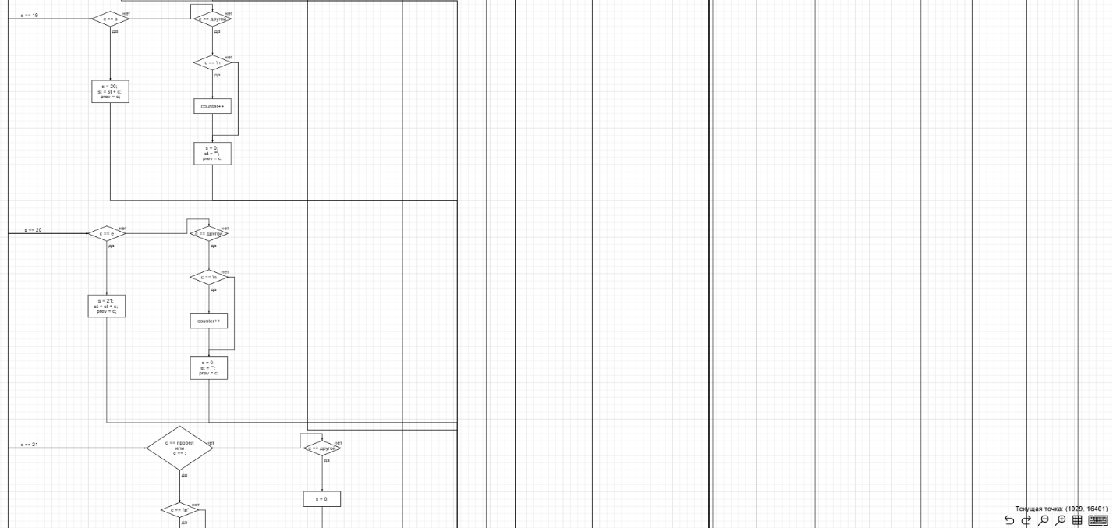

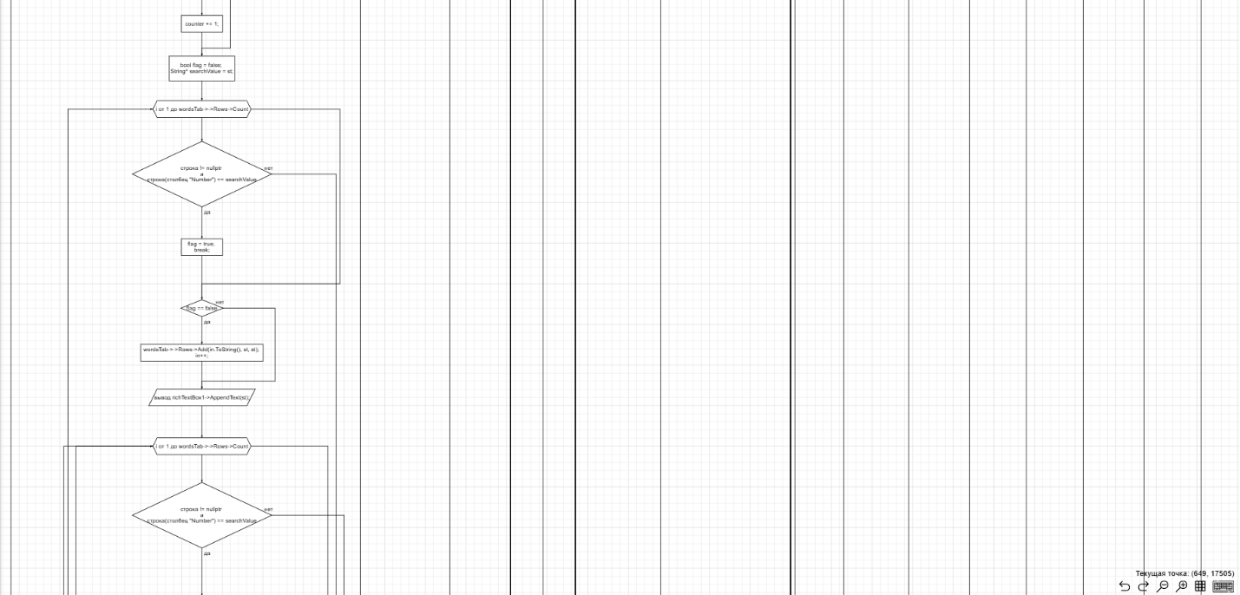

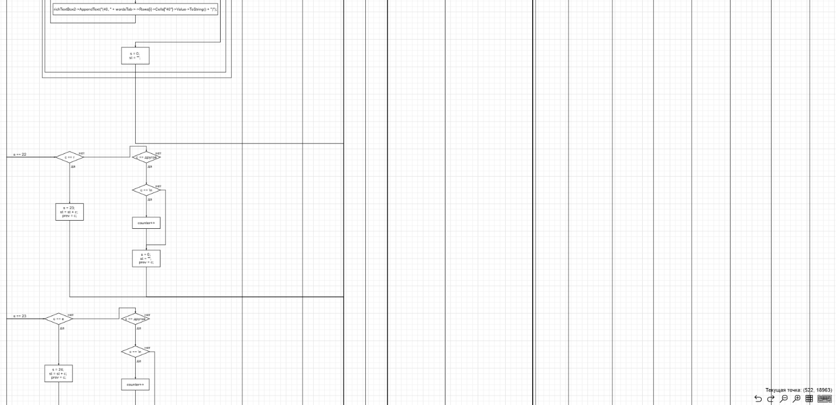

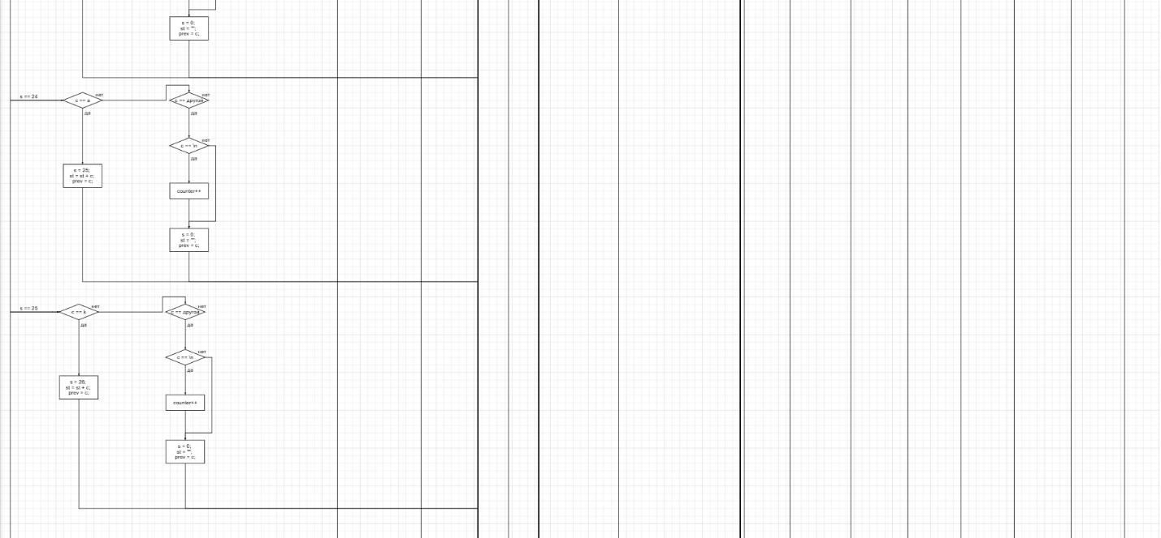

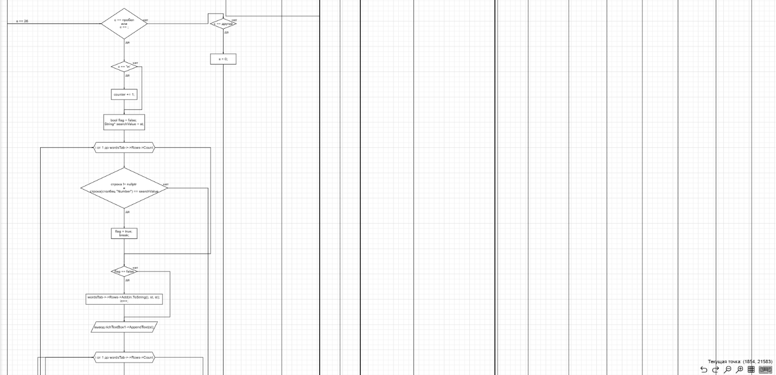

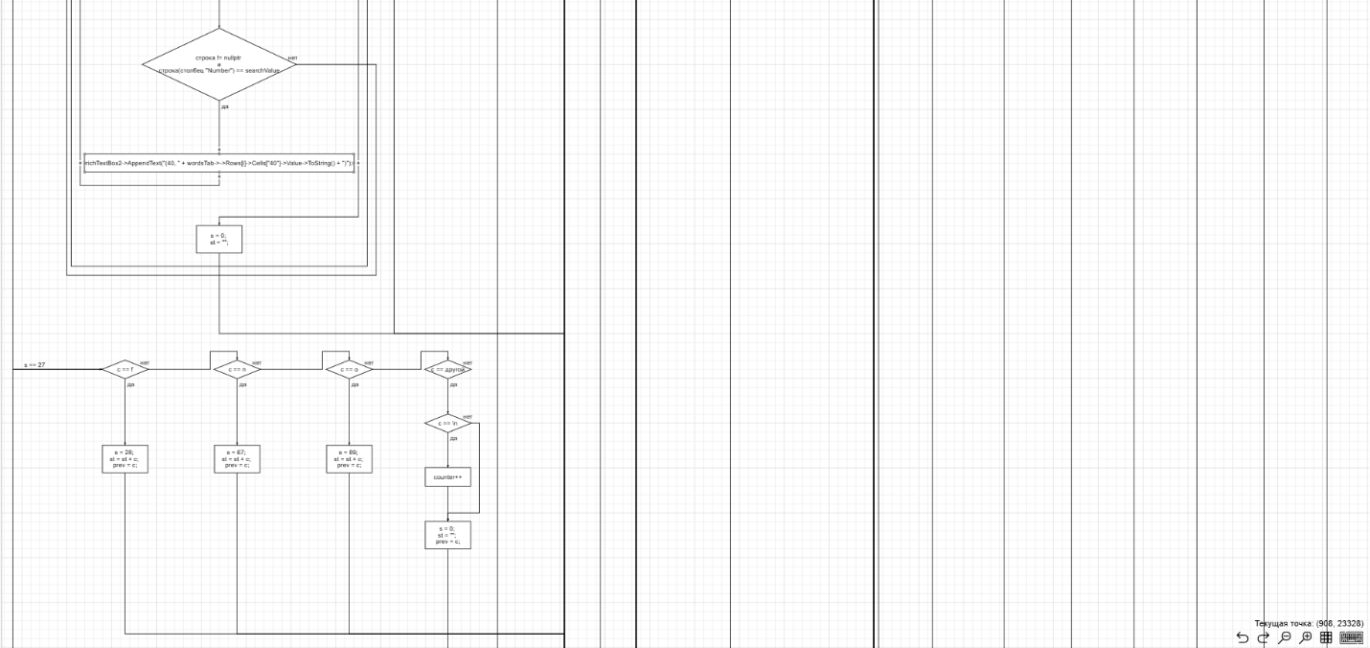

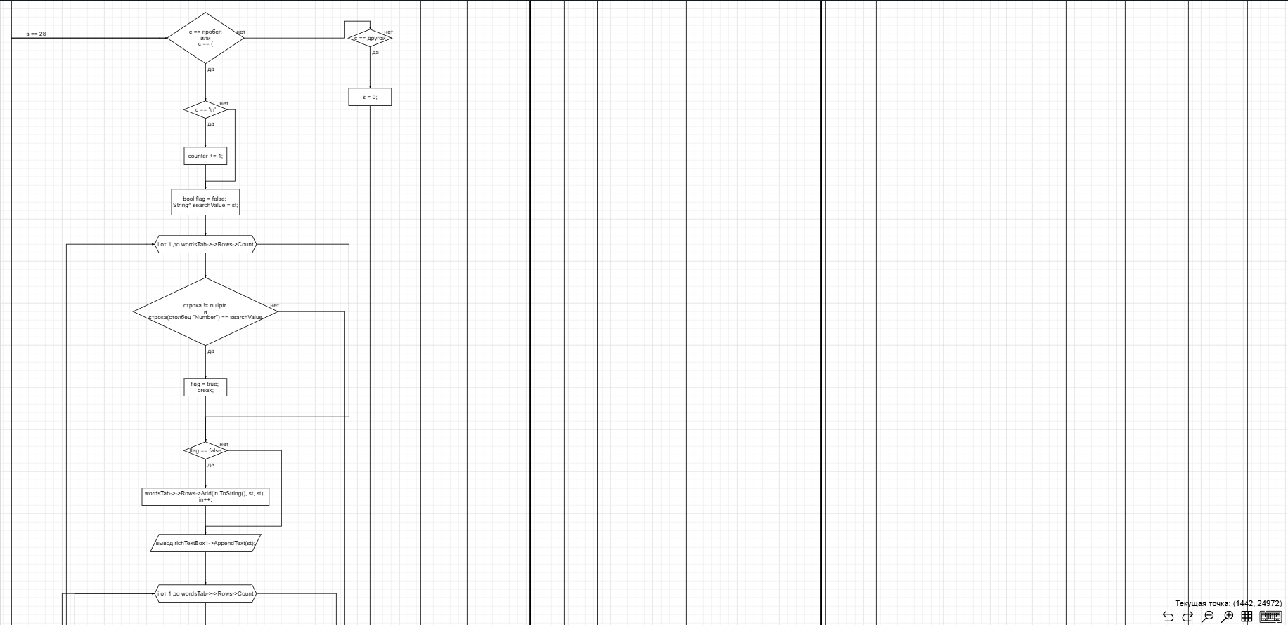

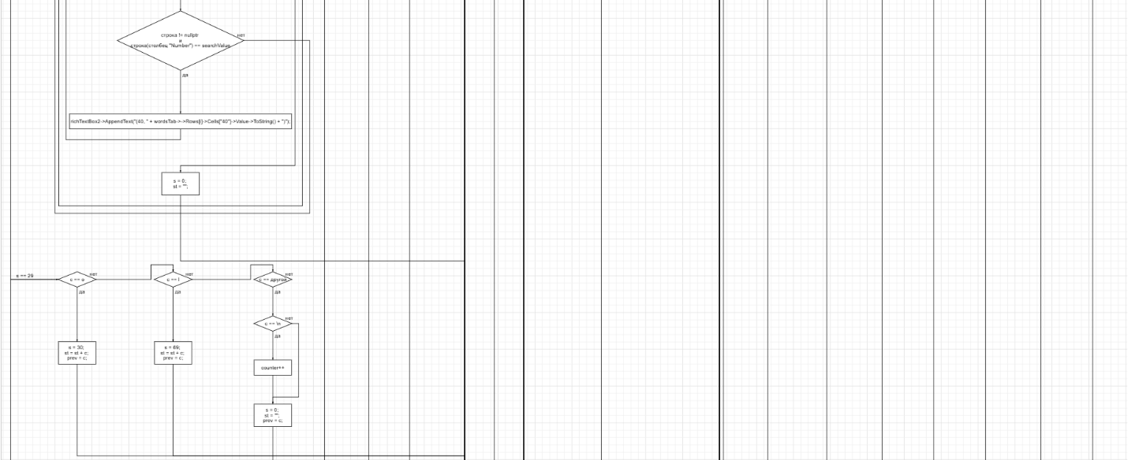

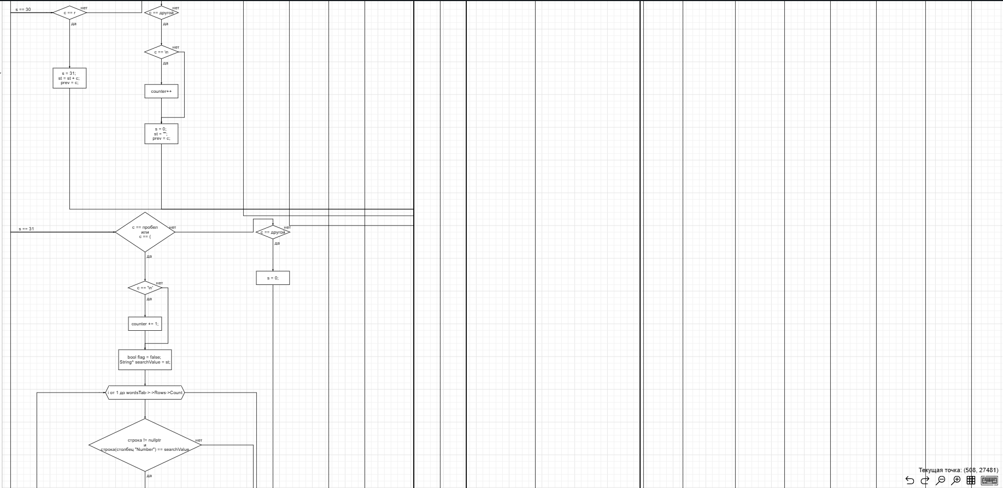

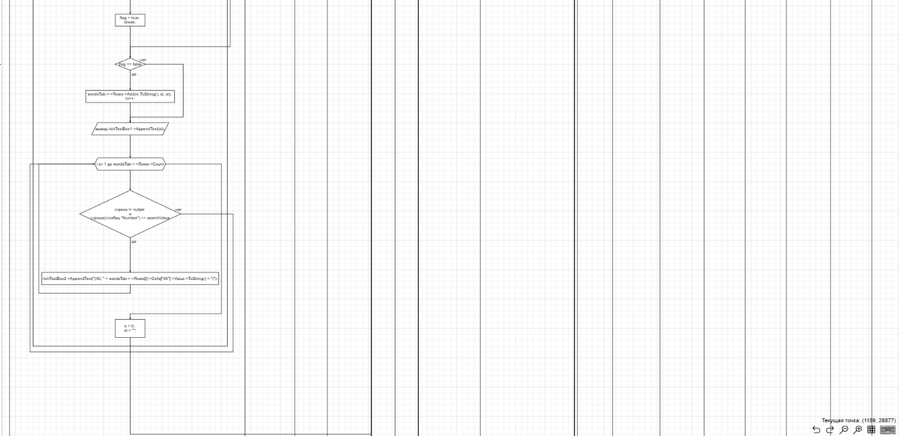

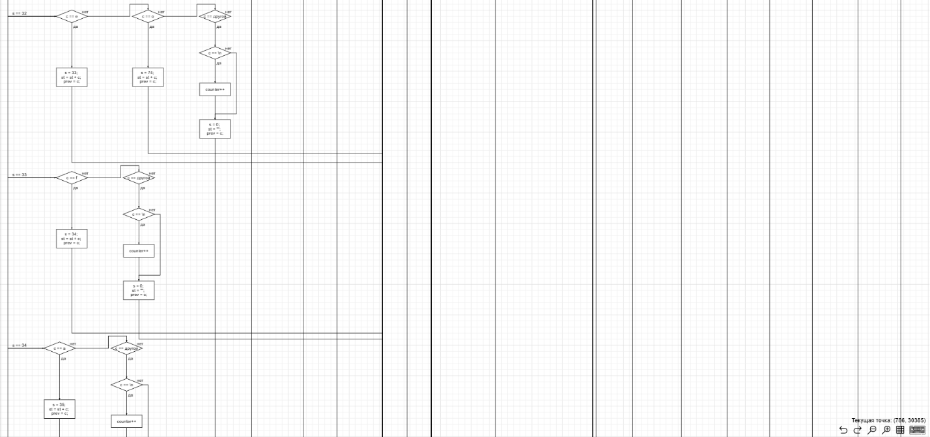

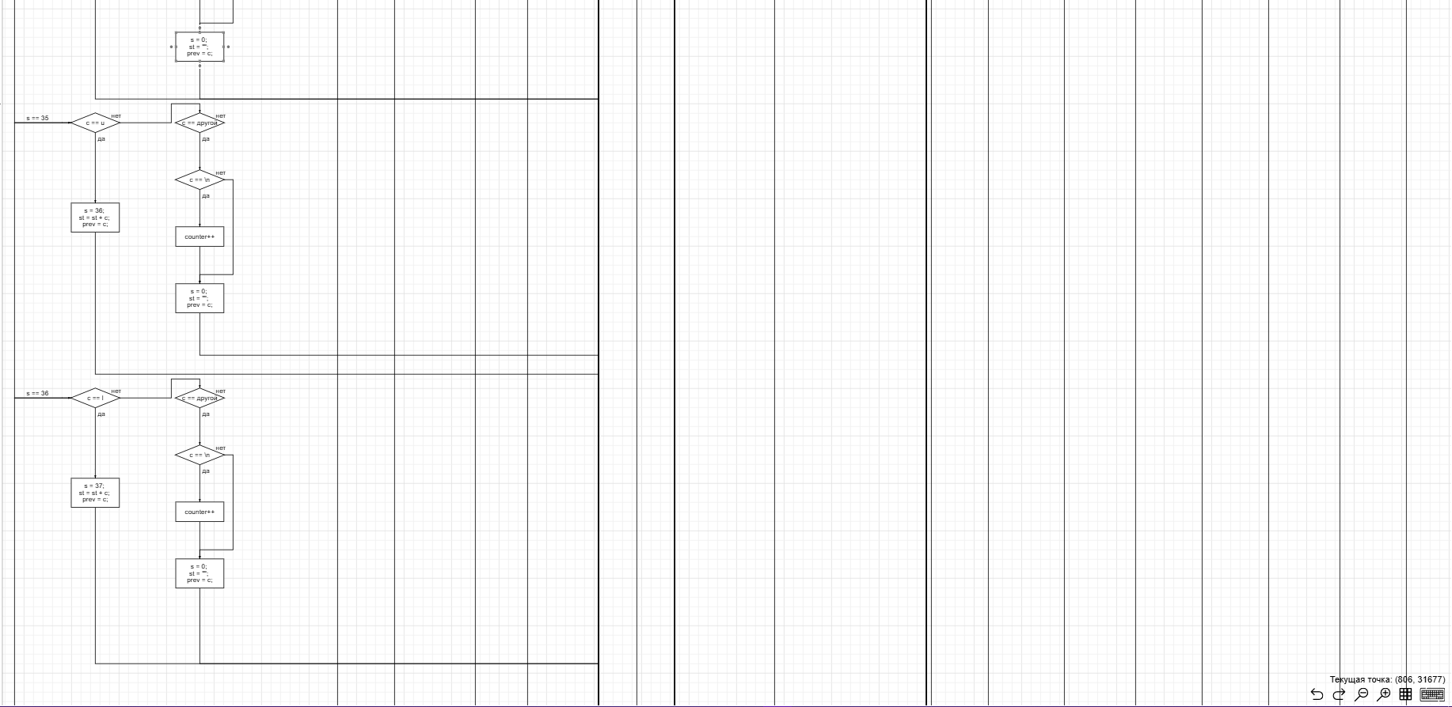

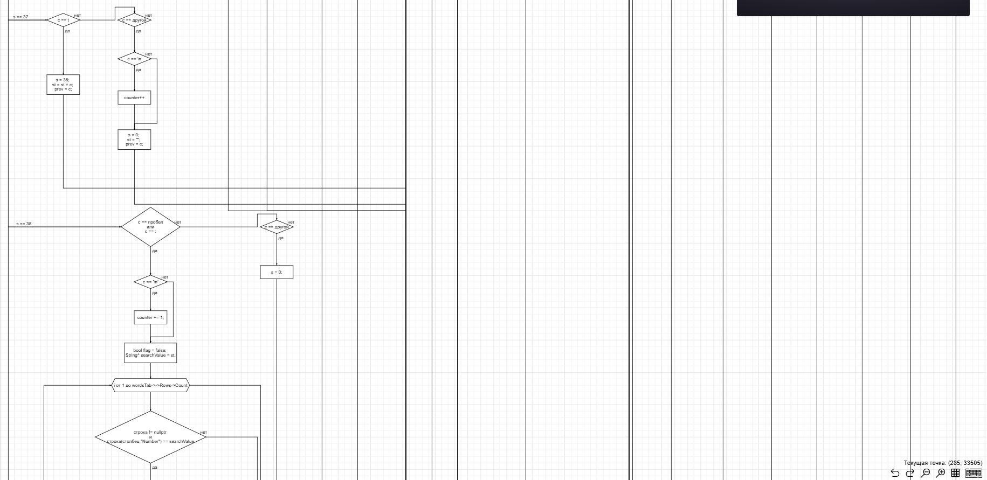

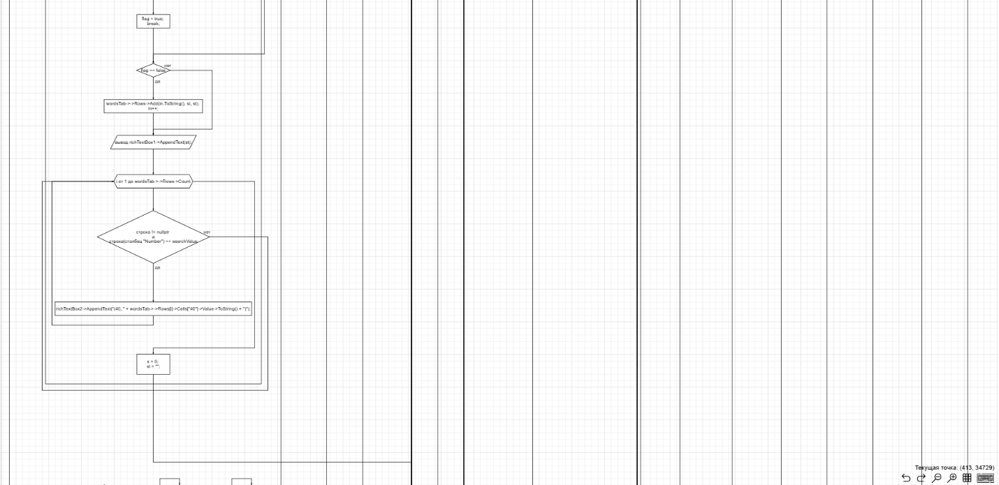

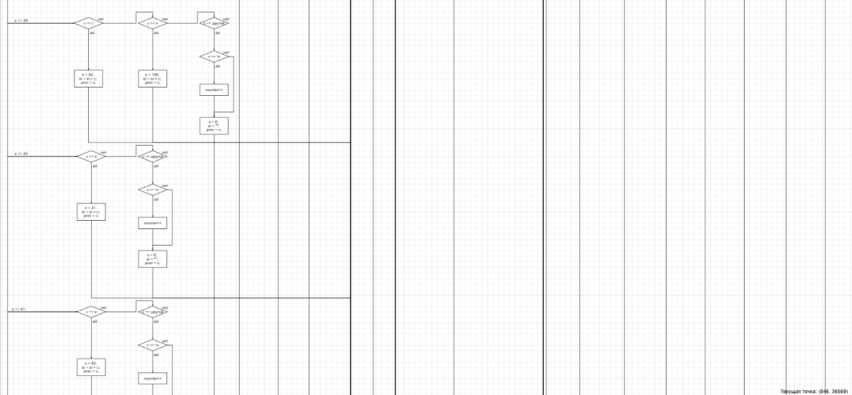

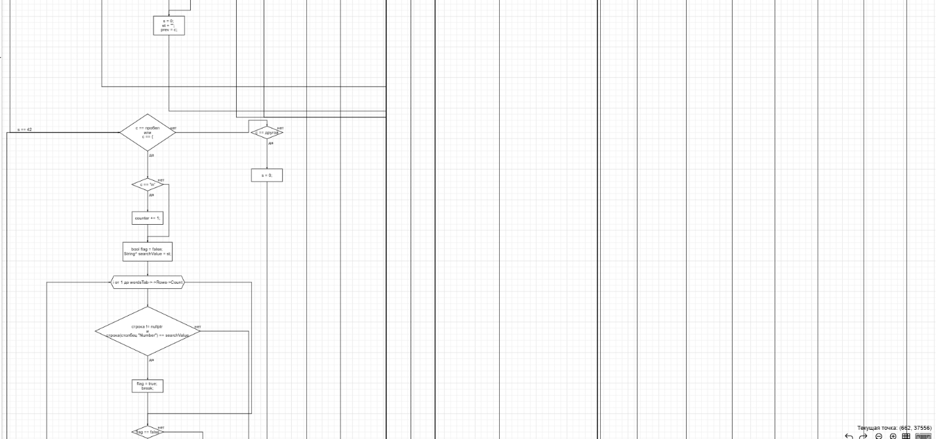

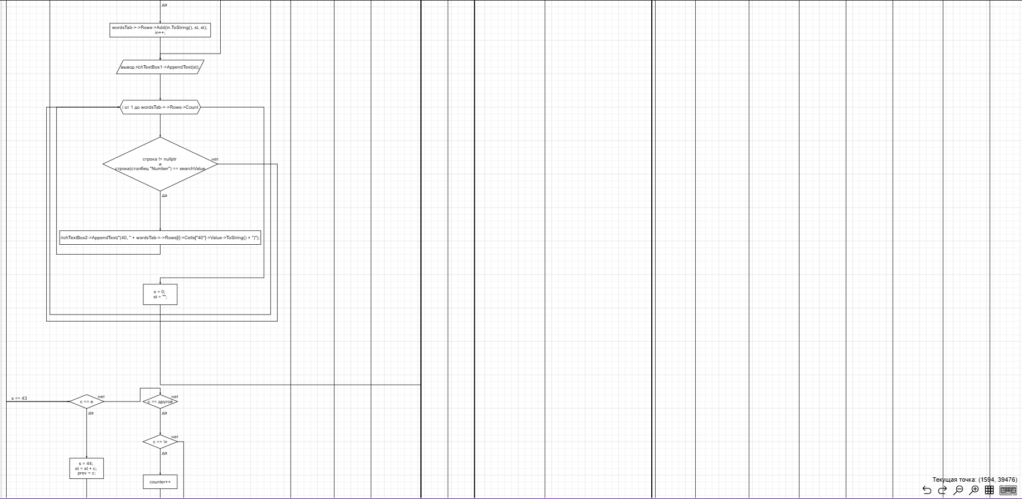

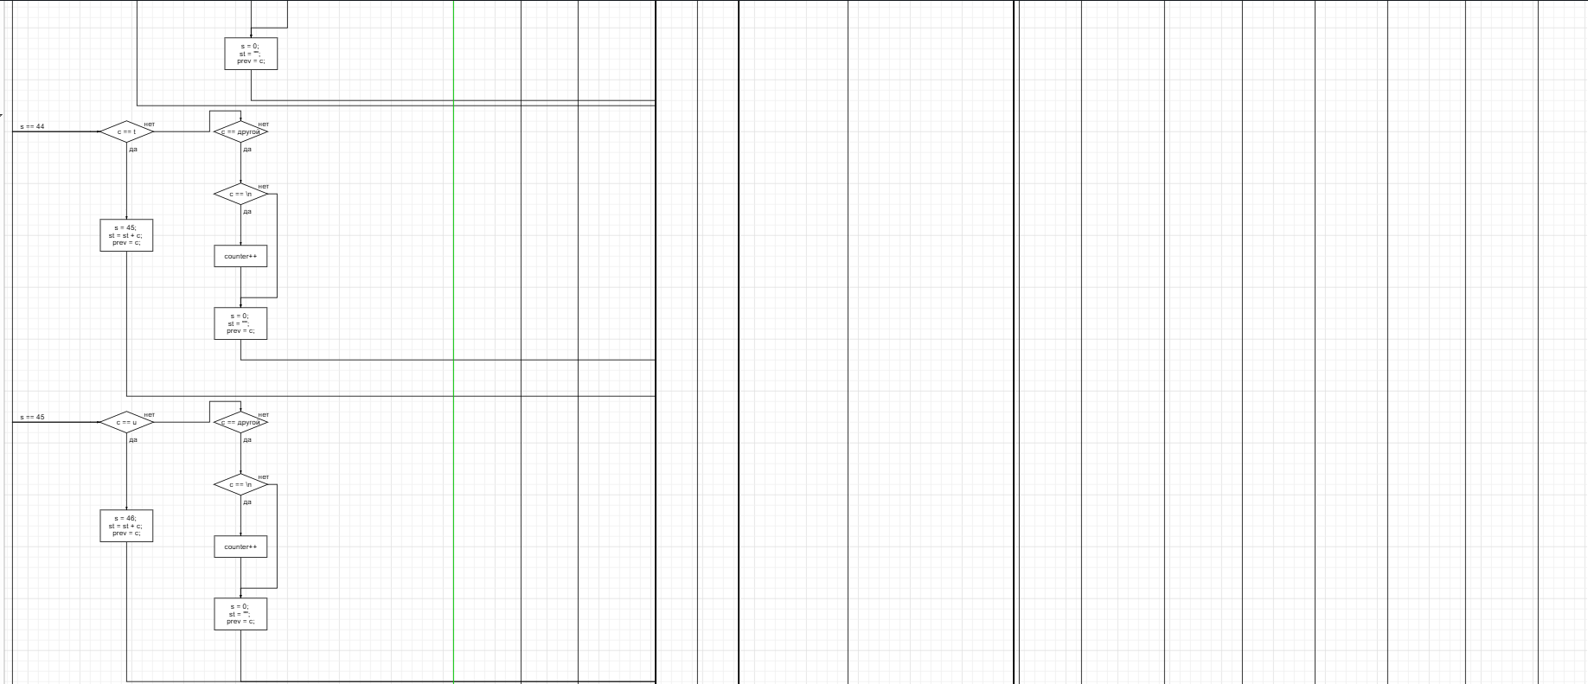

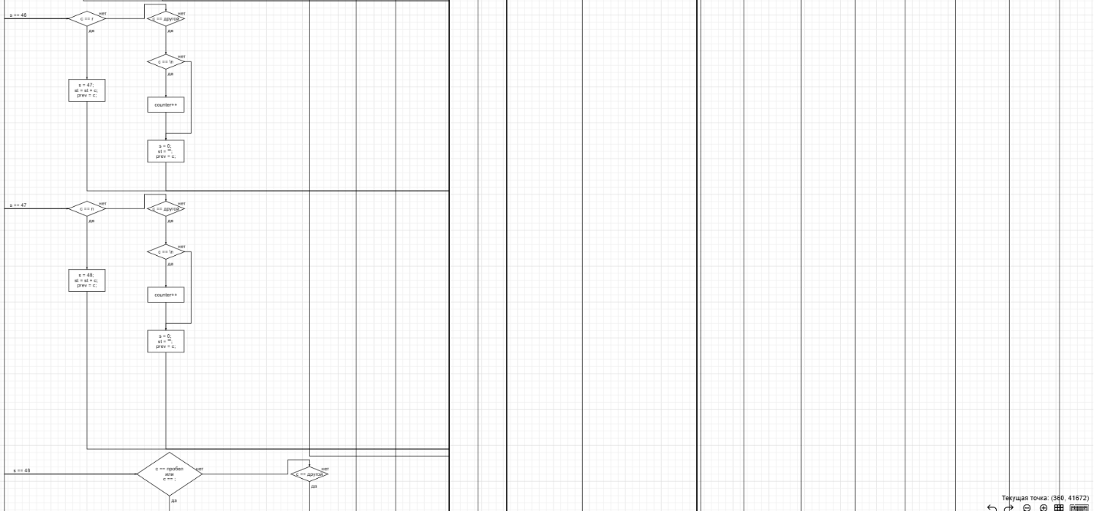

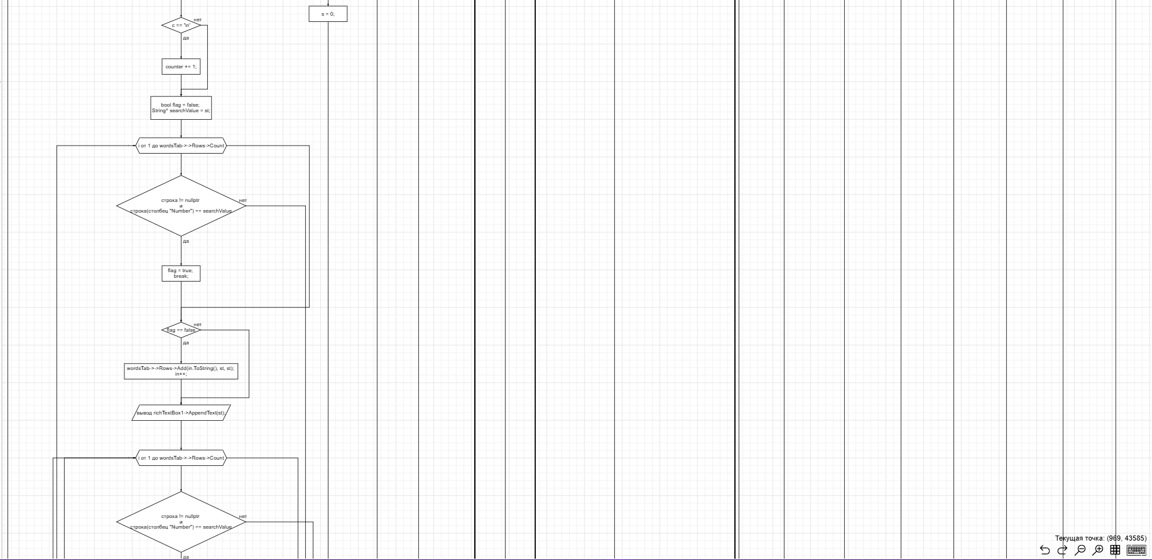

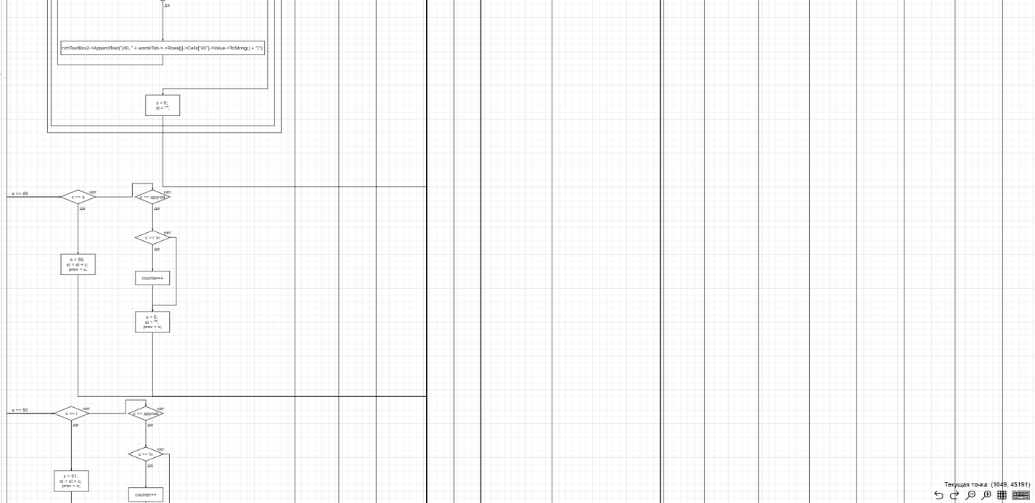

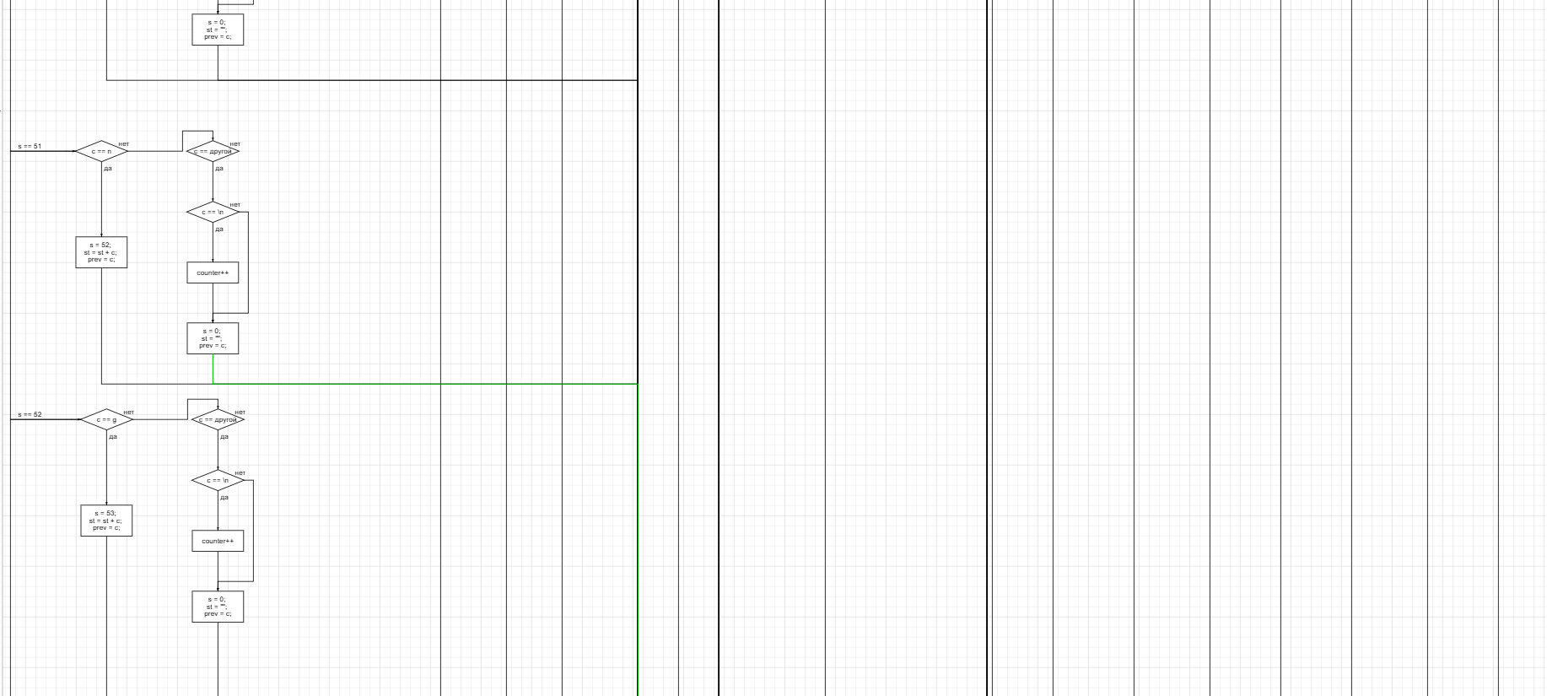

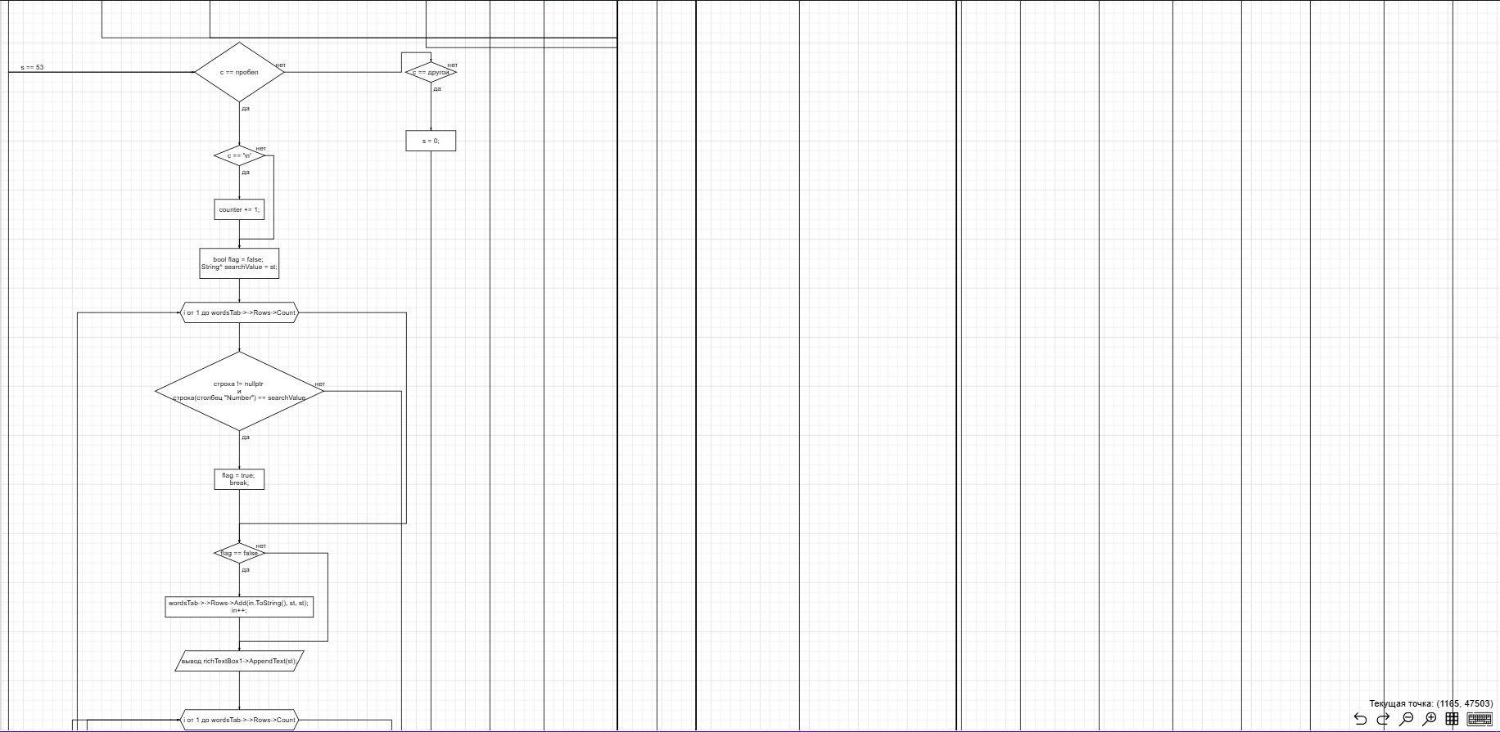

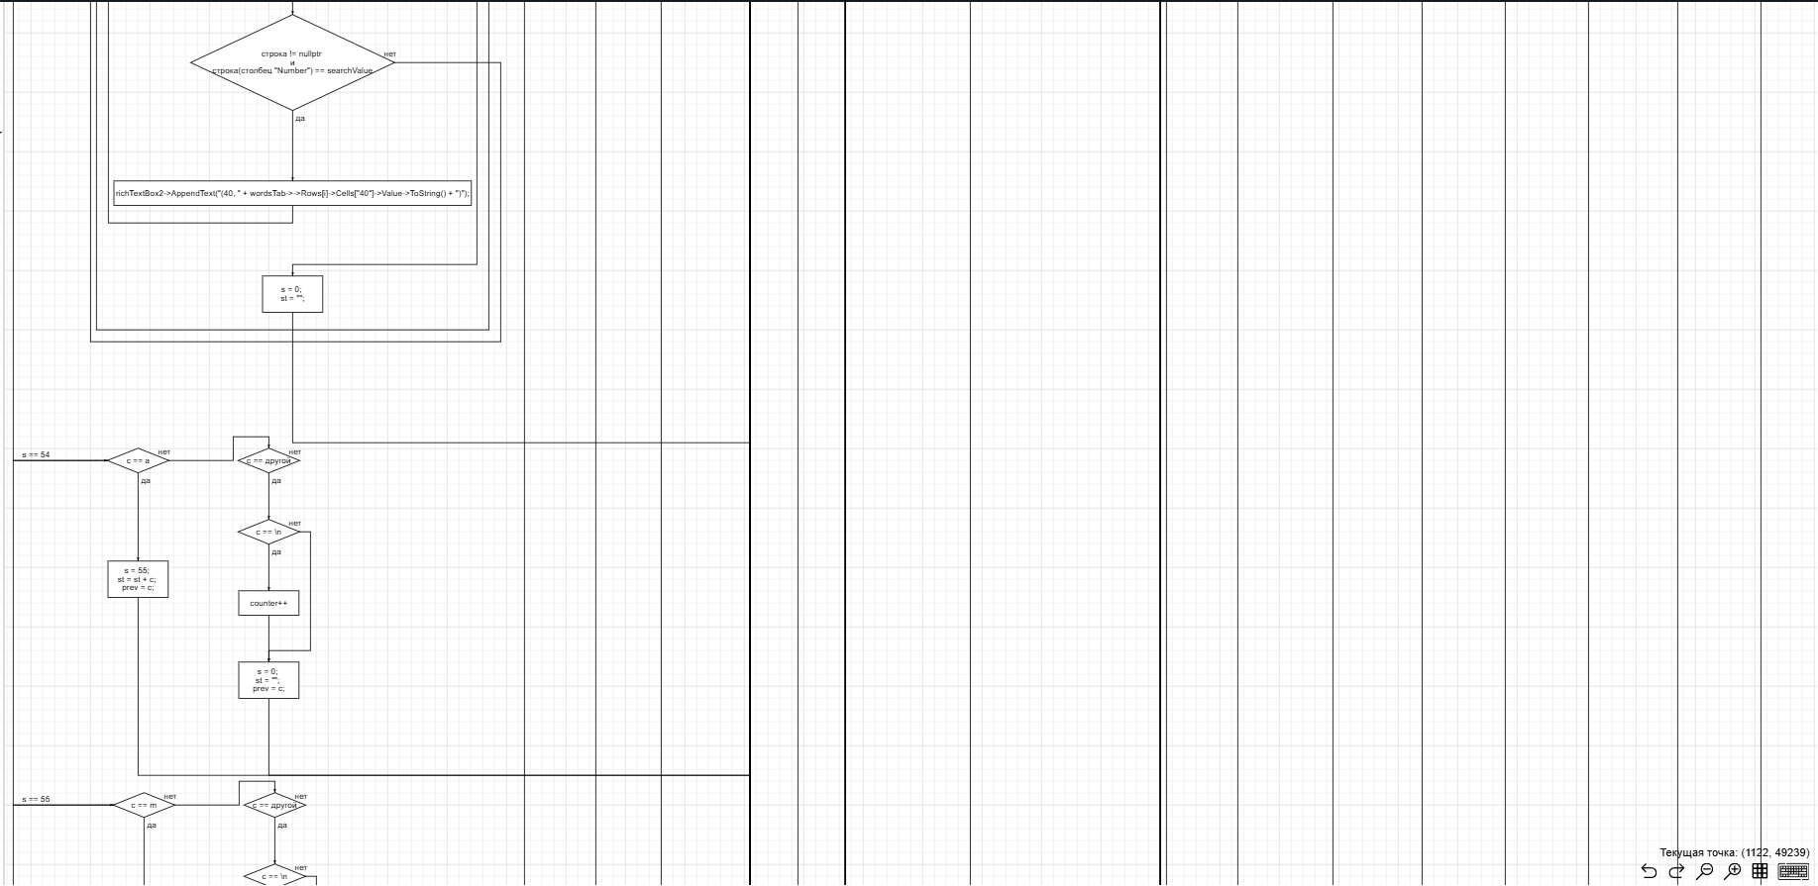

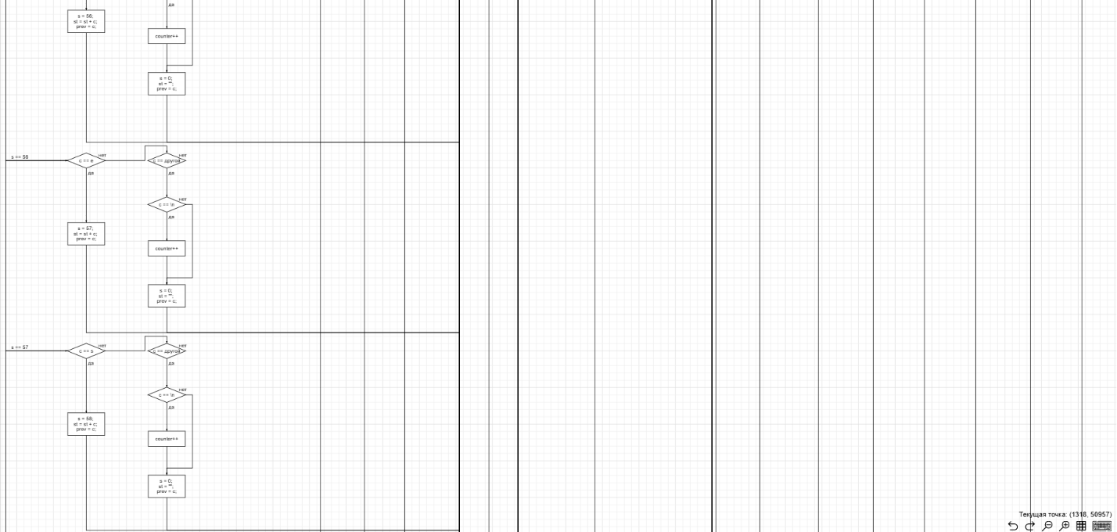

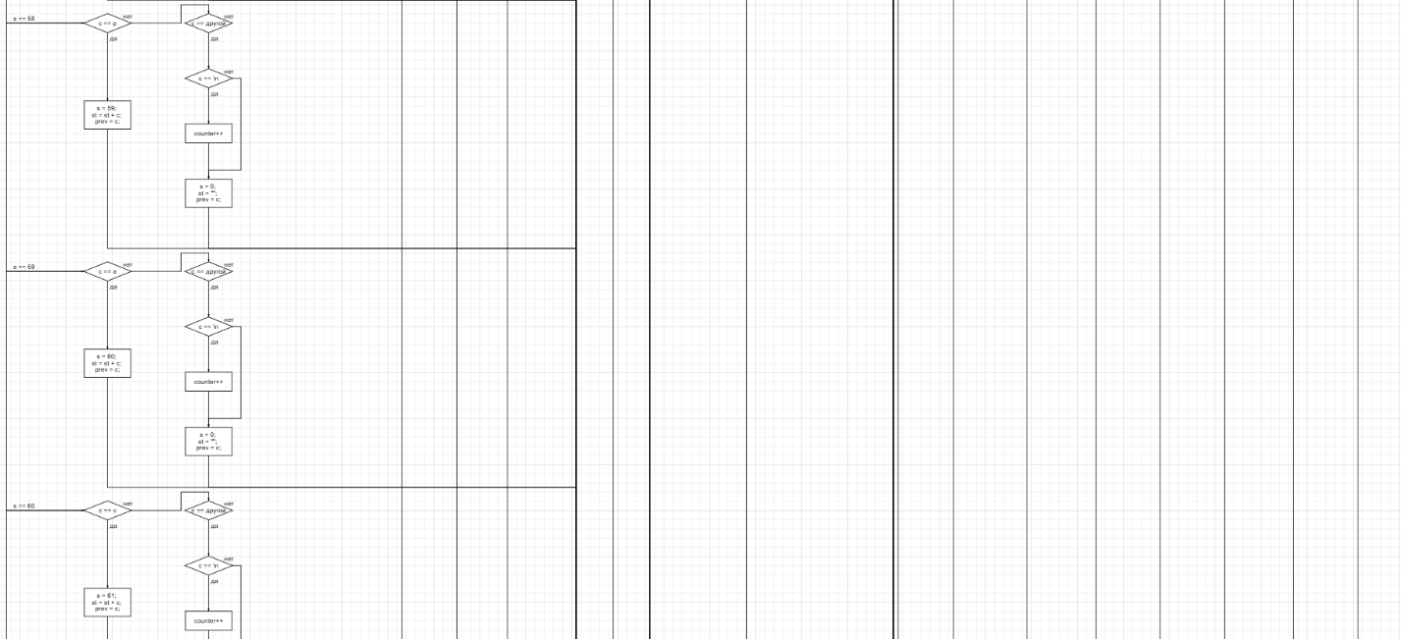

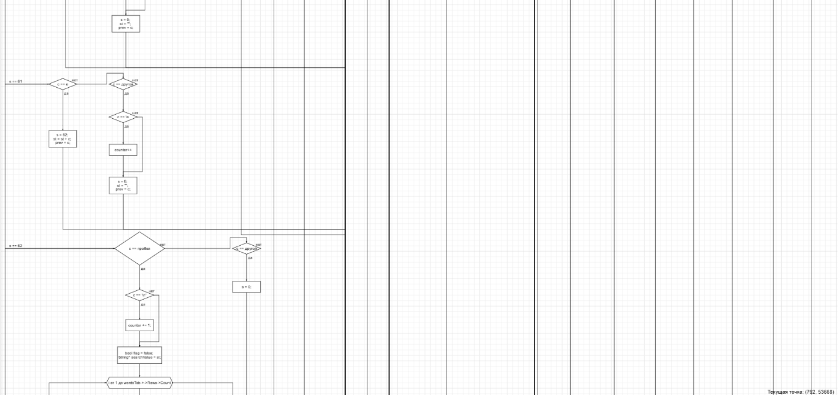

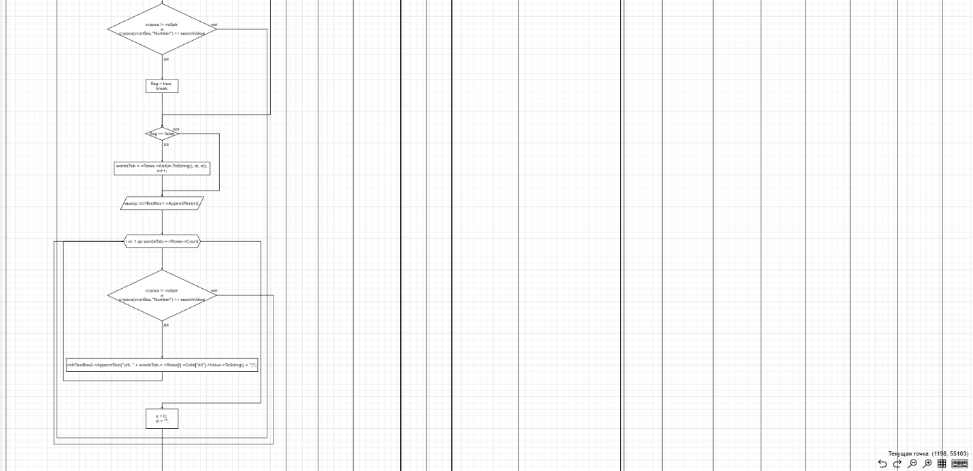

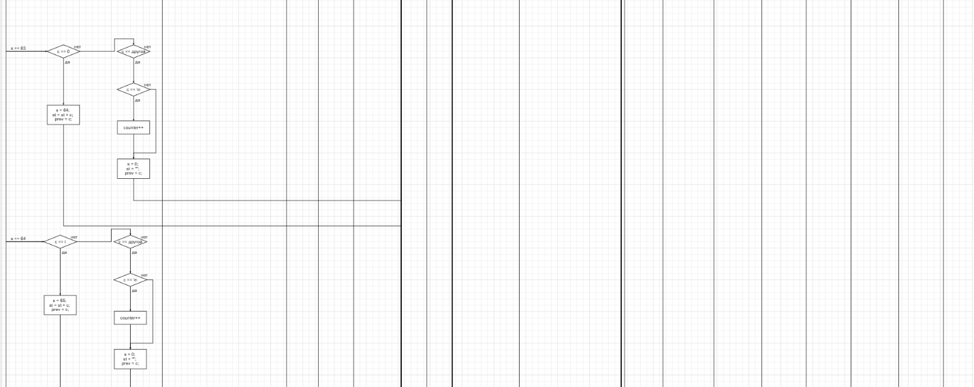

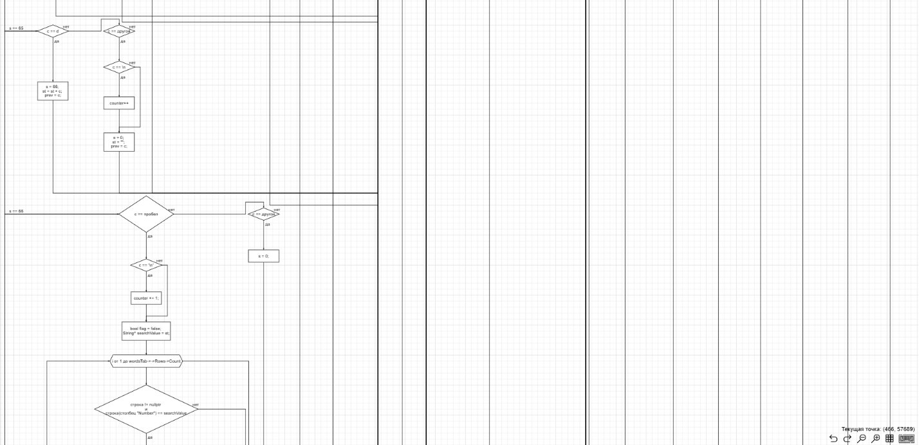

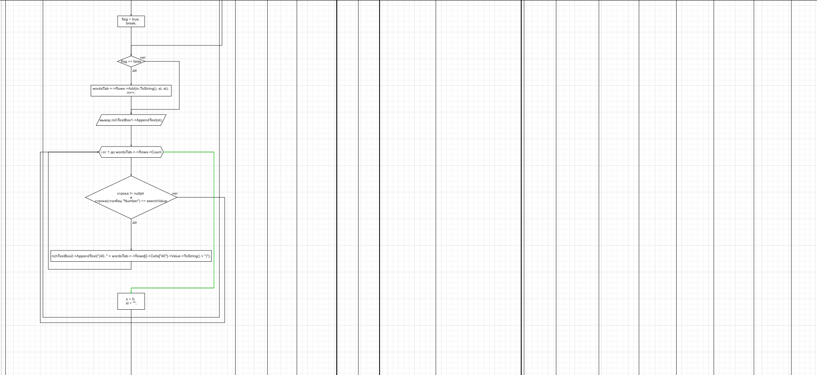

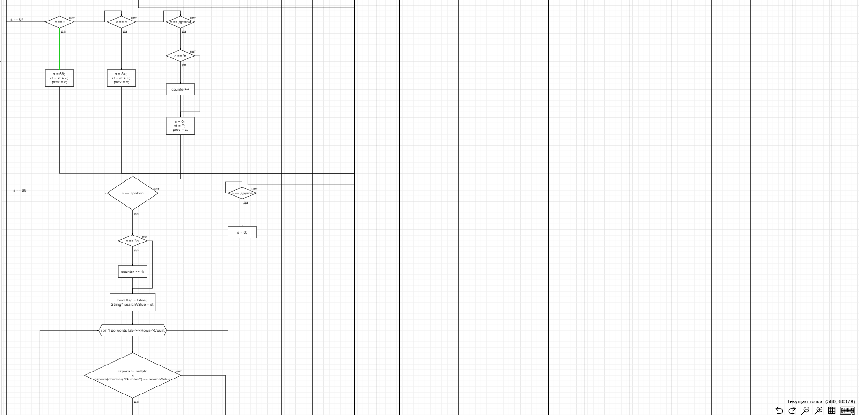

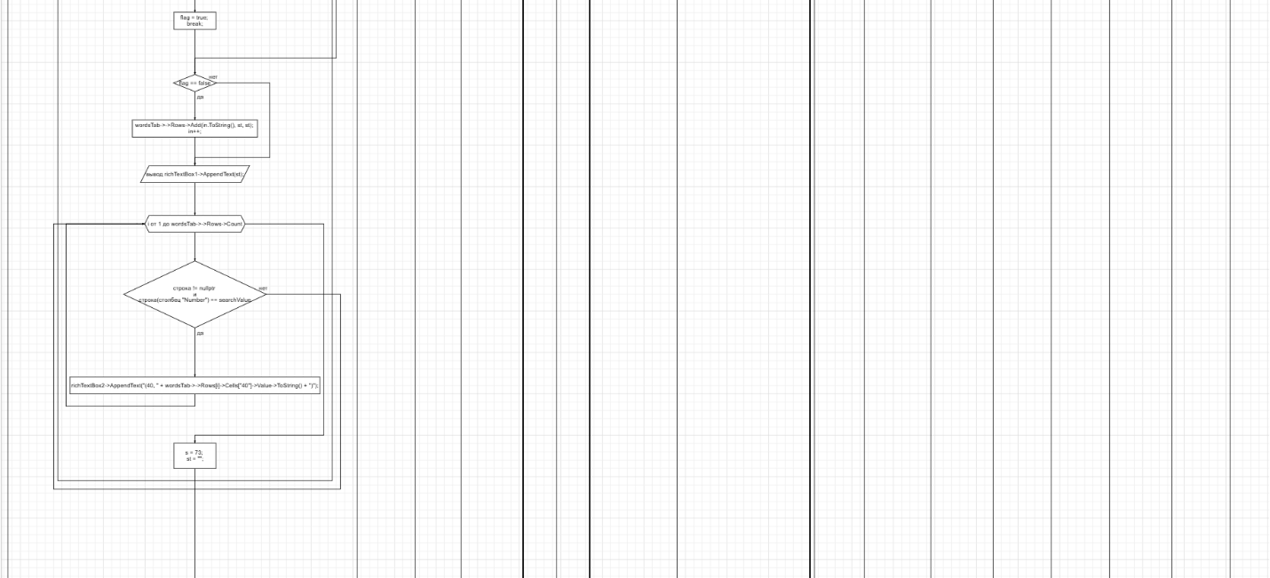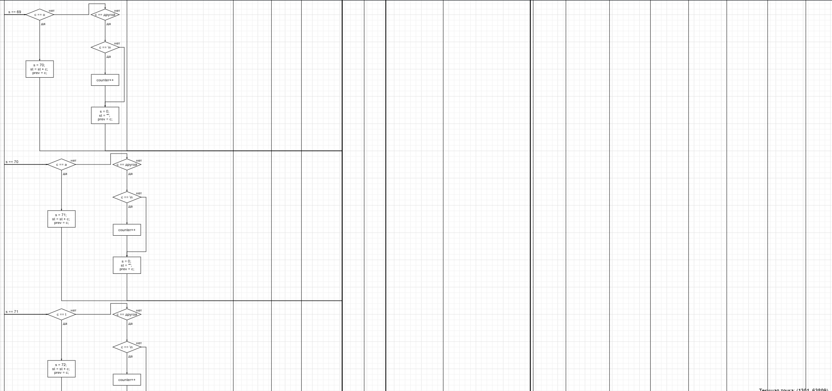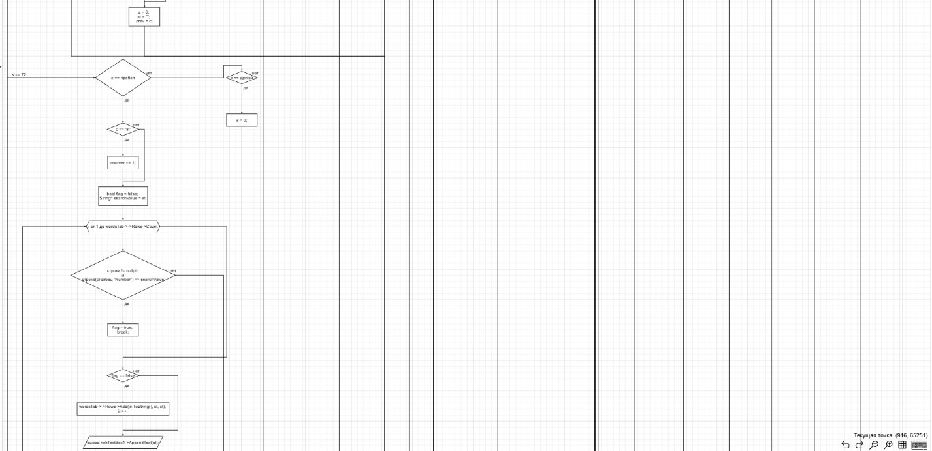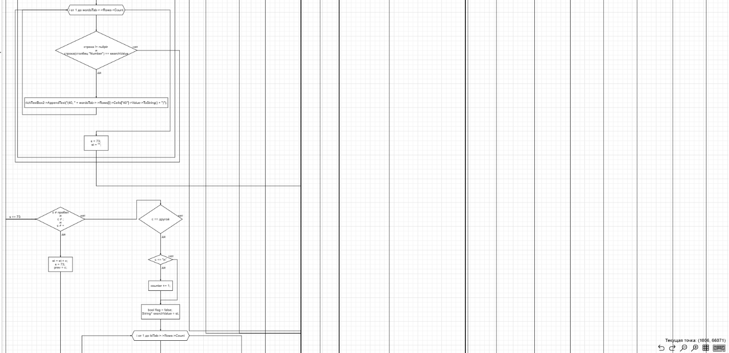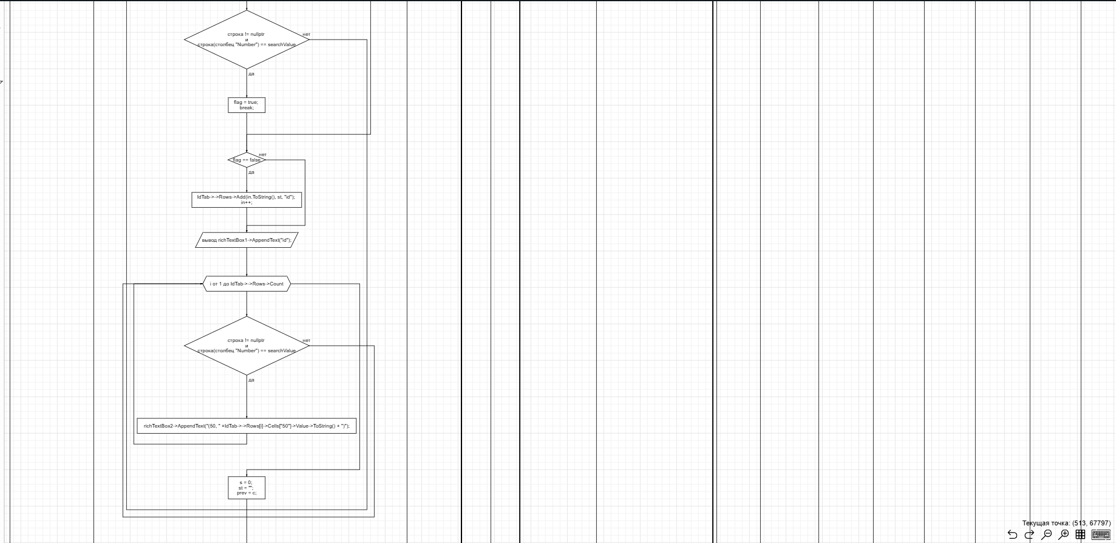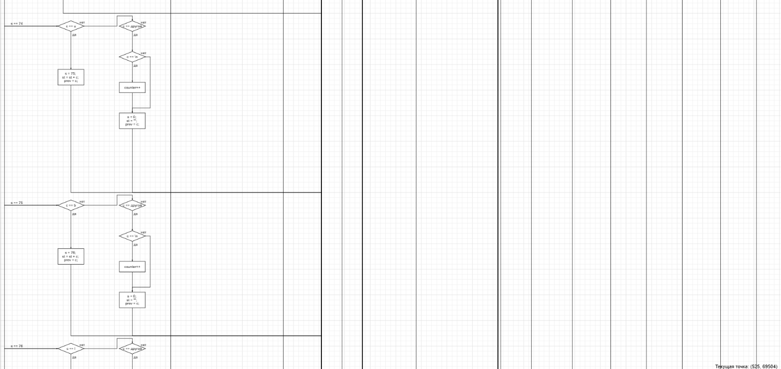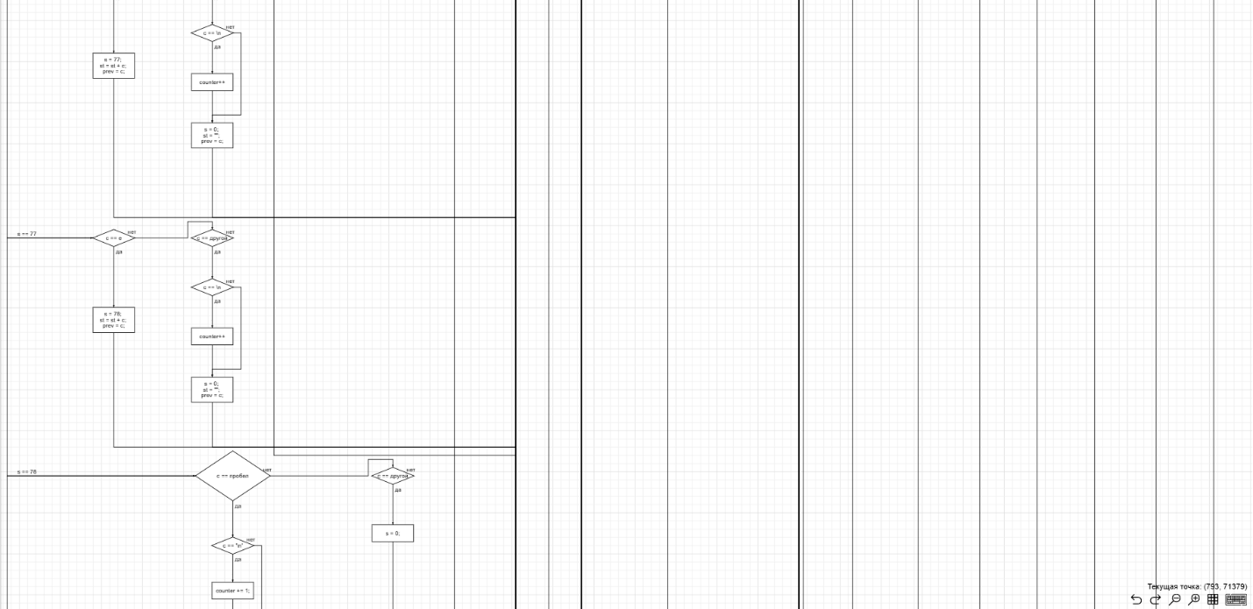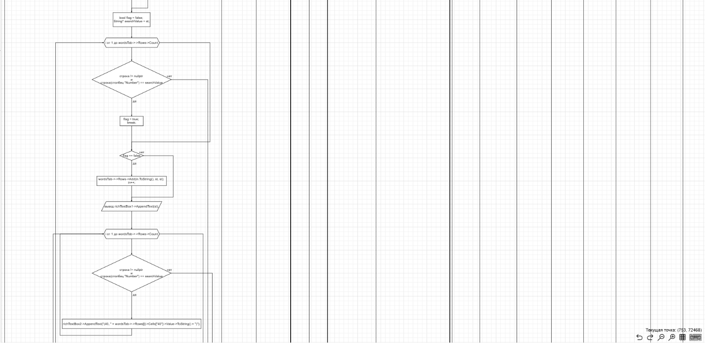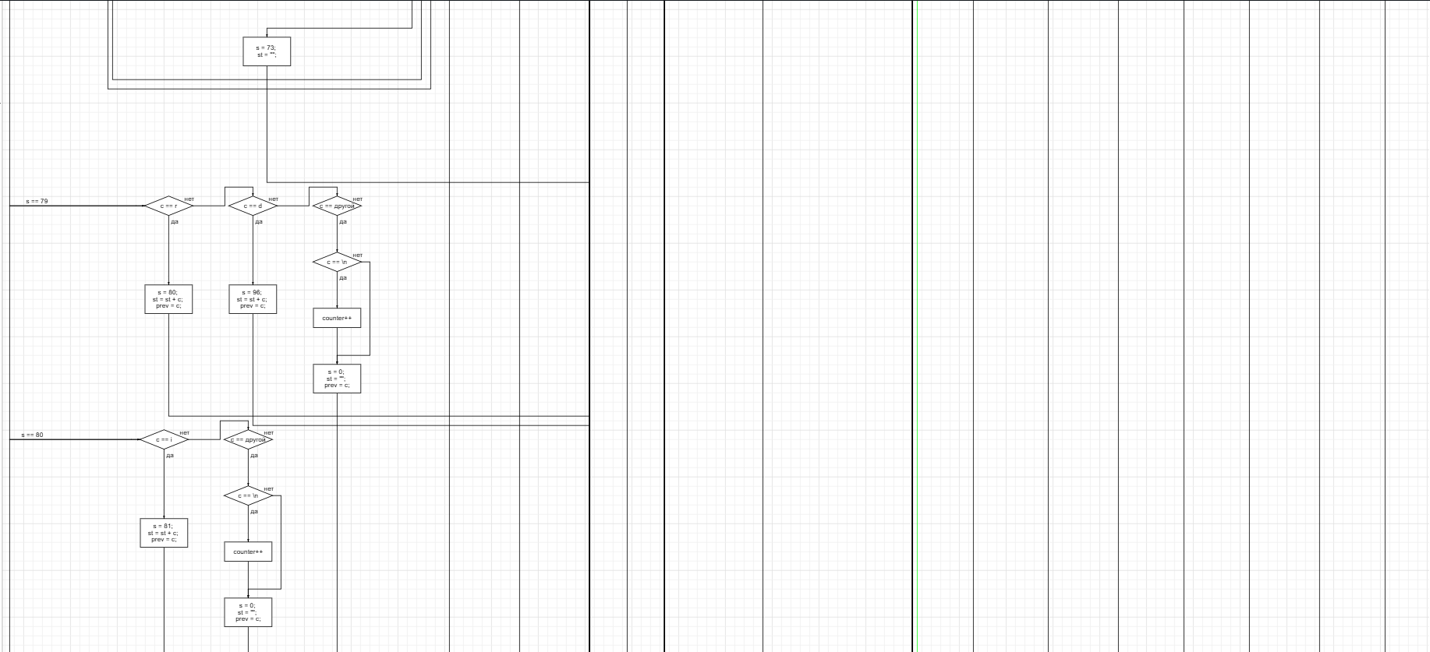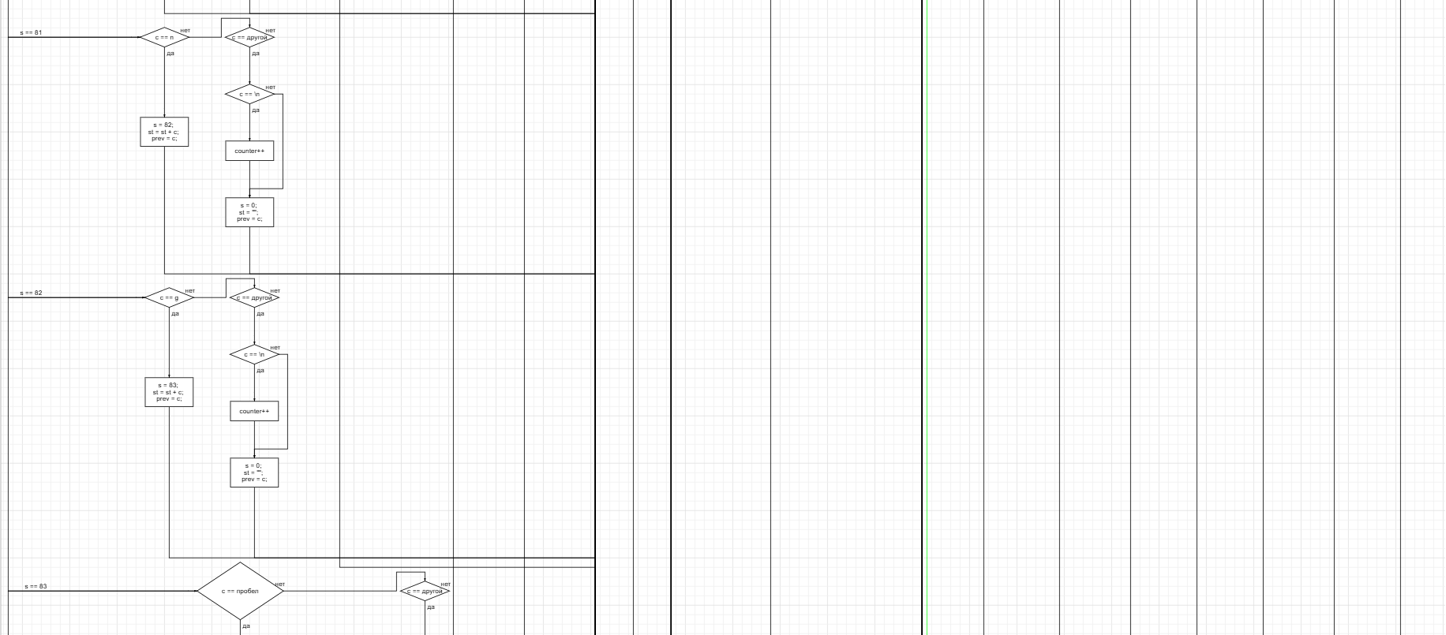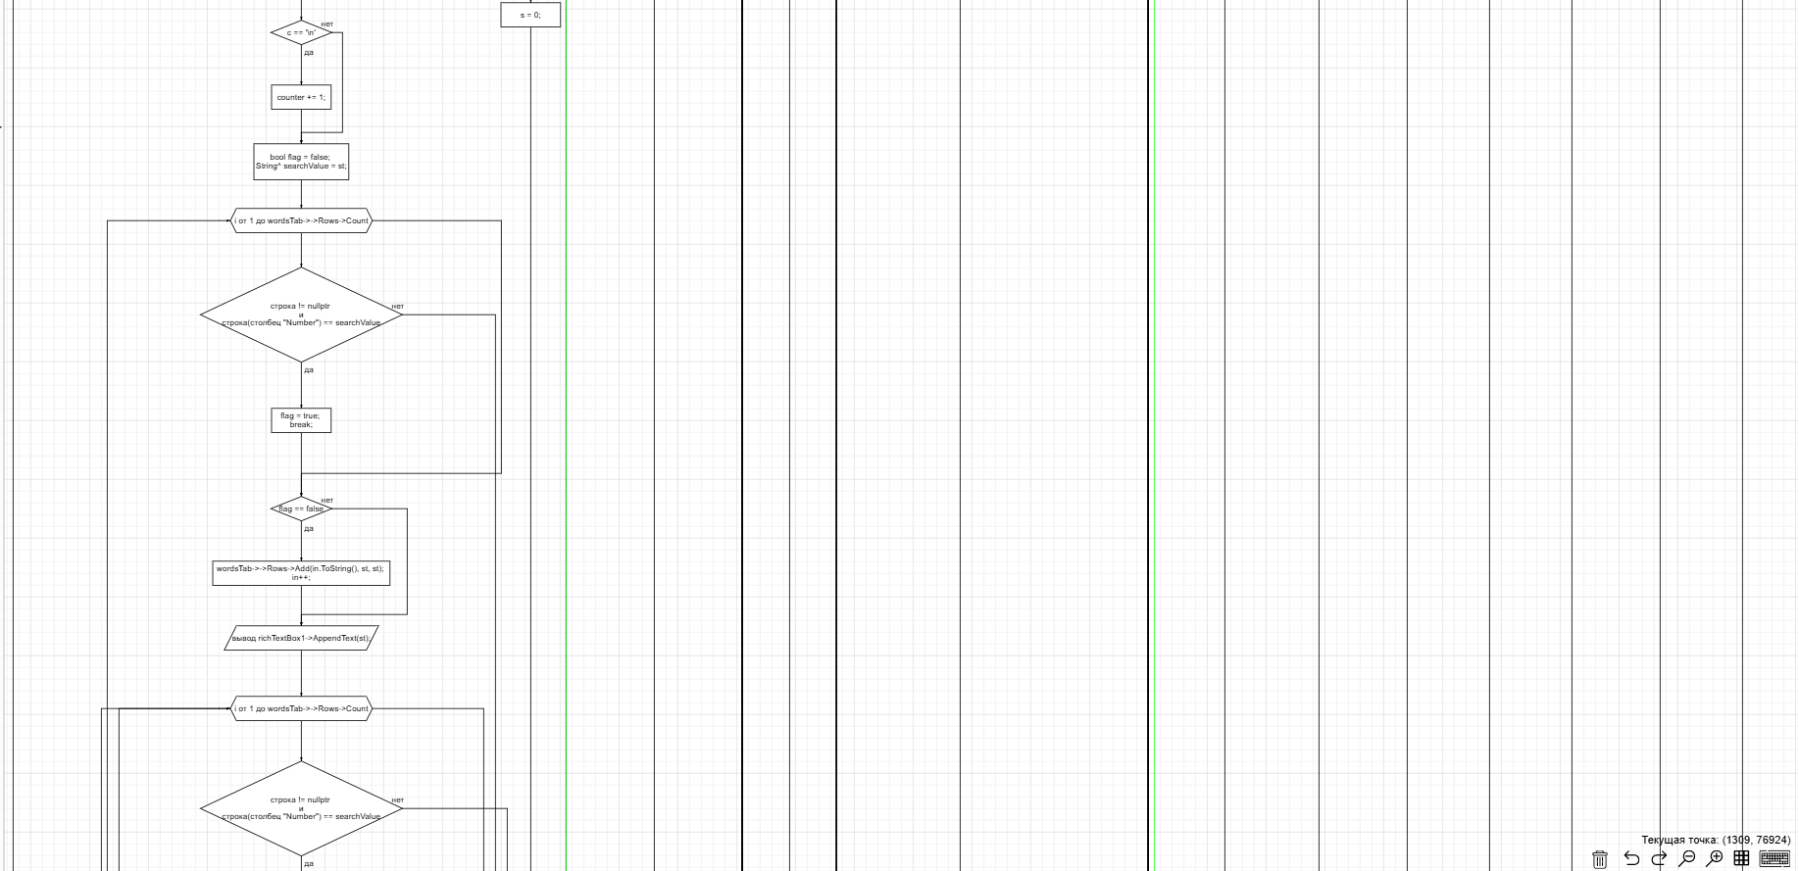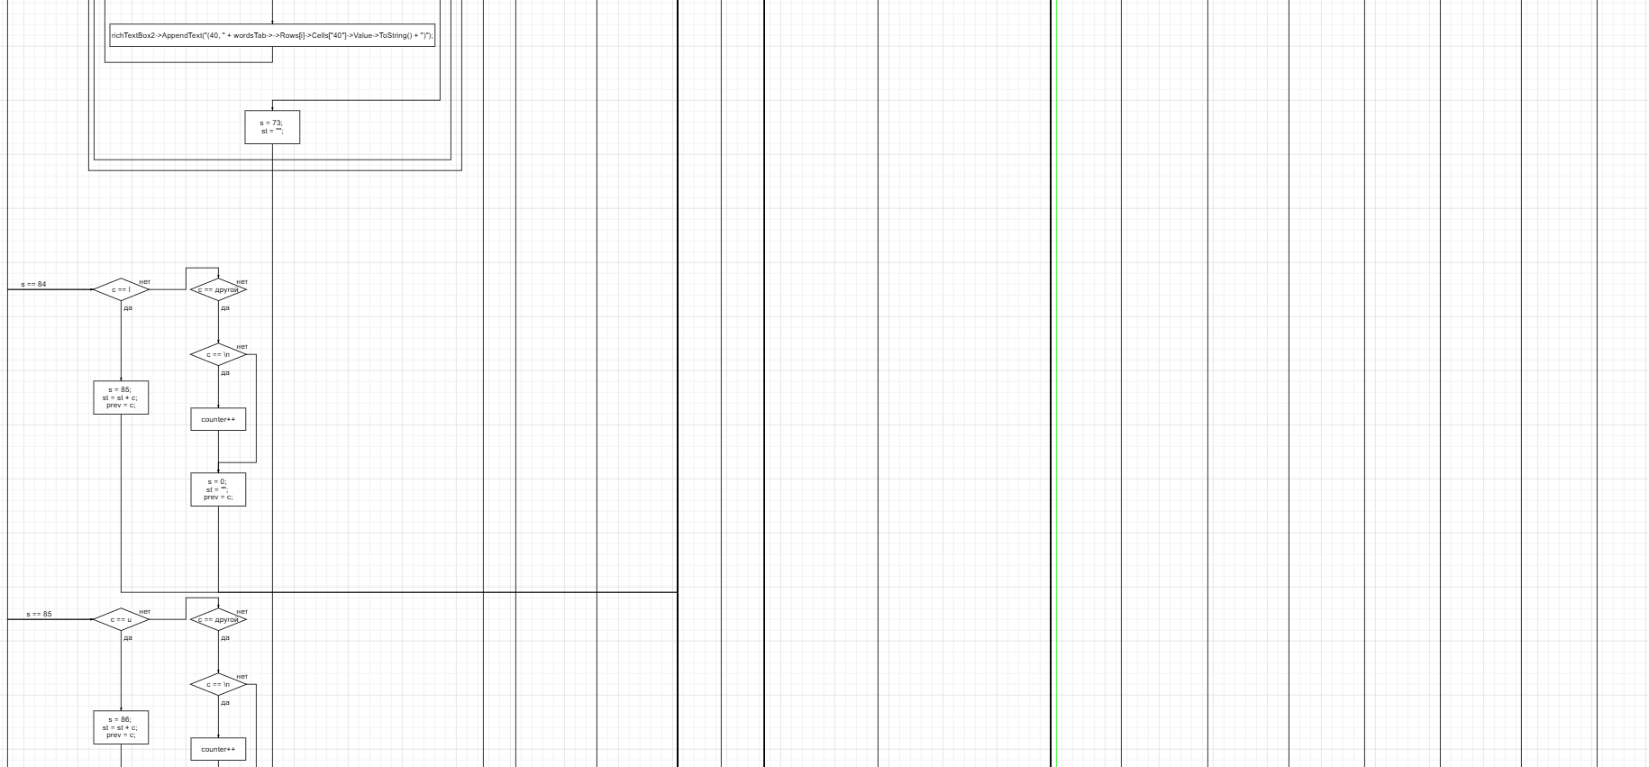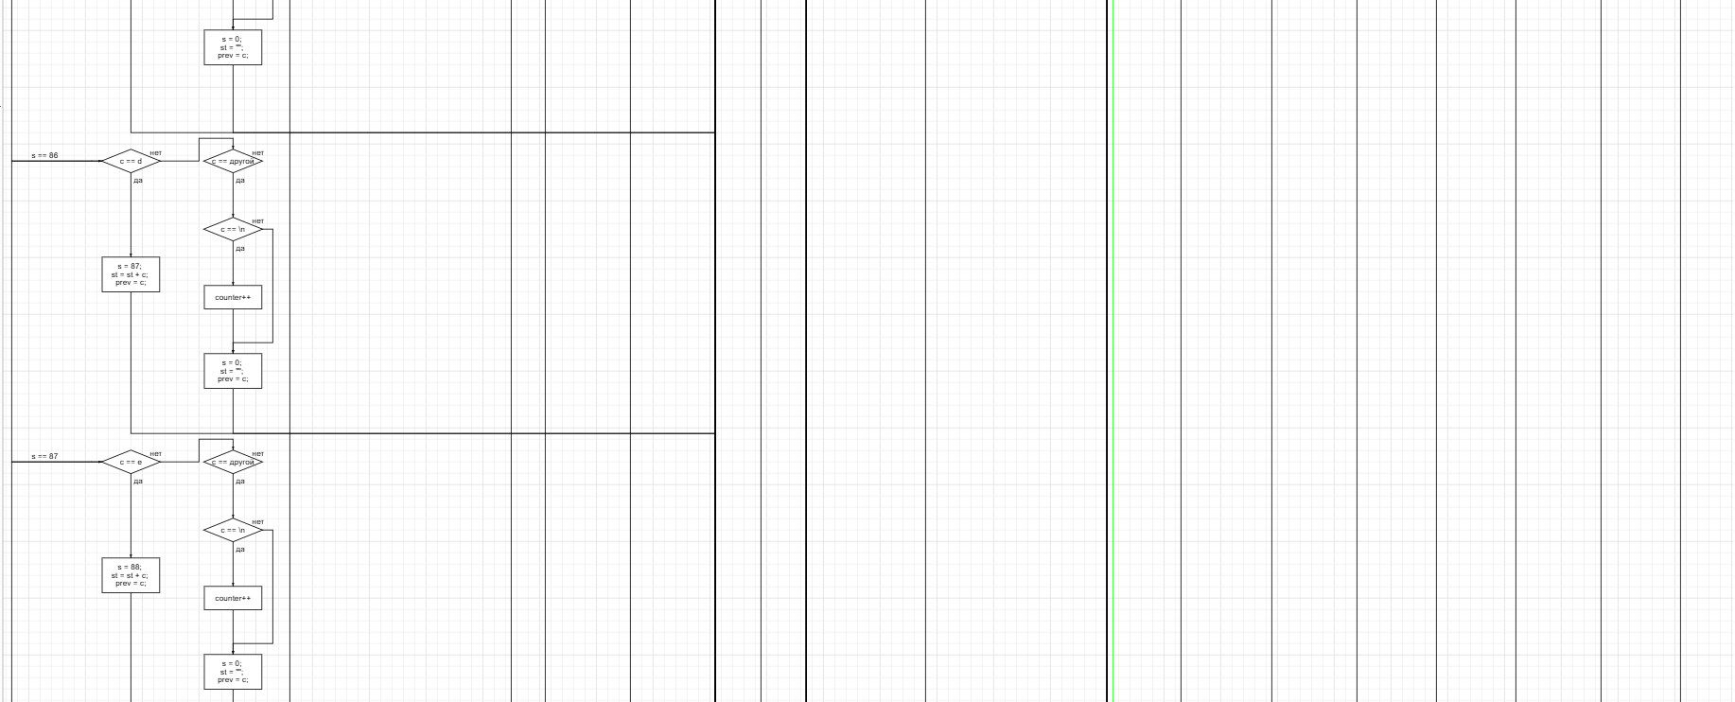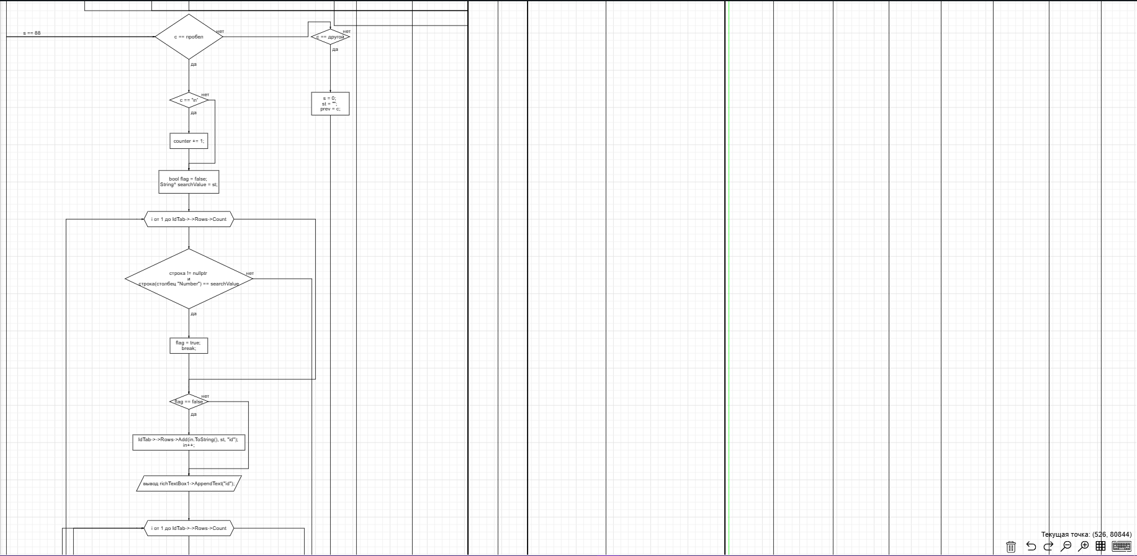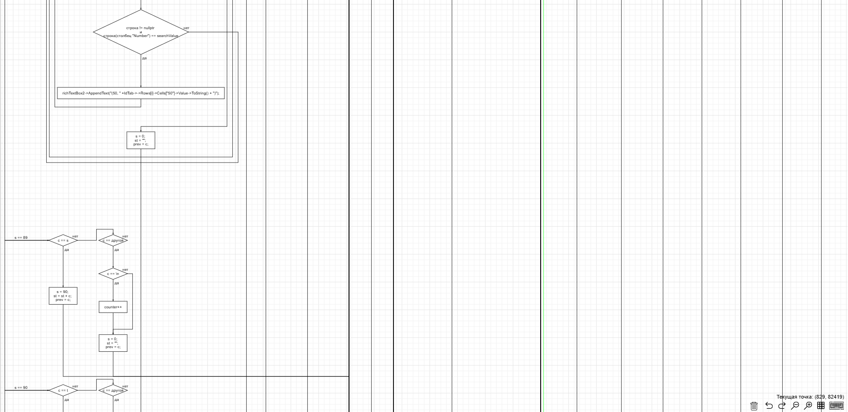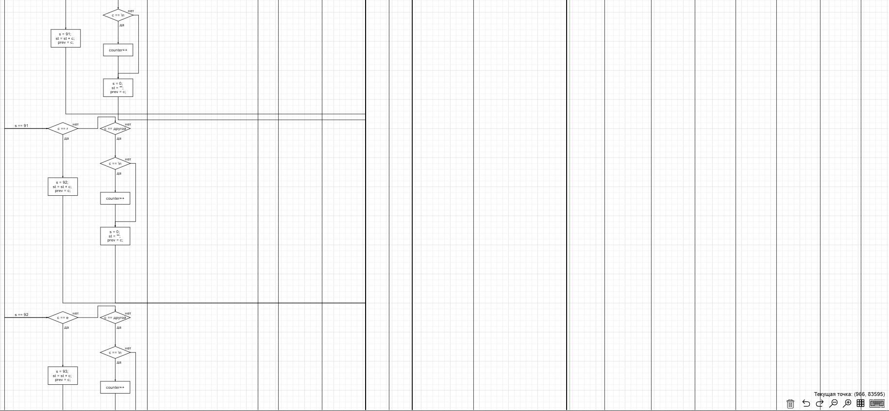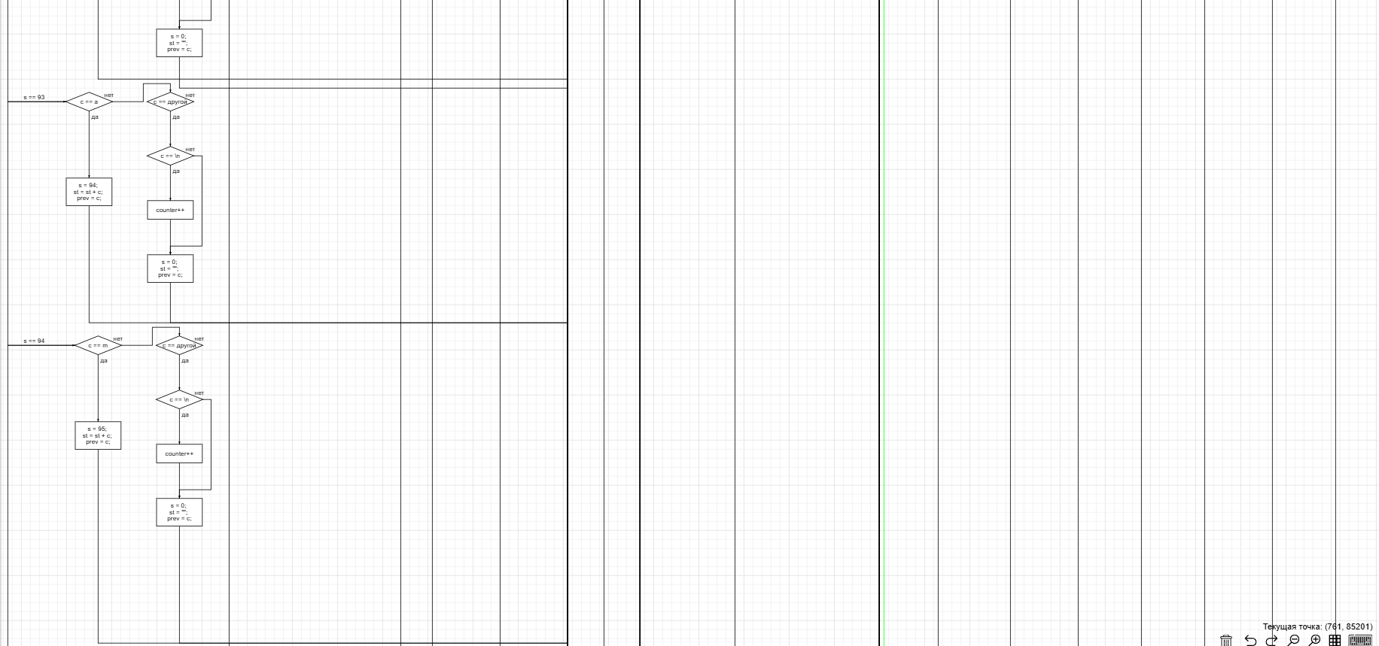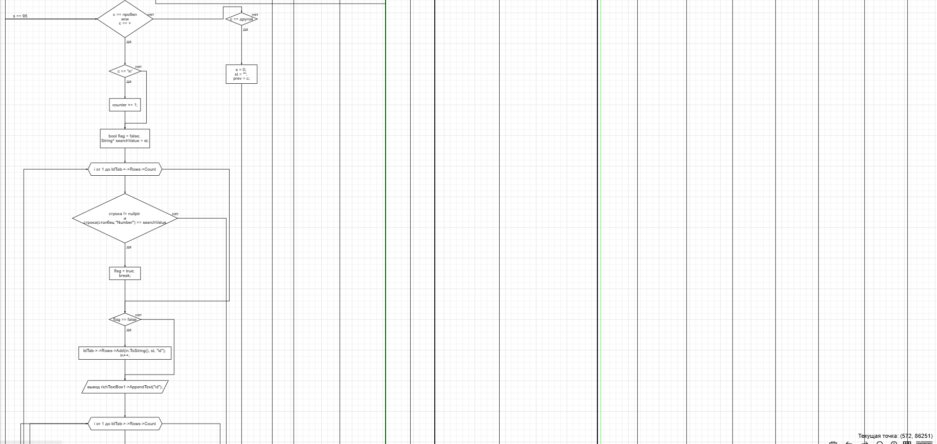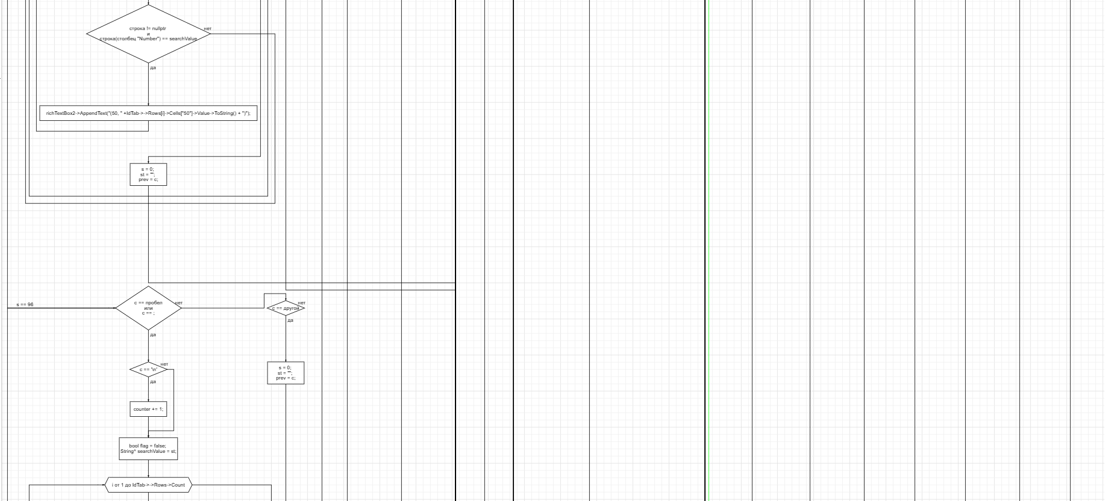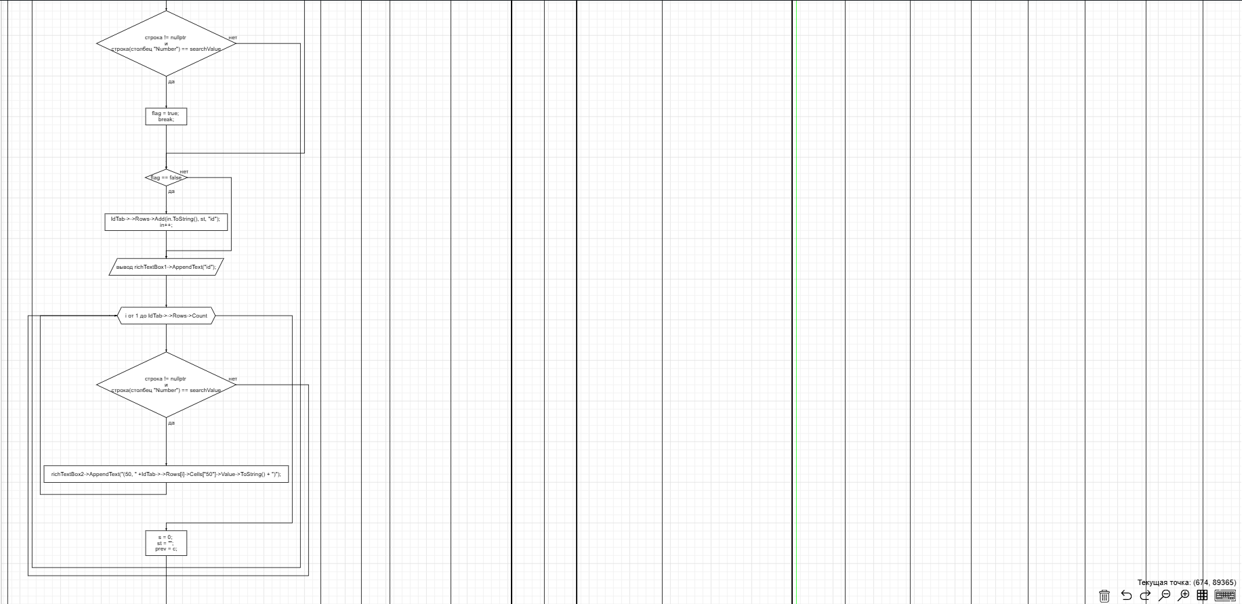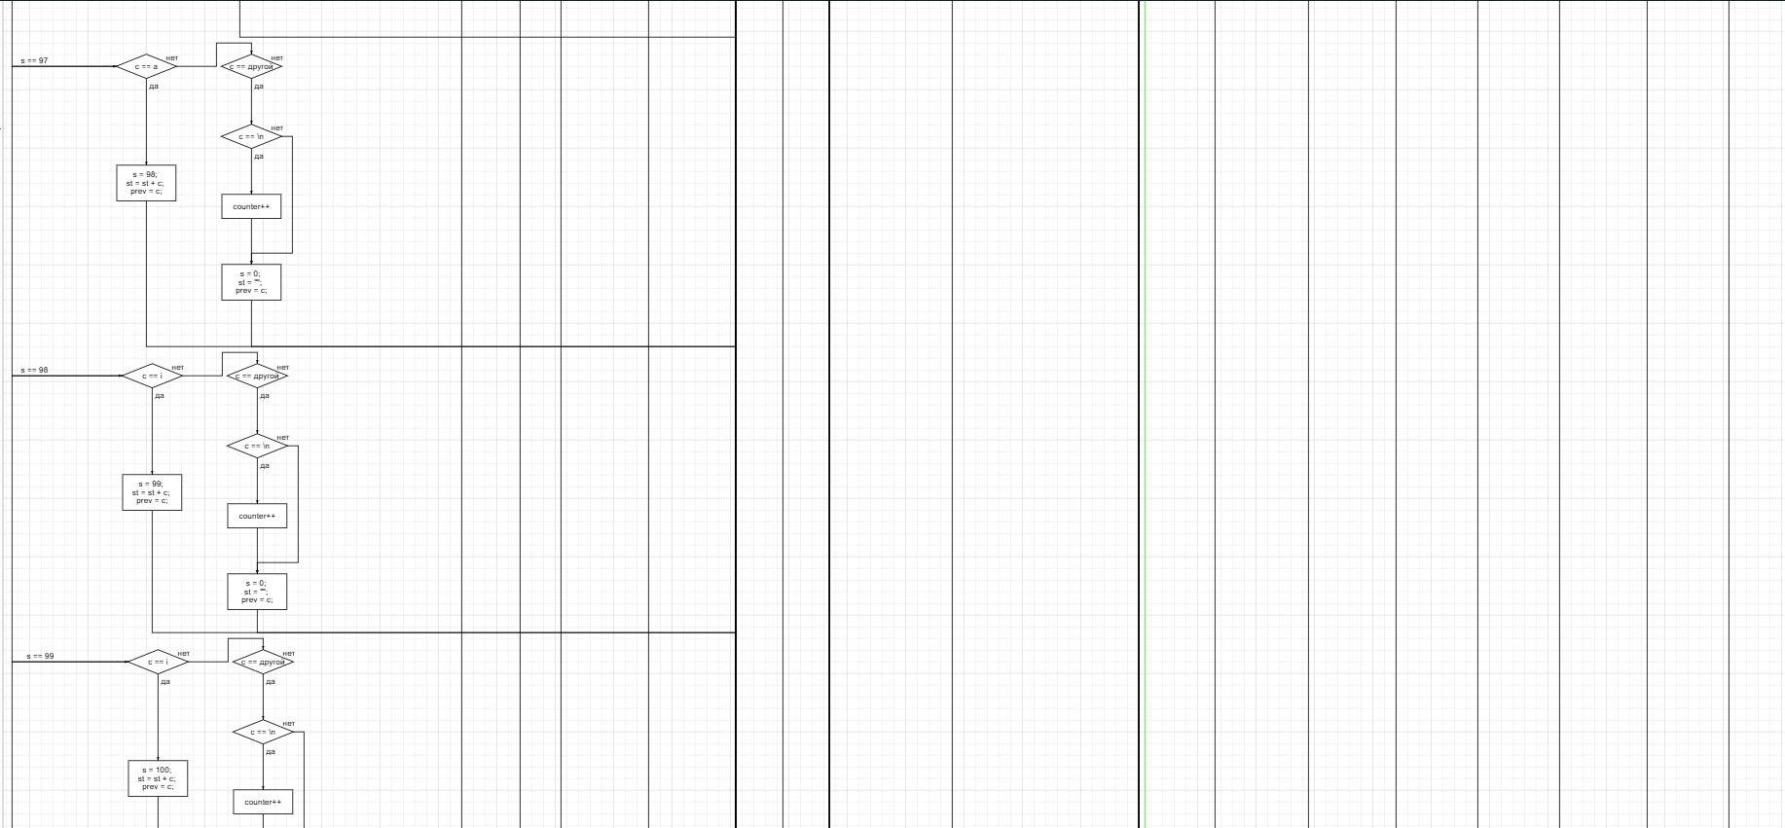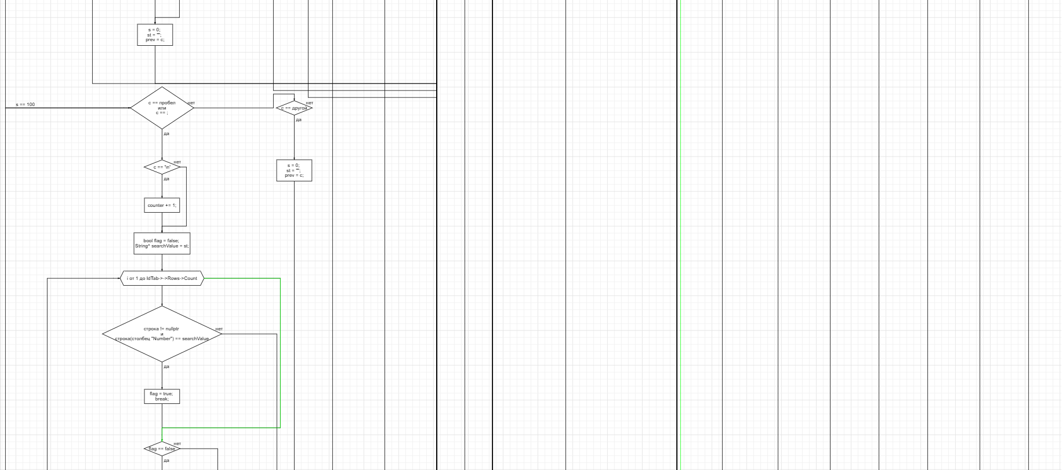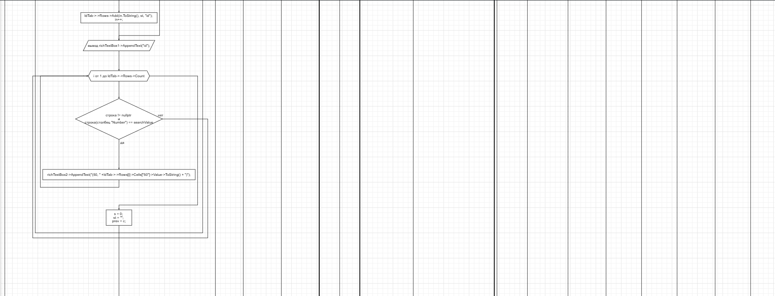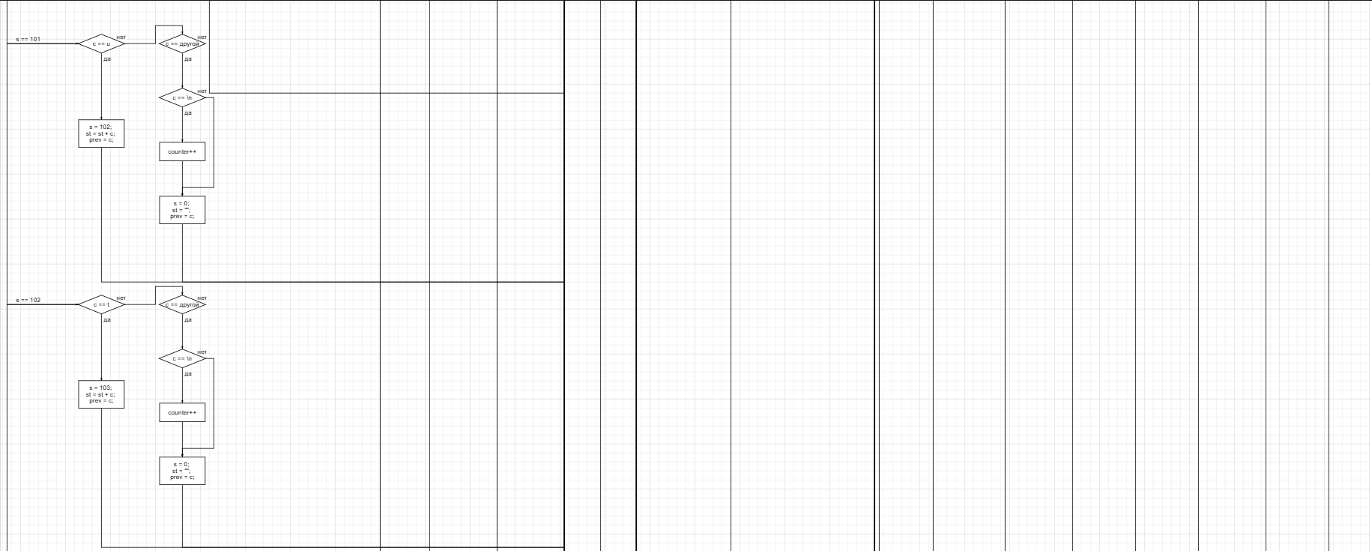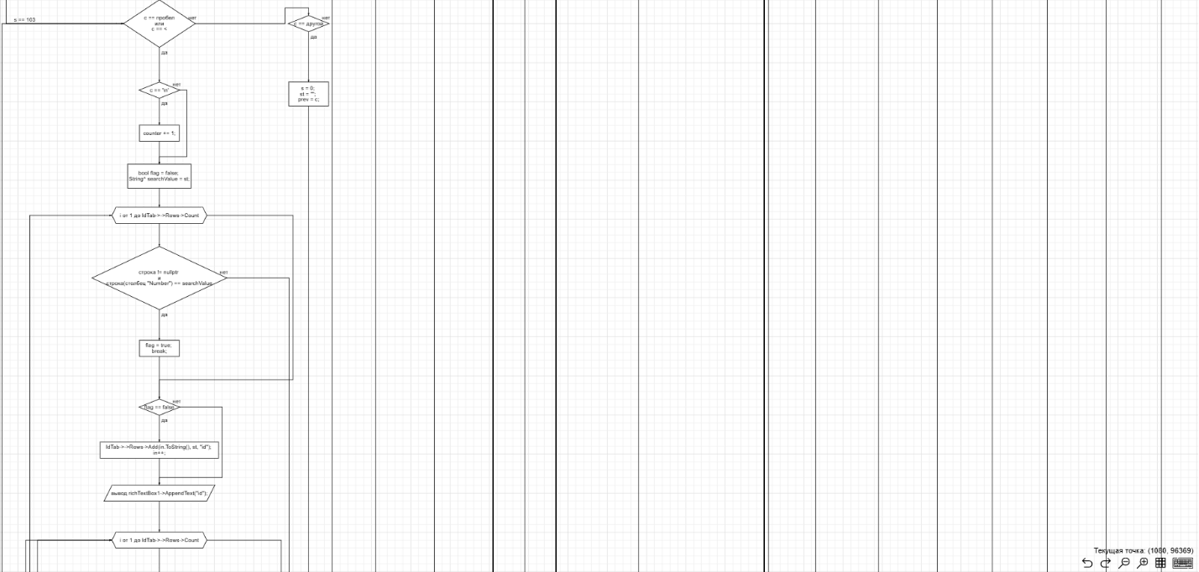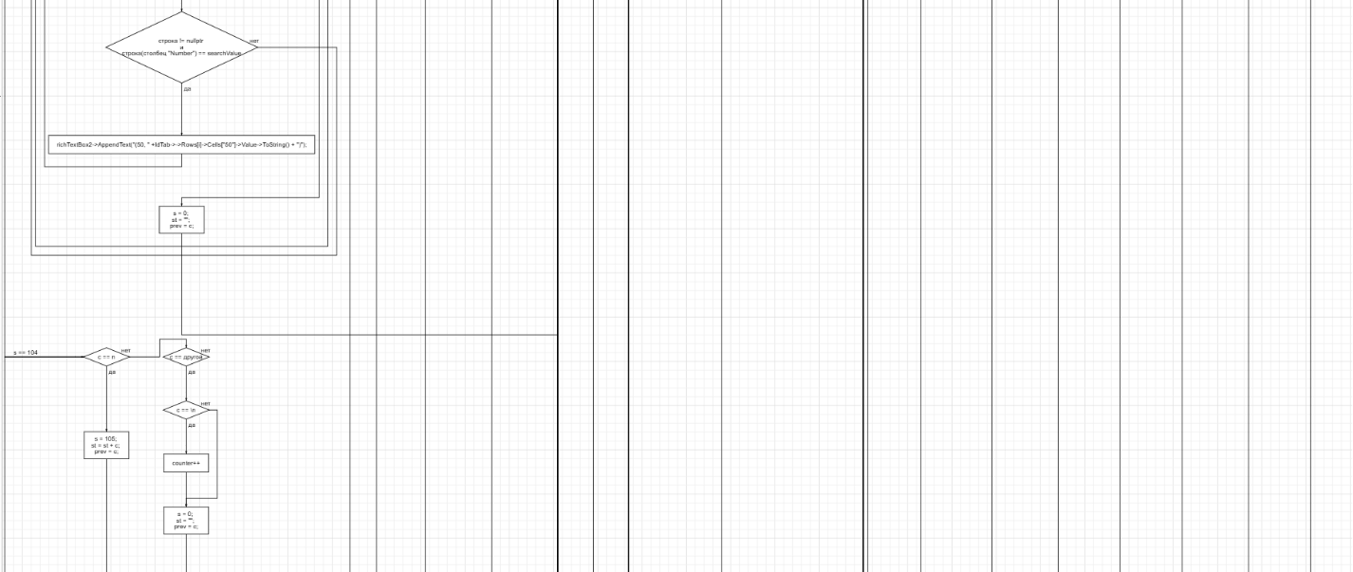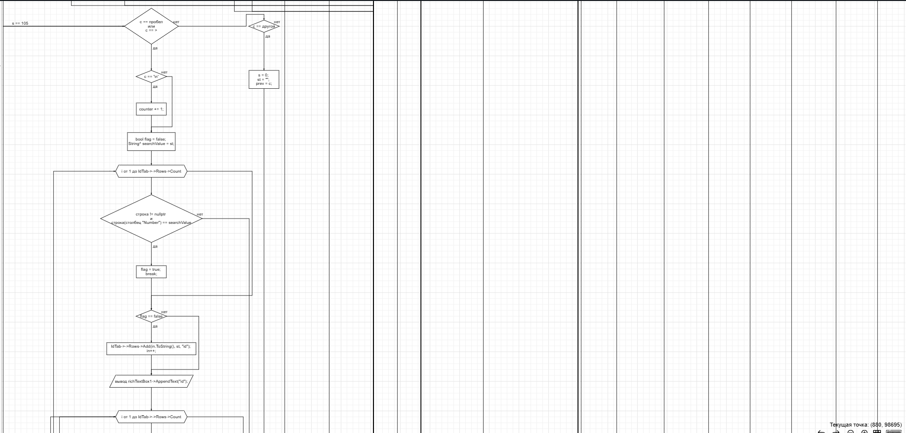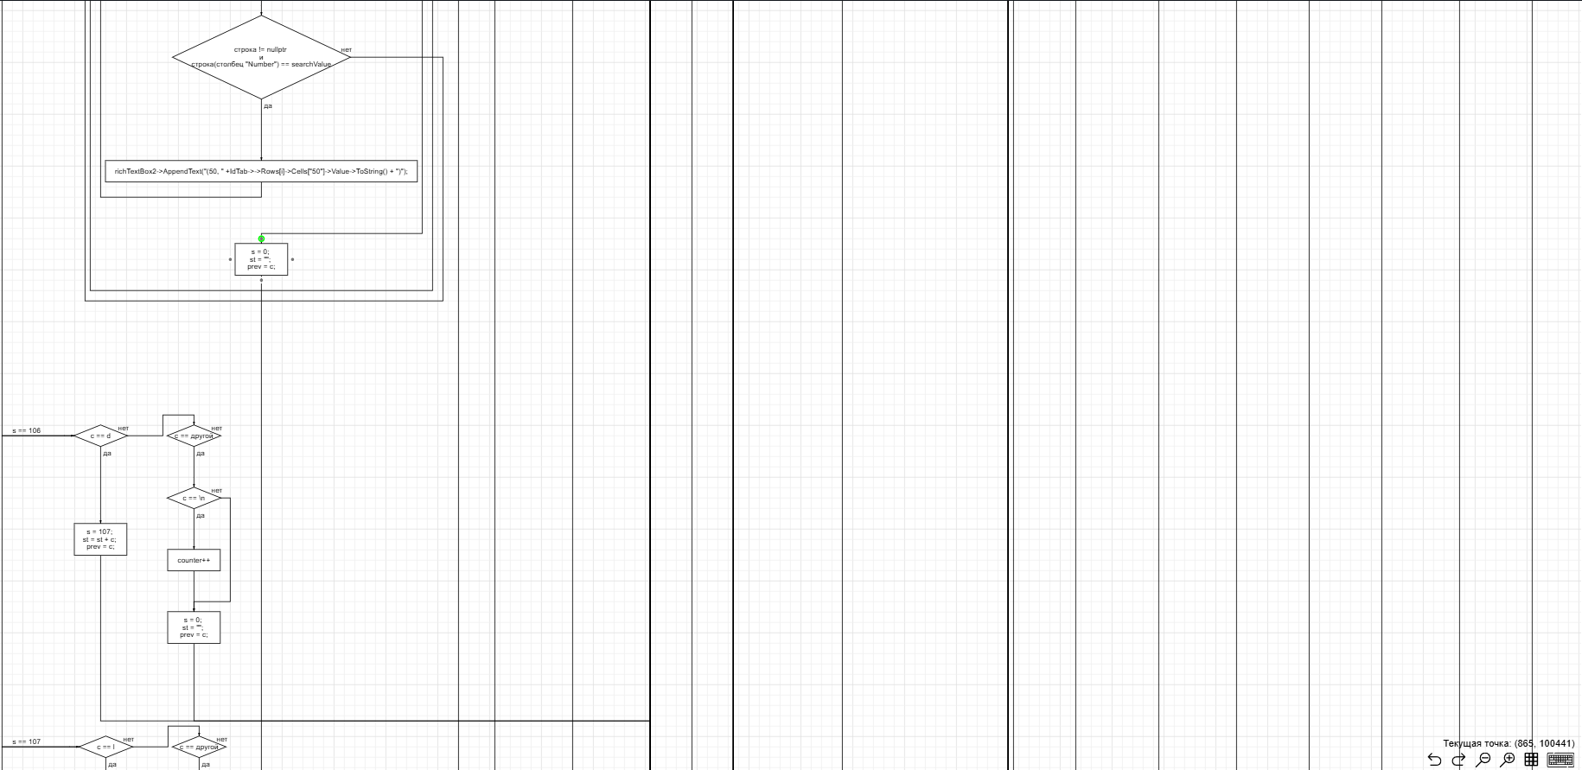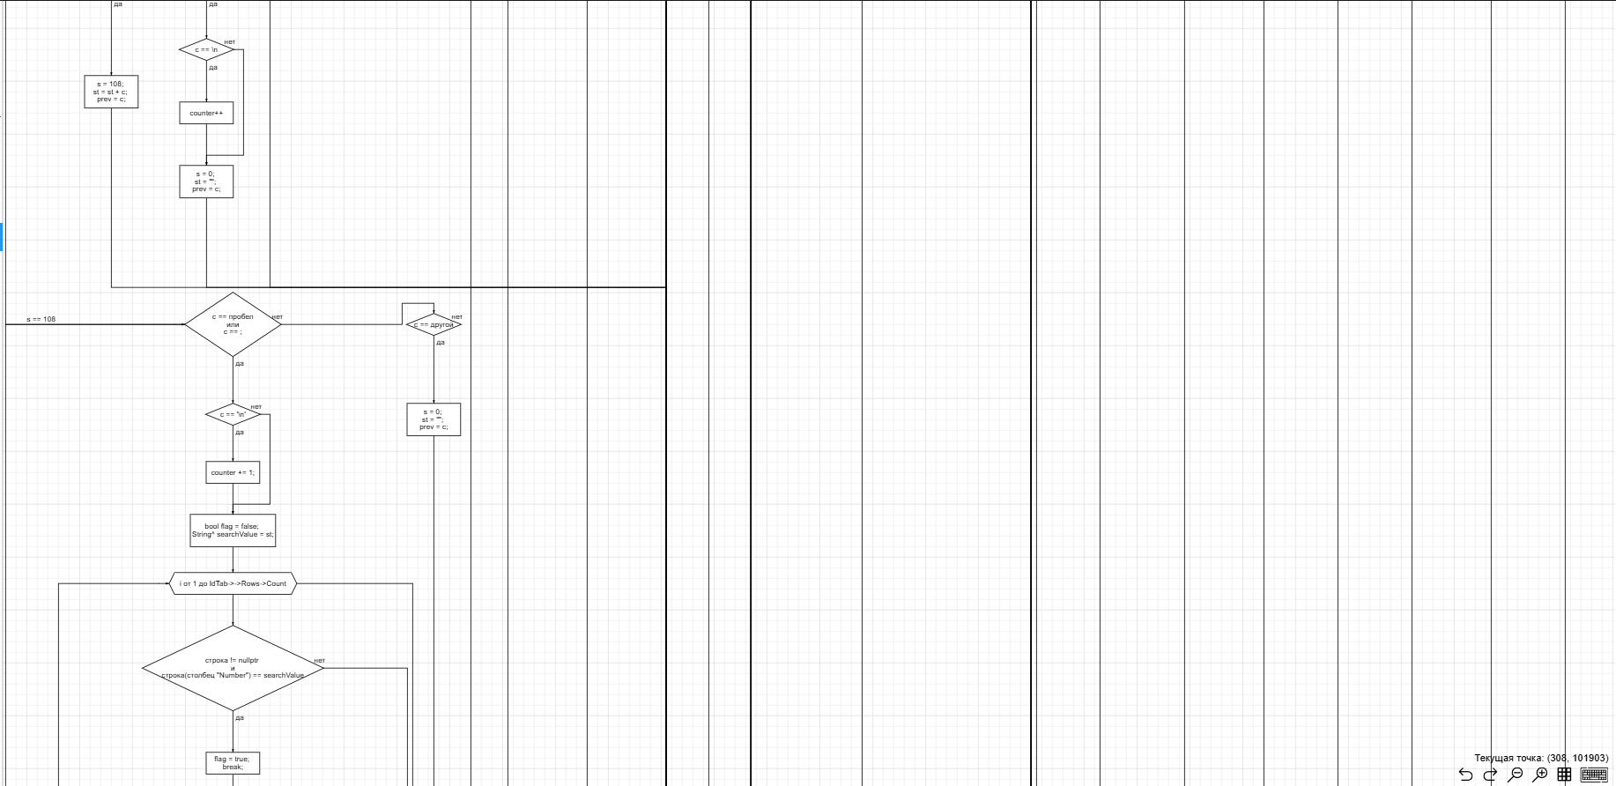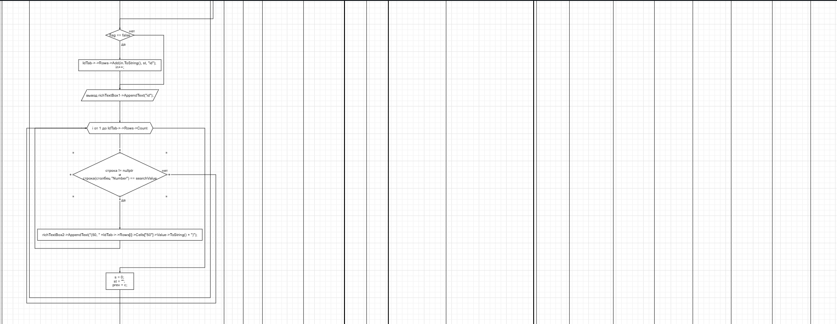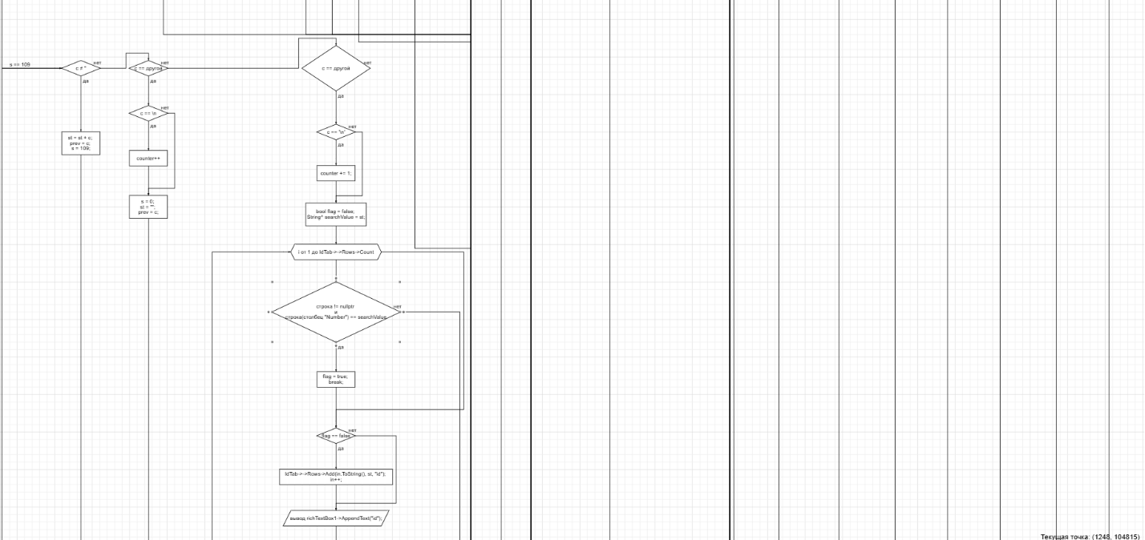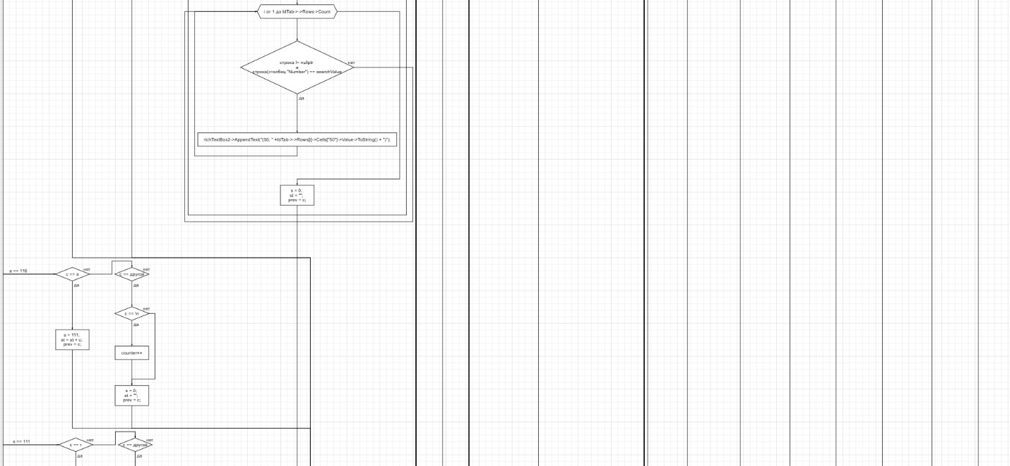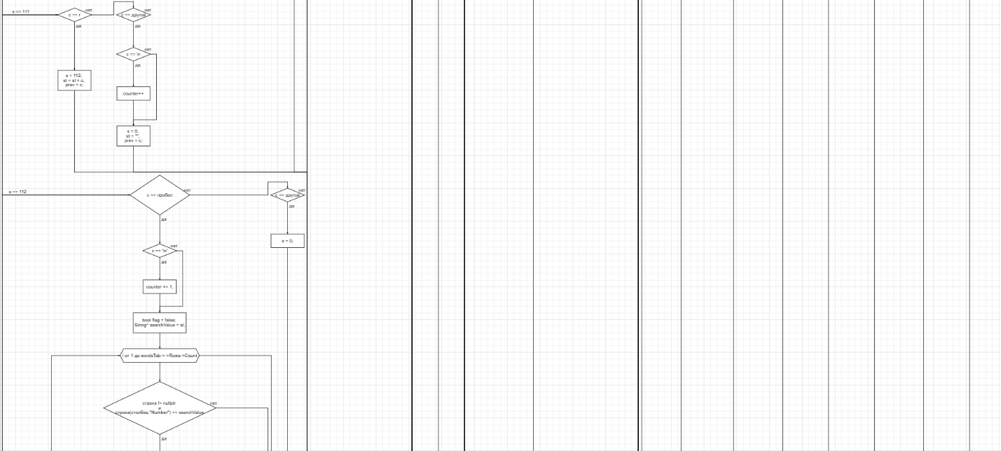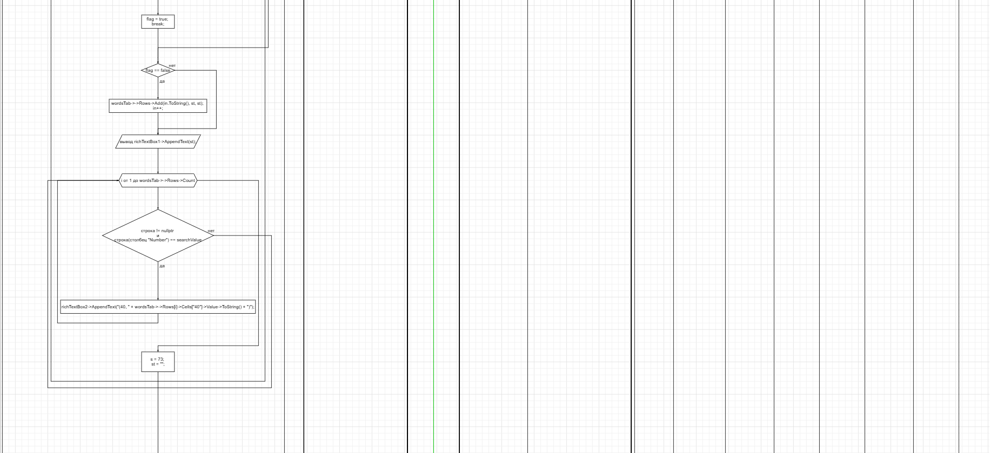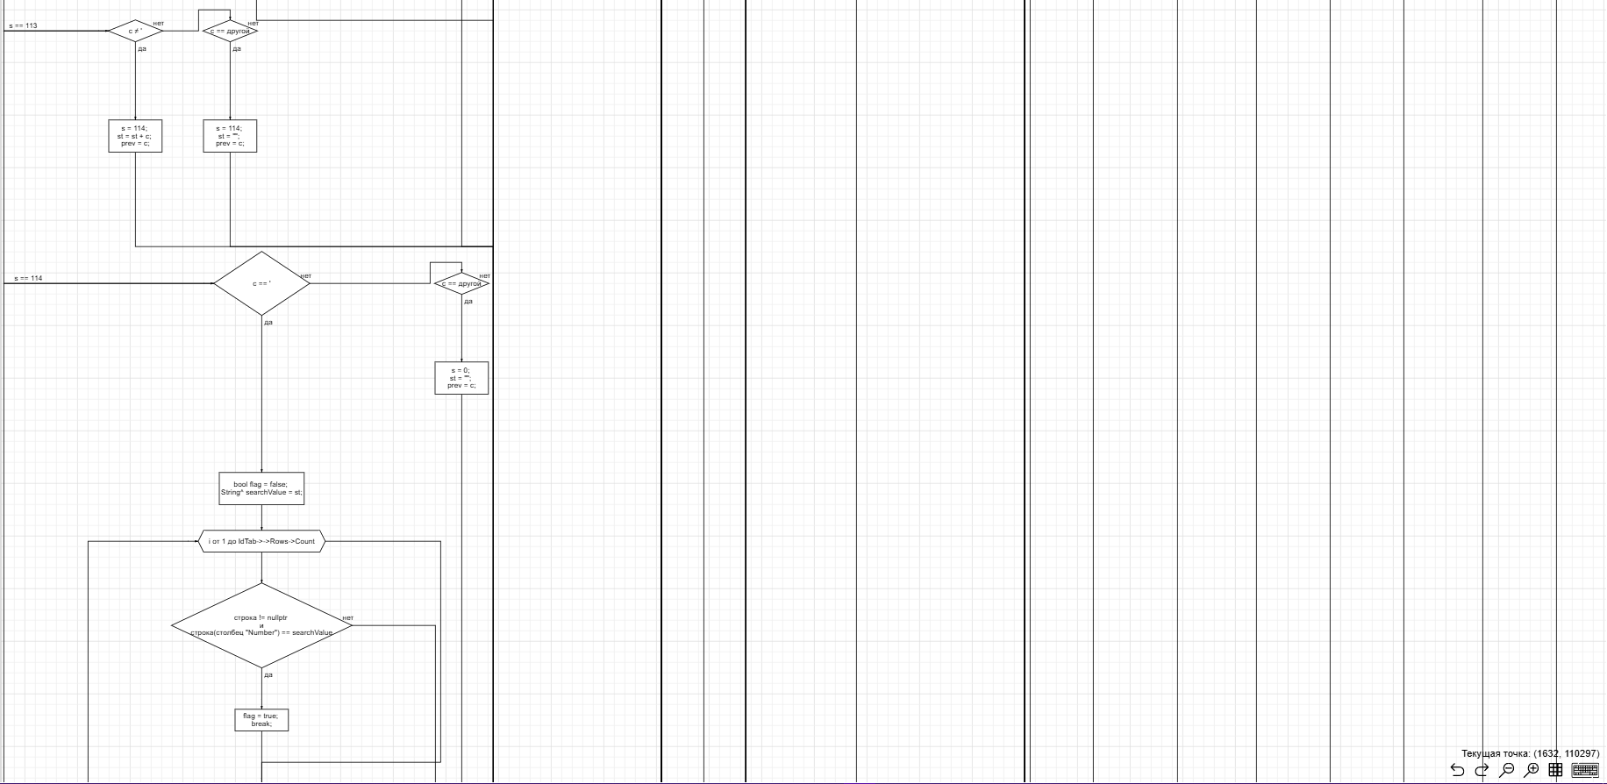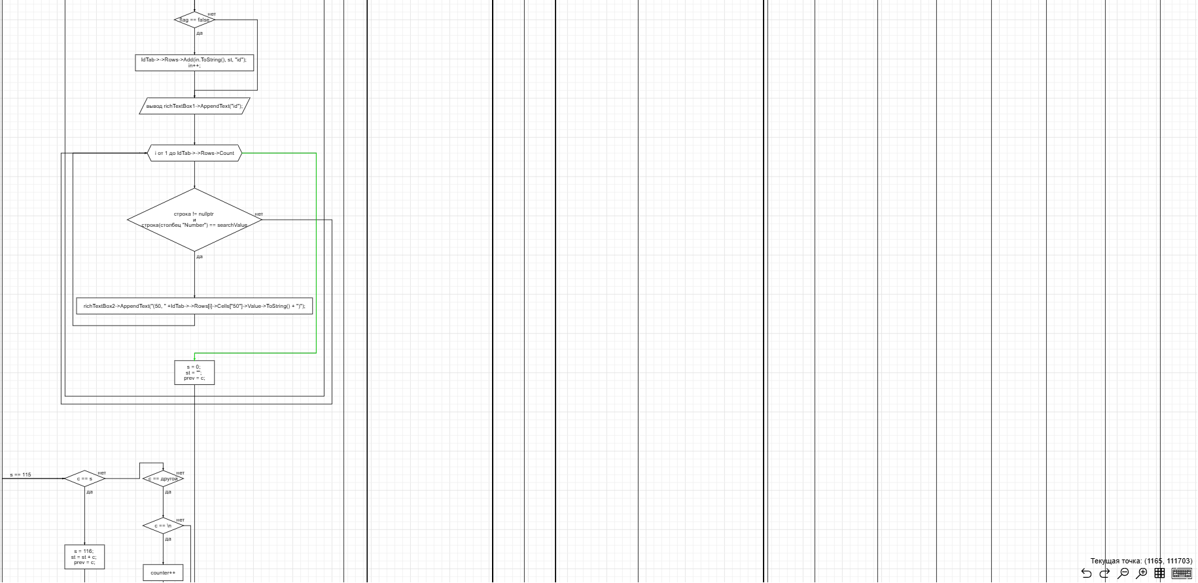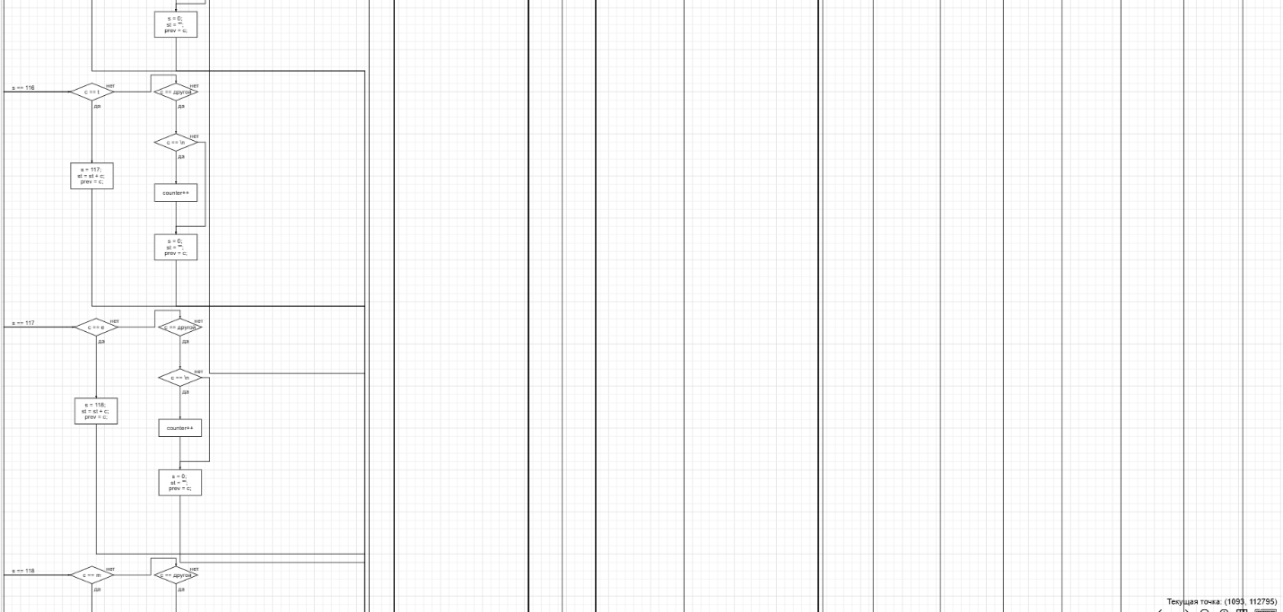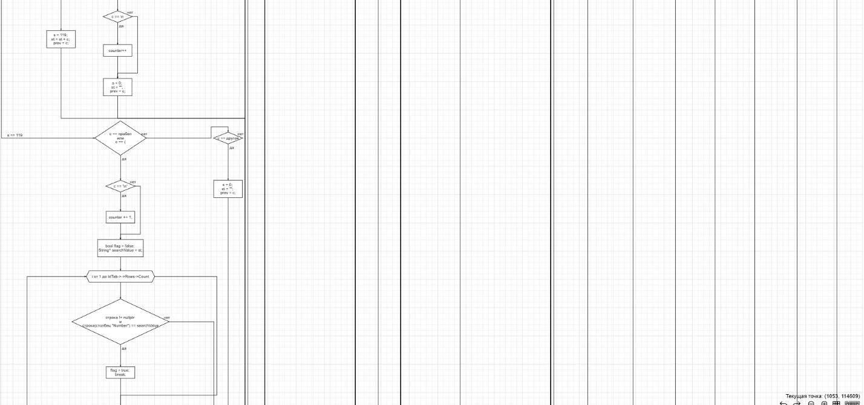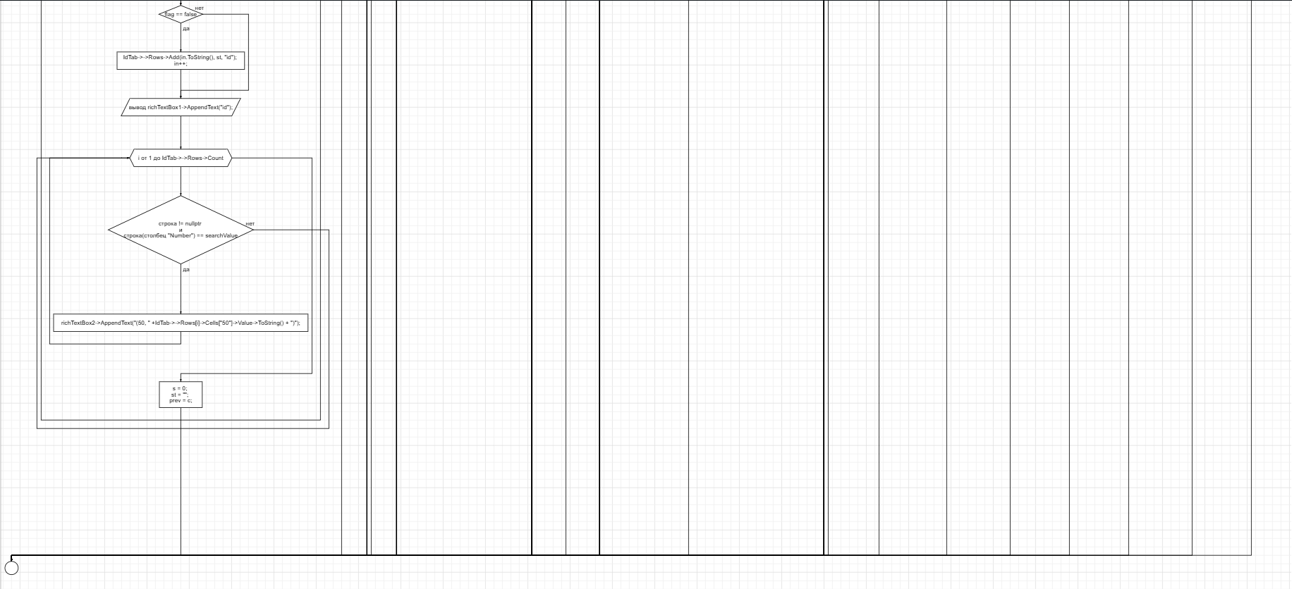

Рис. 2. Блок-схема программы

Входной код

#include <iostream>

using namespace std;

void main() {

// инициализируем переменные

int a = 150;

int aa = 21;

double b = 2.3;

double bb = 54.2;

float c = 2.3e+12;

float cc = 5.5e+10;

int n = 4;

// открываем цикл for

for (int i = 0; i < n; i++) {

// запускаем switch

switch (i)

{

// выводим на экран переменные типа int, а затем их сумму

case 0:

cout << a << " " << aa << endl;

cout << "a+aa=" << a + aa << endl;

break;

// выводим на экран переменные типа double, а затем их сумму

case 1:

cout << b << " " << bb << endl;

cout << "b+bb=" << b + bb << endl;

break;

// выводим на экран переменные типа float, а затем их сумму

case 2:

cout << c << " " << cc << endl;

cout << "c+cc=" << c + cc << endl;

// если выходим из диапозона, то выводим информацию об ошибке

default:

cout << "Index out of range";

break;

}

}

}

Тестирование

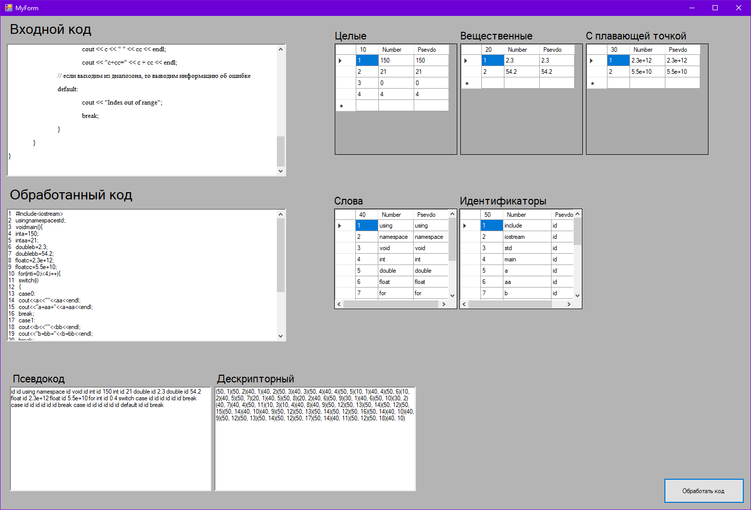

Рис. 3. Демонстрация работы программы

Вывод

В ходе выполнения лабораторной работы была написана часть/функция лексического анализатора, обрабатывающая входную строку по конечному автомату на основе оператора выбора, формирование таблиц с классами лексем, (это часть с предыдущей работы) реализующая построение дескрипторного кода и псевдокода.

Текст программы

#pragma once

#include <cctype>

namespace Project1 {

using namespace System;

using namespace System::ComponentModel;

using namespace System::Collections;

using namespace System::Windows::Forms;

using namespace System::Data;

using namespace System::Drawing;

/// <summary>

/// Сводка для MyForm

/// </summary>

public ref class MyForm : public System::Windows::Forms::Form

{

public:

MyForm(void)

{

InitializeComponent();

//

//TODO: добавьте код конструктора

//

}

protected:

/// <summary>

/// Освободить все используемые ресурсы.

/// </summary>

~MyForm()

{

if (components)

{

delete components;

}

}

private: System::Windows::Forms::RichTextBox^ input;

private: System::Windows::Forms::RichTextBox^ output;

protected:

protected:

private: System::Windows::Forms::Label^ label1;

private: System::Windows::Forms::Label^ label2;

private: System::Windows::Forms::Button^ button1;

private: System::Windows::Forms::DataGridView^ IntVal;

private: System::Windows::Forms::DataGridView^ floatVal;

private: System::Windows::Forms::DataGridView^ doubleVal;

private: System::Windows::Forms::Label^ label3;

private: System::Windows::Forms::Label^ label4;

private: System::Windows::Forms::Label^ label5;

private: System::Windows::Forms::Label^ label9;

private: System::Windows::Forms::Label^ label8;

private: System::Windows::Forms::DataGridView^ IdTab;

private: System::Windows::Forms::DataGridView^ wordsTab;

private: System::Windows::Forms::Label^ label7;

private: System::Windows::Forms::Label^ label6;

private: System::Windows::Forms::RichTextBox^ richTextBox2;

private: System::Windows::Forms::RichTextBox^ richTextBox1;

private:

/// <summary>

/// Обязательная переменная конструктора.

/// </summary>

System::ComponentModel::Container ^components;

#pragma region Windows Form Designer generated code

/// <summary>

/// Требуемый метод для поддержки конструктора — не изменяйте

/// содержимое этого метода с помощью редактора кода.

/// </summary>

void InitializeComponent(void)

{

this->input = (gcnew System::Windows::Forms::RichTextBox());

this->output = (gcnew System::Windows::Forms::RichTextBox());

this->label1 = (gcnew System::Windows::Forms::Label());

this->label2 = (gcnew System::Windows::Forms::Label());

this->button1 = (gcnew System::Windows::Forms::Button());

this->IntVal = (gcnew System::Windows::Forms::DataGridView());

this->floatVal = (gcnew System::Windows::Forms::DataGridView());

this->doubleVal = (gcnew System::Windows::Forms::DataGridView());

this->label3 = (gcnew System::Windows::Forms::Label());

this->label4 = (gcnew System::Windows::Forms::Label());

this->label5 = (gcnew System::Windows::Forms::Label());

this->label9 = (gcnew System::Windows::Forms::Label());

this->label8 = (gcnew System::Windows::Forms::Label());

this->IdTab = (gcnew System::Windows::Forms::DataGridView());

this->wordsTab = (gcnew System::Windows::Forms::DataGridView());

this->label7 = (gcnew System::Windows::Forms::Label());

this->label6 = (gcnew System::Windows::Forms::Label());

this->richTextBox2 = (gcnew System::Windows::Forms::RichTextBox());

this->richTextBox1 = (gcnew System::Windows::Forms::RichTextBox());

(cli::safe_cast<System::ComponentModel::ISupportInitialize^>(this->IntVal))->BeginInit();

(cli::safe_cast<System::ComponentModel::ISupportInitialize^>(this->floatVal))->BeginInit();

(cli::safe_cast<System::ComponentModel::ISupportInitialize^>(this->doubleVal))->BeginInit();

(cli::safe_cast<System::ComponentModel::ISupportInitialize^>(this->IdTab))->BeginInit();

(cli::safe_cast<System::ComponentModel::ISupportInitialize^>(this->wordsTab))->BeginInit();

this->SuspendLayout();

//

// input

//

this->input->Location = System::Drawing::Point(12, 54);

this->input->Name = L"input";

this->input->Size = System::Drawing::Size(545, 259);

this->input->TabIndex = 0;

this->input->Text = L"";

//

// output

//

this->output->Location = System::Drawing::Point(12, 376);

this->output->Name = L"output";

this->output->Size = System::Drawing::Size(545, 259);

this->output->TabIndex = 1;

this->output->Text = L"";

//

// label1

//

this->label1->AutoSize = true;

this->label1->Font = (gcnew System::Drawing::Font(L"Microsoft Sans Serif", 20, System::Drawing::FontStyle::Regular, System::Drawing::GraphicsUnit::Point,

static_cast<System::Byte>(204)));

this->label1->Location = System::Drawing::Point(12, 9);

this->label1->Name = L"label1";

this->label1->Size = System::Drawing::Size(173, 31);

this->label1->TabIndex = 2;

this->label1->Text = L"Входной код";

//

// label2

//

this->label2->AutoSize = true;

this->label2->Font = (gcnew System::Drawing::Font(L"Microsoft Sans Serif", 20, System::Drawing::FontStyle::Regular, System::Drawing::GraphicsUnit::Point,

static_cast<System::Byte>(204)));

this->label2->Location = System::Drawing::Point(12, 332);

this->label2->Name = L"label2";

this->label2->Size = System::Drawing::Size(253, 31);

this->label2->TabIndex = 3;

this->label2->Text = L"Обработанный код";

//

// button1

//

this->button1->Location = System::Drawing::Point(1294, 902);

this->button1->Name = L"button1";

this->button1->Size = System::Drawing::Size(157, 49);

this->button1->TabIndex = 4;

this->button1->Text = L"Обработать код";

this->button1->UseVisualStyleBackColor = true;

this->button1->Click += gcnew System::EventHandler(this, &MyForm::button1_Click);

//

// IntVal

//

this->IntVal->ColumnHeadersHeightSizeMode = System::Windows::Forms::DataGridViewColumnHeadersHeightSizeMode::AutoSize;

this->IntVal->Location = System::Drawing::Point(652, 54);

this->IntVal->Name = L"IntVal";

this->IntVal->Size = System::Drawing::Size(239, 217);

this->IntVal->TabIndex = 5;

//

// floatVal

//

this->floatVal->ColumnHeadersHeightSizeMode = System::Windows::Forms::DataGridViewColumnHeadersHeightSizeMode::AutoSize;

this->floatVal->Location = System::Drawing::Point(1142, 54);

this->floatVal->Name = L"floatVal";

this->floatVal->Size = System::Drawing::Size(239, 217);

this->floatVal->TabIndex = 6;

//

// doubleVal

//

this->doubleVal->ColumnHeadersHeightSizeMode = System::Windows::Forms::DataGridViewColumnHeadersHeightSizeMode::AutoSize;

this->doubleVal->Location = System::Drawing::Point(897, 54);

this->doubleVal->Name = L"doubleVal";

this->doubleVal->Size = System::Drawing::Size(239, 217);

this->doubleVal->TabIndex = 7;

//

// label3

//

this->label3->AutoSize = true;

this->label3->Font = (gcnew System::Drawing::Font(L"Microsoft Sans Serif", 15, System::Drawing::FontStyle::Regular, System::Drawing::GraphicsUnit::Point,

static_cast<System::Byte>(204)));

this->label3->Location = System::Drawing::Point(647, 26);

this->label3->Name = L"label3";

this->label3->Size = System::Drawing::Size(74, 25);

this->label3->TabIndex = 8;

this->label3->Text = L"Целые";

//

// label4

//

this->label4->AutoSize = true;

this->label4->Font = (gcnew System::Drawing::Font(L"Microsoft Sans Serif", 15, System::Drawing::FontStyle::Regular, System::Drawing::GraphicsUnit::Point,

static_cast<System::Byte>(204)));

this->label4->Location = System::Drawing::Point(892, 26);

this->label4->Name = L"label4";

this->label4->Size = System::Drawing::Size(153, 25);

this->label4->TabIndex = 9;

this->label4->Text = L"Вещественные";

//

// label5

//

this->label5->AutoSize = true;

this->label5->Font = (gcnew System::Drawing::Font(L"Microsoft Sans Serif", 15, System::Drawing::FontStyle::Regular, System::Drawing::GraphicsUnit::Point,

static_cast<System::Byte>(204)));

this->label5->Location = System::Drawing::Point(1137, 26);

this->label5->Name = L"label5";

this->label5->Size = System::Drawing::Size(208, 25);

this->label5->TabIndex = 10;

this->label5->Text = L"С плавающей точкой";

//

// label9

//

this->label9->AutoSize = true;

this->label9->Font = (gcnew System::Drawing::Font(L"Microsoft Sans Serif", 15, System::Drawing::FontStyle::Regular, System::Drawing::GraphicsUnit::Point,

static_cast<System::Byte>(204)));

this->label9->Location = System::Drawing::Point(891, 348);

this->label9->Name = L"label9";

this->label9->Size = System::Drawing::Size(181, 25);

this->label9->TabIndex = 23;

this->label9->Text = L"Идентификаторы";

//

// label8

//

this->label8->AutoSize = true;

this->label8->Font = (gcnew System::Drawing::Font(L"Microsoft Sans Serif", 15, System::Drawing::FontStyle::Regular, System::Drawing::GraphicsUnit::Point,

static_cast<System::Byte>(204)));

this->label8->Location = System::Drawing::Point(646, 348);

this->label8->Name = L"label8";

this->label8->Size = System::Drawing::Size(68, 25);

this->label8->TabIndex = 22;

this->label8->Text = L"Слова";

//

// IdTab

//

this->IdTab->ColumnHeadersHeightSizeMode = System::Windows::Forms::DataGridViewColumnHeadersHeightSizeMode::AutoSize;

this->IdTab->Location = System::Drawing::Point(895, 376);

this->IdTab->Name = L"IdTab";

this->IdTab->Size = System::Drawing::Size(240, 196);

this->IdTab->TabIndex = 21;

//

// wordsTab

//

this->wordsTab->ColumnHeadersHeightSizeMode = System::Windows::Forms::DataGridViewColumnHeadersHeightSizeMode::AutoSize;

this->wordsTab->Location = System::Drawing::Point(651, 376);

this->wordsTab->Name = L"wordsTab";

this->wordsTab->Size = System::Drawing::Size(240, 196);

this->wordsTab->TabIndex = 20;

//

// label7

//

this->label7->AutoSize = true;

this->label7->Font = (gcnew System::Drawing::Font(L"Microsoft Sans Serif", 15, System::Drawing::FontStyle::Regular, System::Drawing::GraphicsUnit::Point,

static_cast<System::Byte>(204)));

this->label7->Location = System::Drawing::Point(417, 695);

this->label7->Name = L"label7";

this->label7->Size = System::Drawing::Size(163, 25);

this->label7->TabIndex = 27;

this->label7->Text = L"Дескрипторный";

//

// label6

//

this->label6->AutoSize = true;

this->label6->Font = (gcnew System::Drawing::Font(L"Microsoft Sans Serif", 15, System::Drawing::FontStyle::Regular, System::Drawing::GraphicsUnit::Point,

static_cast<System::Byte>(204)));

this->label6->Location = System::Drawing::Point(19, 695);

this->label6->Name = L"label6";

this->label6->Size = System::Drawing::Size(113, 25);

this->label6->TabIndex = 26;

this->label6->Text = L"Псевдокод";

//

// richTextBox2

//

this->richTextBox2->Location = System::Drawing::Point(417, 723);

this->richTextBox2->Name = L"richTextBox2";

this->richTextBox2->Size = System::Drawing::Size(393, 204);

this->richTextBox2->TabIndex = 25;

this->richTextBox2->Text = L"";

//

// richTextBox1

//

this->richTextBox1->Location = System::Drawing::Point(18, 723);

this->richTextBox1->Name = L"richTextBox1";

this->richTextBox1->Size = System::Drawing::Size(393, 204);

this->richTextBox1->TabIndex = 24;

this->richTextBox1->Text = L"";

//

// MyForm

//

this->AutoScaleDimensions = System::Drawing::SizeF(6, 13);

this->AutoScaleMode = System::Windows::Forms::AutoScaleMode::Font;

this->BackColor = System::Drawing::SystemColors::ActiveBorder;

this->ClientSize = System::Drawing::Size(1463, 963);

this->Controls->Add(this->label7);

this->Controls->Add(this->label6);

this->Controls->Add(this->richTextBox2);

this->Controls->Add(this->richTextBox1);

this->Controls->Add(this->label9);

this->Controls->Add(this->label8);

this->Controls->Add(this->IdTab);

this->Controls->Add(this->wordsTab);

this->Controls->Add(this->label5);

this->Controls->Add(this->label4);

this->Controls->Add(this->label3);

this->Controls->Add(this->doubleVal);

this->Controls->Add(this->floatVal);

this->Controls->Add(this->IntVal);

this->Controls->Add(this->button1);

this->Controls->Add(this->label2);

this->Controls->Add(this->label1);

this->Controls->Add(this->output);

this->Controls->Add(this->input);

this->Name = L"MyForm";

this->Text = L"MyForm";

(cli::safe_cast<System::ComponentModel::ISupportInitialize^>(this->IntVal))->EndInit();

(cli::safe_cast<System::ComponentModel::ISupportInitialize^>(this->floatVal))->EndInit();

(cli::safe_cast<System::ComponentModel::ISupportInitialize^>(this->doubleVal))->EndInit();

(cli::safe_cast<System::ComponentModel::ISupportInitialize^>(this->IdTab))->EndInit();

(cli::safe_cast<System::ComponentModel::ISupportInitialize^>(this->wordsTab))->EndInit();

this->ResumeLayout(false);

this->PerformLayout();

}

#pragma endregion

private: System::Void button1_Click(System::Object^ sender, System::EventArgs^ e) {

// Очистим поле для обратного кода

output->Clear();

// Получим текст из поля записи

String^ text = input->Text;

text = text + " ";

// Создадим переменную для хранения состояний

int s = 0;

bool closed = 1;

int counter = 1;

output->AppendText(counter.ToString() + " ");

counter++;

char prev = '/';

// Обойдём каждый символ кода

for each (Char c in text) {

switch (s)

{

case 0:

if (c == '\n') { // если c - это переход на следующую строку

if (c != prev && prev != '/') {

output->AppendText(c.ToString());

output->AppendText(counter.ToString() + " ");

counter++;

}

prev = c;

s = 7;

}

if (!Char::IsWhiteSpace(c) && c != '\n' && c != '/' && c != '\r' && c != '\t' && c != '*') {// если символ - это буква

s = 0;

output->AppendText(c.ToString());

prev = c;

}

if (c == '/') {// если с = /

s = 1;

prev = c;

}

if (c == ' ') { // если c - это пробел

s = 5;

prev = c;

}

if (c == '*') {

s = 0;

output->AppendText(c.ToString());

prev = c;

}

if (c == '\t') {

s = 6;

prev = c;

}

break;

case 1:

if (!Char::IsWhiteSpace(c) && c != '\n' && c != '/' && c != '\r' && c != 't' && c != '*') { // если c - это символ

s = 0;

output->AppendText("/");

output->AppendText(c.ToString());

prev = c;

}

else if (c == '/') {

s = 2;

if (c != prev) {

output->AppendText(c.ToString());

}

/*output->AppendText("\n");

output->AppendText(counter.ToString() + " ");*/

prev = c;

}

else if (c == '*') {

if (prev != '/') {

output->AppendText("/");

}

s = 3;

prev = c;

}

else if (c == '\n') {

s = 0;

if (c != prev) {

output->AppendText("/");

output->AppendText(c.ToString());

output->AppendText(counter.ToString() + " ");

counter++;

}

prev = c;

}

else if (c == '\t') {

output->AppendText("/");

s = 0;

prev = c;

}

else if (' ') {

output->AppendText("/");

s = 0;

prev = c;

}

break;

case 2:

if (!Char::IsWhiteSpace(c) && c != '\n' && c != '/' && c != '\r' && c != 't' && c != '*') {

s = 2;

prev = c;

}

else if (c == '\n') {

s = 0;

}

else if (c == '*') {

s = 2;

prev = c;

}

else if (c == '\t') {

s = 2;

}

else if (c == '/') {

s = 2;

prev = c;

}

else if (c == ' ') {

s = 2;

prev = c;

}

break;

case 3:

if (!Char::IsWhiteSpace(c) && c != '\n' && c != '/' && c != '\r' && c != 't' && c != '*') {

s = 3;

prev = c;

}

else if (c == ' ') {

s = 3;

prev = c;

}

else if ('\t') {

s = 3;

prev = c;

}

else if ('\n') {

s = 3;

if (c != prev) {

counter++;

}

prev = c;

}

else if (c == '/') {

s = 3;

prev = c;

}

if (c == '*') {

s = 4;

prev = c;

}

break;

case 4:

if (c == '/') {

s = 0;

prev = c;

}

else if (!Char::IsWhiteSpace(c) && c != '\n' && c != '/' && c != '\r' && c != 't' && c != '*') {

s = 3;

prev = c;

}

else if (c == ' ') {

s = 3;

prev = c;

}

else if (c == '\t') {

s = 3;

prev = c;

}

else if (c == '\n') {

s = 3;

if (c != prev) {

counter++;

}

prev = c;

}

else if (c == '*') {

s = 3;

prev = c;

}

break;

case 5:

if (!Char::IsWhiteSpace(c) && c != '\n' && c != '/' && c != '\r' && c != 't' && c != '*') {

s = 0;

output->AppendText(c.ToString());

prev = c;

}

else if (c == '\t') {

s = 6;

prev = c;

}

else if (c == '\n') {

s = 7;

prev = c;

if (c != prev) {

output->AppendText(c.ToString());

output->AppendText(counter.ToString() + " ");

counter++;

}

}

else if (c == ' ') {

s = 5;

prev = c;

}

else if (c == '*') {

s = 5;

output->AppendText(c.ToString());

prev = c;

}

else if (c == '/') {

s = 1;

prev = c;

}

break;

case 6:

if (!Char::IsWhiteSpace(c) && c != '\n' && c != '/' && c != '\r' && c != 't' && c != '*') {

s = 0;

output->AppendText(c.ToString());

prev = c;

}

else if (c == '\t') {

s = 6;

prev = c;

}

else if (c == '\n') {

s = 7;

if (c != prev) {

output->AppendText(c.ToString());

output->AppendText(counter.ToString() + " ");

counter++;

}

prev = c;

}

else if (c == ' ') {

s = 5;

prev = c;

}

else if (c == '*') {

s = 6;

output->AppendText(c.ToString());

prev = c;

}

else if (c == '/') {

s = 1;

prev = c;

}

break;

case 7:

if (!Char::IsWhiteSpace(c) && c != '\n' && c != '/' && c != '\r' && c != 't' && c != '*') {

s = 0;

output->AppendText(c.ToString());

prev = c;

}

else if (c == '\t') {

s = 6;

prev = c;

}

else if (c == '\n') {

s = 7;

if (c != prev) {

output->AppendText(c.ToString());

output->AppendText(counter.ToString() + " ");

counter++;

}

prev = c;

}

else if (c == '*') {

s = 7;

output->AppendText(c.ToString());

prev = c;

}

else if (c == ' ') {

s = 5;

prev = c;

}

else if (c == '/') {

s = 1;

prev = c;

}

break;

default:

break;

}

}

s = 0;

IntVal->Rows->Clear();

if (IntVal->Columns->Count == 0) {

DataGridViewTextBoxColumn^ column1 = gcnew DataGridViewTextBoxColumn();

column1->AutoSizeMode = DataGridViewAutoSizeColumnMode::AllCells;

column1->Name = "10";

IntVal->Columns->Add(column1);

DataGridViewTextBoxColumn^ column2 = gcnew DataGridViewTextBoxColumn();

column2->AutoSizeMode = DataGridViewAutoSizeColumnMode::AllCells;

column2->Name = "Number";

IntVal->Columns->Add(column2);

DataGridViewTextBoxColumn^ column3 = gcnew DataGridViewTextBoxColumn();

column3->AutoSizeMode = DataGridViewAutoSizeColumnMode::AllCells;

column3->Name = "Psevdo";

IntVal->Columns->Add(column3);

}

doubleVal->Rows->Clear();

if (doubleVal->Columns->Count == 0) {

DataGridViewTextBoxColumn^ column1 = gcnew DataGridViewTextBoxColumn();

column1->AutoSizeMode = DataGridViewAutoSizeColumnMode::AllCells;

column1->Name = "20";

doubleVal->Columns->Add(column1);

DataGridViewTextBoxColumn^ column2 = gcnew DataGridViewTextBoxColumn();

column2->AutoSizeMode = DataGridViewAutoSizeColumnMode::AllCells;

column2->Name = "Number";

doubleVal->Columns->Add(column2);

DataGridViewTextBoxColumn^ column3 = gcnew DataGridViewTextBoxColumn();

column3->AutoSizeMode = DataGridViewAutoSizeColumnMode::AllCells;

column3->Name = "Psevdo";

doubleVal->Columns->Add(column3);

}

floatVal->Rows->Clear();

if (floatVal->Columns->Count == 0) {

DataGridViewTextBoxColumn^ column1 = gcnew DataGridViewTextBoxColumn();

column1->AutoSizeMode = DataGridViewAutoSizeColumnMode::AllCells;

column1->Name = "30";

floatVal->Columns->Add(column1);

DataGridViewTextBoxColumn^ column2 = gcnew DataGridViewTextBoxColumn();

column2->AutoSizeMode = DataGridViewAutoSizeColumnMode::AllCells;

column2->Name = "Number";

floatVal->Columns->Add(column2);

DataGridViewTextBoxColumn^ column3 = gcnew DataGridViewTextBoxColumn();

column3->AutoSizeMode = DataGridViewAutoSizeColumnMode::AllCells;

column3->Name = "Psevdo";

floatVal->Columns->Add(column3);

}

wordsTab->Rows->Clear();

if (wordsTab->Columns->Count == 0) {

DataGridViewTextBoxColumn^ column1 = gcnew DataGridViewTextBoxColumn();

column1->AutoSizeMode = DataGridViewAutoSizeColumnMode::AllCells;

column1->Name = "40";

wordsTab->Columns->Add(column1);

DataGridViewTextBoxColumn^ column2 = gcnew DataGridViewTextBoxColumn();

column2->AutoSizeMode = DataGridViewAutoSizeColumnMode::AllCells;

column2->Name = "Number";

wordsTab->Columns->Add(column2);

DataGridViewTextBoxColumn^ column3 = gcnew DataGridViewTextBoxColumn();

column3->AutoSizeMode = DataGridViewAutoSizeColumnMode::AllCells;

column3->Name = "Psevdo";

wordsTab->Columns->Add(column3);

}

IdTab->Rows->Clear();

if (IdTab->Columns->Count == 0) {

DataGridViewTextBoxColumn^ column1 = gcnew DataGridViewTextBoxColumn();

column1->AutoSizeMode = DataGridViewAutoSizeColumnMode::AllCells;

column1->Name = "50";

IdTab->Columns->Add(column1);

DataGridViewTextBoxColumn^ column2 = gcnew DataGridViewTextBoxColumn();

column2->AutoSizeMode = DataGridViewAutoSizeColumnMode::AllCells;

column2->Name = "Number";

IdTab->Columns->Add(column2);

DataGridViewTextBoxColumn^ column3 = gcnew DataGridViewTextBoxColumn();

column3->AutoSizeMode = DataGridViewAutoSizeColumnMode::AllCells;

column3->Name = "Psevdo";

IdTab->Columns->Add(column3);

}

richTextBox1->Clear();

richTextBox2->Clear();

prev = NULL;

int code = 0;

counter = 1;

int in = 1, dou = 1, fl = 1;

int w = 1, id = 1;

String^ st = "";

for each (Char c in text) {

switch (s)

{

case 0:// проверка на число

if (c == '-') {

s = 1;

st = st + c;

prev = c;

}

else if ((c == '0' || c == '1' || c == '2' || c == '3' || c == '4' || c == '5' || c == '6'

|| c == '7' || c == '8' || c == '9') && (Char::IsWhiteSpace(prev) || prev == NULL)) {

s = 1;

prev = c;

st = st + c;

}

else if (c == '/') {

prev = c;

s = 8;

}

else if (c == 's') {

s = 2;

st = st + c;

prev = c;

}

else if (c == 'c') {

s = 18;

st = st + c;

prev = c;

}

else if (c == 'b') {

s = 22;

st = st + c;

prev = c;

}

else if (c == 'i') {

s = 27;

st = st + c;

prev = c;

}

else if (c == 'f') {

s = 29;

st = st + c;

prev = c;

}

else if (c == 'd') {

s = 32;

st = st + c;

prev = c;

}

else if (c == 'e') {

s = 39;

st = st + c;

prev = c;

}

else if (c == 'r') {

s = 43;

st = st + c;

prev = c;

}

else if (c == 'u') {

s = 49;

st = st + c;

prev = c;

}

else if (c == 'n') {

s = 54;

st = st + c;

prev = c;

}

else if (c == 'v') {

s = 63;

st = st + c;

prev = c;

}

else if (c == 'm') {

s = 97;

st = st + c;

prev = c;

}

else if (c == '"') {

s = 109;

prev = c;

}

else if (c == '\'') {

s = 113;

prev = c;

}

else {

if (c == '\n') {

counter += 1;

}

s = 0;

prev = c;

}

break;

case 1:

if (c == '0' || c == '1' || c == '2' || c == '3' || c == '4' || c == '5' || c == '6'

|| c == '7' || c == '8' || c == '9') {

st = st + c;

prev = c;

s = 1;

}

else if (c == '.') {

st = st + c;

s = 3;

prev = c;

}

else if (Char::IsWhiteSpace(c) || c == ',' || c == ';') {

if (c == '\n') {

counter += 1;

}

bool flag = false;

String^ searchValue = st;

for (int i = 0; i < IntVal->Rows->Count; i++) {

if (IntVal->Rows[i]->Cells["Number"]->Value != nullptr && IntVal->Rows[i]->Cells["Number"]->Value->ToString()->Equals(searchValue)) {

flag = true;

break;

}

}

if (!flag) {

IntVal->Rows->Add(in.ToString(), st, st);

in++;

}

richTextBox1->AppendText(st + " ");

for (int i = 0; i < IntVal->Rows->Count; i++) {

if (IntVal->Rows[i]->Cells["Number"]->Value != nullptr &&

IntVal->Rows[i]->Cells["Number"]->Value->ToString()->Equals(searchValue)) {

richTextBox2->AppendText("(10, " + IntVal->Rows[i]->Cells["10"]->Value->ToString() + ")");

}

}

s = 0;

st = "";

prev = c;

}

else {

st = "";

code = 0;

s = 7;

prev = c;

}

break;

case 2:

if (c == 'w') {

prev = c;

s = 13;

st = st + c;

}

else if (c == 't') {

prev = c;

s = 79;

st = st + c;

}

else if (c == 'y') {

prev = c;

s = 115;

st = st + c;

}

else {

if (c == '\n') {

counter++;

}

s = 0;

st = "";

prev = c;

}

break;

case 3:

if (c == '0' || c == '1' || c == '2' || c == '3' || c == '4' || c == '5' || c == '6'

|| c == '7' || c == '8' || c == '9') {

st = st + c;

s = 3;

prev = c;

}

else if (Char::IsWhiteSpace(c) || c == ',' || c == ';') {

if (prev != '.') {

bool flag = false;

String^ searchValue = st;

for (int i = 0; i < doubleVal->Rows->Count; i++) {

if (doubleVal->Rows[i]->Cells["Number"]->Value != nullptr && doubleVal->Rows[i]->Cells["Number"]->Value->ToString()->Equals(searchValue)) {

flag = true;

break;

}

}

if (!flag) {

doubleVal->Rows->Add(dou.ToString(), st, st);

dou++;

}

richTextBox1->AppendText(st + " ");

for (int i = 0; i < doubleVal->Rows->Count; i++) {

if (doubleVal->Rows[i]->Cells["Number"]->Value != nullptr &&

doubleVal->Rows[i]->Cells["Number"]->Value->ToString()->Equals(searchValue)) {

richTextBox2->AppendText("(20, " + doubleVal->Rows[i]->Cells["20"]->Value->ToString() + ")");

}

}

}

if (c == '\n') {

counter += 1;

}

prev = c;

s = 0;

st = "";

}

else if ((c == 'e' || c == 'E') && (prev == '0' || prev == '1' || prev == '2' || prev == '3' || prev == '4' || prev == '5' || prev == '6'

|| prev == '7' || prev == '8' || prev == '9')) {

st = st + c;

s = 4;

prev = c;

}

else {

st = "";

code = 1;

s = 7;

prev = c;

}

break;

case 4:

if (c == '0' || c == '1' || c == '2' || c == '3' || c == '4' || c == '5' || c == '6'

|| c == '7' || c == '8' || c == '9') {

prev = c;

s = 6;

st = st + c;

}

else if (c == '+' || c == '-') {

s = 5;

st = st + c;

prev = c;

}

else {

if (c == '\n') {

counter += 1;

}

st = "";

code = 1;

s = 7;

prev = c;

}

break;

case 5:

if (c == '0' || c == '1' || c == '2' || c == '3' || c == '4' || c == '5' || c == '6'

|| c == '7' || c == '8' || c == '9') {

s = 6;

prev = c;

st = st + c;

}

else {

if (c == '\n') {

counter += 1;

}

st = "";

code = 2;

prev = c;

s = 7;

}

break;

case 6:

if (c == '0' || c == '1' || c == '2' || c == '3' || c == '4' || c == '5' || c == '6'

|| c == '7' || c == '8' || c == '9') {

st = st + c;

s = 6;

prev = c;

}

else if (Char::IsWhiteSpace(c) || c == ',' || c == ';') {

if (c == '\n') {

counter += 1;

}

bool flag = false;

String^ searchValue = st;

for (int i = 0; i < floatVal->Rows->Count; i++) {

if (floatVal->Rows[i]->Cells["Number"]->Value != nullptr && floatVal->Rows[i]->Cells["Number"]->Value->ToString()->Equals(searchValue)) {

flag = true;

break;

}

}

if (!flag) {

floatVal->Rows->Add(fl.ToString(), st, st);

fl++;

}

richTextBox1->AppendText(st + " ");

for (int i = 0; i < floatVal->Rows->Count; i++) {

if (floatVal->Rows[i]->Cells["Number"]->Value != nullptr &&

floatVal->Rows[i]->Cells["Number"]->Value->ToString()->Equals(searchValue)) {

richTextBox2->AppendText("(30, " + floatVal->Rows[i]->Cells["30"]->Value->ToString() + ")");

}

}

prev = c;

s = 0;

st = "";

}

else {

st = "";

code = 2;

prev = c;

s = 7;

}

break;

case 7:

if (code == 0) {

MessageBox::Show("Проверьте строку " + counter + " возможно там ошибка связанная с типом int", "Ошибка", MessageBoxButtons::OK, MessageBoxIcon::Warning);

s = 0;

if (c == '\n') {

counter += 1;

}

prev = c;

}

if (code == 1) {

MessageBox::Show("Проверьте строку " + counter + " возможно там ошибка связанная с типом double/float", "Ошибка", MessageBoxButtons::OK, MessageBoxIcon::Warning);

s = 0;

if (c == '\n') {

counter += 1;

}

prev = c;

}

if (code == 2) {

MessageBox::Show("Проверьте строку " + counter + " возможно там ошибка связанная с типом float", "Ошибка", MessageBoxButtons::OK, MessageBoxIcon::Warning);

s = 0;

if (c == '\n') {

counter += 1;

}

prev = c;

}

break;

case 8:

if (c == '/') {

s = 9;

}

else if (c == '*') {

s = 10;

}

break;

case 9:

if (c == '\n') {

prev = c;

s = 0;

}

else {

s = 9;

}

break;

case 10:

if (c == '*') {

s = 11;

}

else {

s = 10;

}

break;

case 11:

if (c == '/') {

//prev = ' ';

s = 12;

}

else {

s = 10;

}

break;

case 12:

if (Char::IsWhiteSpace(c)) {

s = 0;

prev = c;

}

else {

s = 0;

prev = c;

}

break;

case 13:

if (c == 'i') {

s = 14;

st = st + c;

prev = c;

}

else {

if (c == '\n') {

counter++;

}

s = 0;

st = "";

prev = c;

}

break;

case 14:

if (c == 't') {

s = 15;

st = st + c;

prev = c;

}

else {

if (c == '\n') {

counter++;

}

s = 0;

st = "";

prev = c;

}

break;

case 15:

if (c == 'c') {

s = 16;

st = st + c;

prev = c;

}

else {

if (c == '\n') {

counter++;

}

s = 0;

st = "";

prev = c;

}

break;

case 16:

if (c == 'h') {

s = 17;

st = st + c;

prev = c;

}

else {

if (c == '\n') {

counter++;

}

s = 0;

st = "";

prev = c;

}

break;

case 17:

if (Char::IsWhiteSpace(c) || c == '(') {

if (c == '\n') {

counter += 1;

}

bool flag = false;

String^ searchValue = st->ToString();

for (int i = 0; i < wordsTab->Rows->Count; i++)

{

if (wordsTab->Rows[i]->Cells["Number"]->Value != nullptr &&

wordsTab->Rows[i]->Cells["Number"]->Value->ToString()->Equals(searchValue))

{

flag = true;

break;

}

}

richTextBox1->AppendText(st + " ");

if (!flag)

{

wordsTab->Rows->Add(w.ToString(), st, st);

w++;

}

for (int i = 0; i < wordsTab->Rows->Count; i++) {

if (wordsTab->Rows[i]->Cells["Number"]->Value != nullptr &&

wordsTab->Rows[i]->Cells["Number"]->Value->ToString()->Equals(searchValue)) {

richTextBox2->AppendText("(40, " + wordsTab->Rows[i]->Cells["40"]->Value->ToString() + ")");

}

}

s = 0;

st = "";

}

else {

s = 0;

st = "";

}

break;

case 18:

if (c == 'a') {

s = 19;

st = st + c;

prev = c;

}

else if (c == 'o') {

s = 101;

st = st + c;

prev = c;

}

else if (c == 'i') {

s = 104;

st = st + c;

prev = c;

}

else if (c == 'h') {

s = 110;

st = st + c;

prev = c;

}

else {

if (c == '\n') {

counter++;

}

s = 0;

st = "";

prev = c;

}

break;

case 19:

if (c == 's') {

s = 20;

st = st + c;

prev = c;

}

else {

if (c == '\n') {

counter++;

}

s = 0;

st = "";

prev = c;

}

break;

case 20:

if (c == 'e') {

s = 21;

st = st + c;

prev = c;

}

else {

if (c == '\n') {

counter++;

}

s = 0;

st = "";

prev = c;

}

break;

case 21:

if (Char::IsWhiteSpace(c) || c == ':') {

bool flag = false;

String^ searchValue = st->ToString();

for (int i = 0; i < wordsTab->Rows->Count; i++)

{

if (wordsTab->Rows[i]->Cells["Number"]->Value != nullptr &&

wordsTab->Rows[i]->Cells["Number"]->Value->ToString()->Equals(searchValue))

{

flag = true;

break;

}

}

richTextBox1->AppendText(st + " ");

if (!flag)

{

wordsTab->Rows->Add(w.ToString(), st, st);

w++;

}

for (int i = 0; i < wordsTab->Rows->Count; i++) {

if (wordsTab->Rows[i]->Cells["Number"]->Value != nullptr &&

wordsTab->Rows[i]->Cells["Number"]->Value->ToString()->Equals(searchValue)) {

richTextBox2->AppendText("(40, " + wordsTab->Rows[i]->Cells["40"]->Value->ToString() + ")");

}

}

s = 0;

st = "";

}

else {

s = 0;

}

break;

case 22:

if (c == 'r') {

s = 23;

st = st + c;

prev = c;

}

else {

if (c == '\n') {

counter++;

}

s = 0;

st = "";

prev = c;

}

break;

case 23:

if (c == 'e') {

s = 24;

st = st + c;

prev = c;

}

else {

if (c == '\n') {

counter++;

}

s = 0;

st = "";

prev = c;

}

break;

case 24:

if (c == 'a') {

s = 25;

st = st + c;

prev = c;

}

else {

if (c == '\n') {

counter++;

}

s = 0;

st = "";

prev = c;

}

break;

case 25:

if (c == 'k') {

s = 26;

st = st + c;

prev = c;

}

else {

if (c == '\n') {

counter++;

}

s = 0;

st = "";

prev = c;

}

break;

case 26:

if (Char::IsWhiteSpace(c) || c == ';') {

if (c == '\n') {

counter += 1;

}

bool flag = false;

String^ searchValue = st->ToString();

for (int i = 0; i < wordsTab->Rows->Count; i++)

{

if (wordsTab->Rows[i]->Cells["Number"]->Value != nullptr &&

wordsTab->Rows[i]->Cells["Number"]->Value->ToString()->Equals(searchValue))

{

flag = true;

break;

}

}

richTextBox1->AppendText(st + " ");

if (!flag)

{

wordsTab->Rows->Add(w.ToString(), st, st);

w++;

}

for (int i = 0; i < wordsTab->Rows->Count; i++) {

if (wordsTab->Rows[i]->Cells["Number"]->Value != nullptr &&

wordsTab->Rows[i]->Cells["Number"]->Value->ToString()->Equals(searchValue)) {

richTextBox2->AppendText("(40, " + wordsTab->Rows[i]->Cells["40"]->Value->ToString() + ")");

}

}

s = 0;

st = "";

}

else {

s = 0;

}

break;

case 27:

if (c == 'f') {

s = 28;

st = st + c;

prev = c;

}

else if (c == 'n') {

s = 67;

st = st + c;

prev = c;

}

else if (c == 'o') {

s = 89;

st = st + c;

prev = c;

}

else {

if (c == '\n') {

counter++;

}

s = 0;

st = "";

prev = c;

}

break;

case 28:

if (Char::IsWhiteSpace(c) || c == '(') {

if (c == '\n') {

counter += 1;

}

bool flag = false;

String^ searchValue = st->ToString();

for (int i = 0; i < wordsTab->Rows->Count; i++)

{

if (wordsTab->Rows[i]->Cells["Number"]->Value != nullptr &&

wordsTab->Rows[i]->Cells["Number"]->Value->ToString()->Equals(searchValue))

{

flag = true;

break;

}

}

richTextBox1->AppendText(st + " ");

if (!flag)

{

wordsTab->Rows->Add(w.ToString(), st, st);

w++;

}

for (int i = 0; i < wordsTab->Rows->Count; i++) {

if (wordsTab->Rows[i]->Cells["Number"]->Value != nullptr &&

wordsTab->Rows[i]->Cells["Number"]->Value->ToString()->Equals(searchValue)) {

richTextBox2->AppendText("(40, " + wordsTab->Rows[i]->Cells["40"]->Value->ToString() + ")");

}

}

s = 0;

st = "";

}

else {

s = 0;

}

break;

case 29:

if (c == 'o') {

s = 30;

st = st + c;

prev = c;

}

else if (c == 'l') {

s = 69;

st = st + c;

prev = c;

}

else {

if (c == '\n') {

counter++;

}

s = 0;

st = "";

prev = c;

}

break;

case 30:

if (c == 'r') {

s = 31;

st = st + c;

prev = c;

}

else {

if (c == '\n') {

counter++;

}

s = 0;

st = "";

prev = c;

}

break;

case 31:

if (Char::IsWhiteSpace(c) || c == '(') {

if (c == '\n') {

counter += 1;

}

bool flag = false;

String^ searchValue = st->ToString();

for (int i = 0; i < wordsTab->Rows->Count; i++)

{

if (wordsTab->Rows[i]->Cells["Number"]->Value != nullptr &&

wordsTab->Rows[i]->Cells["Number"]->Value->ToString()->Equals(searchValue))

{

flag = true;

break;

}

}

richTextBox1->AppendText(st + " ");

if (!flag)

{

wordsTab->Rows->Add(w.ToString(), st, st);

w++;

}

for (int i = 0; i < wordsTab->Rows->Count; i++) {

if (wordsTab->Rows[i]->Cells["Number"]->Value != nullptr &&

wordsTab->Rows[i]->Cells["Number"]->Value->ToString()->Equals(searchValue)) {

richTextBox2->AppendText("(40, " + wordsTab->Rows[i]->Cells["40"]->Value->ToString() + ")");

}

}

s = 0;

st = "";

}

else {

s = 0;

}

break;

case 32:

if (c == 'e') {

s = 33;

st = st + c;

prev = c;

}

else if (c == 'o') {

s = 74;

st = st + c;

prev = c;

}

else {

if (c == '\n') {

counter++;

}

s = 0;

st = "";

prev = c;

}

break;

case 33:

if (c == 'f') {

s = 34;

st = st + c;

prev = c;

}

else {

if (c == '\n') {

counter++;

}

s = 0;

st = "";

prev = c;

}

break;

case 34:

if (c == 'a') {

s = 35;

st = st + c;

prev = c;

}

else {

if (c == '\n') {

counter++;

}

s = 0;

st = "";

prev = c;

}

break;

case 35:

if (c == 'u') {

s = 36;

st = st + c;

prev = c;

}

else {

if (c == '\n') {

counter++;

}

s = 0;

st = "";

prev = c;

}

break;

case 36:

if (c == 'l') {

s = 37;

st = st + c;

prev = c;

}

else {

if (c == '\n') {

counter++;

}

s = 0;

st = "";

prev = c;

}

break;

case 37:

if (c == 't') {

s = 38;

st = st + c;

prev = c;

}

else {

if (c == '\n') {

counter++;

}

s = 0;

st = "";

prev = c;

}

break;

case 38:

if (Char::IsWhiteSpace(c) || c == ':') {

if (c == '\n') {

counter += 1;

}

bool flag = false;

String^ searchValue = st->ToString();

for (int i = 0; i < wordsTab->Rows->Count; i++)

{

if (wordsTab->Rows[i]->Cells["Number"]->Value != nullptr &&

wordsTab->Rows[i]->Cells["Number"]->Value->ToString()->Equals(searchValue))

{

flag = true;

break;

}

}

richTextBox1->AppendText(st + " ");

if (!flag)

{

wordsTab->Rows->Add(w.ToString(), st, st);

w++;

}

for (int i = 0; i < wordsTab->Rows->Count; i++) {

if (wordsTab->Rows[i]->Cells["Number"]->Value != nullptr &&

wordsTab->Rows[i]->Cells["Number"]->Value->ToString()->Equals(searchValue)) {

richTextBox2->AppendText("(40, " + wordsTab->Rows[i]->Cells["40"]->Value->ToString() + ")");

}

}

s = 0;

st = "";

}

else {

s = 0;

}

break;

case 39:

if (c == 'l') {

s = 40;

st = st + c;

prev = c;

}

else if (c == 'n') {

s = 106;

st = st + c;

prev = c;

}

else {

if (c == '\n') {

counter++;

}

s = 0;

st = "";

prev = c;

}

break;

case 40:

if (c == 's') {

s = 41;

st = st + c;

prev = c;

}

else {

if (c == '\n') {

counter++;

}

s = 0;

st = "";

prev = c;

}

break;

case 41:

if (c == 'e') {

s = 42;

st = st + c;

prev = c;

}

else {

if (c == '\n') {

counter++;

}

s = 0;

st = "";

prev = c;

}

break;

case 42:

if (Char::IsWhiteSpace(c) || c == '{') {

if (c == '\n') {

counter += 1;

}

bool flag = false;

String^ searchValue = st->ToString();

for (int i = 0; i < wordsTab->Rows->Count; i++)

{

if (wordsTab->Rows[i]->Cells["Number"]->Value != nullptr &&

wordsTab->Rows[i]->Cells["Number"]->Value->ToString()->Equals(searchValue))

{

flag = true;

break;

}

}

richTextBox1->AppendText(st + " ");

if (!flag)

{

wordsTab->Rows->Add(w.ToString(), st, st);

w++;

}

for (int i = 0; i < wordsTab->Rows->Count; i++) {

if (wordsTab->Rows[i]->Cells["Number"]->Value != nullptr &&

wordsTab->Rows[i]->Cells["Number"]->Value->ToString()->Equals(searchValue)) {

richTextBox2->AppendText("(40, " + wordsTab->Rows[i]->Cells["40"]->Value->ToString() + ")");

}

}

s = 0;

st = "";

}

else {

s = 0;

}

break;

case 43:

if (c == 'e') {

s = 44;

st = st + c;

prev = c;

}

else {

if (c == '\n') {

counter++;

}

s = 0;

st = "";

prev = c;

}

break;

case 44:

if (c == 't') {

s = 45;

st = st + c;

prev = c;

}

else {

if (c == '\n') {

counter++;

}

s = 0;

st = "";

prev = c;

}

break;

case 45:

if (c == 'u') {

s = 46;

st = st + c;

prev = c;

}

else {

if (c == '\n') {

counter++;

}

s = 0;

st = "";

prev = c;

}

break;

case 46:

if (c == 'r') {

s = 47;

st = st + c;

prev = c;

}

else {

if (c == '\n') {

counter++;

}

s = 0;

st = "";

prev = c;

}

break;

case 47:

if (c == 'n') {

s = 48;

st = st + c;

prev = c;

}

else {

if (c == '\n') {

counter++;

}

s = 0;

st = "";

prev = c;

}

break;

case 48:

if (Char::IsWhiteSpace(c) || c == ';') {

if (c == '\n') {

counter += 1;

}

bool flag = false;

String^ searchValue = st->ToString();

for (int i = 0; i < wordsTab->Rows->Count; i++)

{

if (wordsTab->Rows[i]->Cells["Number"]->Value != nullptr &&

wordsTab->Rows[i]->Cells["Number"]->Value->ToString()->Equals(searchValue))

{

flag = true;

break;

}

}

richTextBox1->AppendText(st + " ");

if (!flag)

{

wordsTab->Rows->Add(w.ToString(), st, st);

w++;

}

for (int i = 0; i < wordsTab->Rows->Count; i++) {

if (wordsTab->Rows[i]->Cells["Number"]->Value != nullptr &&

wordsTab->Rows[i]->Cells["Number"]->Value->ToString()->Equals(searchValue)) {

richTextBox2->AppendText("(40, " + wordsTab->Rows[i]->Cells["40"]->Value->ToString() + ")");

}

}

s = 0;

st = "";

}

else {

s = 0;

}

break;

case 49:

if (c == 's') {

s = 50;

st = st + c;

prev = c;

}

else {

if (c == '\n') {

counter++;

}

s = 0;

st = "";

prev = c;

}

break;

case 50:

if (c == 'i') {

s = 51;

st = st + c;

prev = c;

}

else {

if (c == '\n') {

counter++;

}

s = 0;

st = "";

prev = c;

}

break;

case 51:

if (c == 'n') {

s = 52;

st = st + c;

prev = c;

}

else {

if (c == '\n') {

counter++;

}

s = 0;

st = "";

prev = c;

}

break;

case 52:

if (c == 'g') {

s = 53;

st = st + c;

prev = c;

}

else {

if (c == '\n') {

counter++;

}

s = 0;

st = "";

prev = c;

}

break;

case 53:

if (Char::IsWhiteSpace(c)) {

if (c == '\n') {

counter += 1;

}

bool flag = false;

String^ searchValue = st->ToString();

for (int i = 0; i < wordsTab->Rows->Count; i++)

{

if (wordsTab->Rows[i]->Cells["Number"]->Value != nullptr &&

wordsTab->Rows[i]->Cells["Number"]->Value->ToString()->Equals(searchValue))

{

flag = true;

break;

}

}

richTextBox1->AppendText(st + " ");

if (!flag)

{

wordsTab->Rows->Add(w.ToString(), st, st);

w++;

}

for (int i = 0; i < wordsTab->Rows->Count; i++) {

if (wordsTab->Rows[i]->Cells["Number"]->Value != nullptr &&

wordsTab->Rows[i]->Cells["Number"]->Value->ToString()->Equals(searchValue)) {

richTextBox2->AppendText("(40, " + wordsTab->Rows[i]->Cells["40"]->Value->ToString() + ")");

}

}

s = 0;

st = "";

}

else {

s = 0;

}

break;

case 54:

if (c == 'a') {

s = 55;

st = st + c;

prev = c;

}

else {

if (c == '\n') {

counter++;

}

s = 0;

st = "";

prev = c;

}

break;

case 55:

if (c == 'm') {

s = 56;

st = st + c;

prev = c;

}

else {

if (c == '\n') {

counter++;

}

s = 0;

st = "";

prev = c;

}

break;

case 56:

if (c == 'e') {

s = 57;

st = st + c;

prev = c;

}

else {

if (c == '\n') {

counter++;

}

s = 0;

st = "";

prev = c;

}

break;

case 57:

if (c == 's') {

s = 58;

st = st + c;

prev = c;

}

else {

if (c == '\n') {

counter++;

}

s = 0;

st = "";

prev = c;

}

break;

case 58:

if (c == 'p') {

s = 59;

st = st + c;

prev = c;

}

else {

if (c == '\n') {

counter++;

}

s = 0;

st = "";

prev = c;

}

break;

case 59:

if (c == 'a') {

s = 60;

st = st + c;

prev = c;

}

else {

if (c == '\n') {

counter++;

}

s = 0;

st = "";

prev = c;

}

break;

case 60:

if (c == 'c') {

s = 61;

st = st + c;

prev = c;

}

else {

if (c == '\n') {

counter++;

}

s = 0;

st = "";

prev = c;

}

break;

case 61:

if (c == 'e') {

s = 62;

st = st + c;

prev = c;

}

else {

if (c == '\n') {

counter++;

}

s = 0;

st = "";

prev = c;

}

break;

case 62:

if (Char::IsWhiteSpace(c)) {

if (c == '\n') {

counter += 1;

}

bool flag = false;

String^ searchValue = st->ToString();

for (int i = 0; i < wordsTab->Rows->Count; i++)

{

if (wordsTab->Rows[i]->Cells["Number"]->Value != nullptr &&

wordsTab->Rows[i]->Cells["Number"]->Value->ToString()->Equals(searchValue))

{

flag = true;

break;

}

}

richTextBox1->AppendText(st + " ");

if (!flag)

{

wordsTab->Rows->Add(w.ToString(), st, st);

w++;

}

for (int i = 0; i < wordsTab->Rows->Count; i++) {

if (wordsTab->Rows[i]->Cells["Number"]->Value != nullptr &&

wordsTab->Rows[i]->Cells["Number"]->Value->ToString()->Equals(searchValue)) {

richTextBox2->AppendText("(40, " + wordsTab->Rows[i]->Cells["40"]->Value->ToString() + ")");

}

}

s = 0;

st = "";

}

else {

s = 0;

}

break;

case 63:

if (c == 'o') {

s = 64;

st = st + c;

prev = c;

}

else {

if (c == '\n') {

counter++;

}

s = 0;

st = "";

prev = c;

}

break;

case 64:

if (c == 'i') {

s = 65;

st = st + c;

prev = c;

}

else {

if (c == '\n') {

counter++;

}

s = 0;

st = "";

prev = c;

}

break;

case 65:

if (c == 'd') {

s = 66;

st = st + c;

prev = c;

}

else {

if (c == '\n') {

counter++;

}

s = 0;

st = "";

prev = c;

}

break;

case 66:

if (Char::IsWhiteSpace(c)) {

if (c == '\n') {

counter += 1;

}

bool flag = false;

String^ searchValue = st->ToString();

for (int i = 0; i < wordsTab->Rows->Count; i++)

{

if (wordsTab->Rows[i]->Cells["Number"]->Value != nullptr &&

wordsTab->Rows[i]->Cells["Number"]->Value->ToString()->Equals(searchValue))

{

flag = true;

break;

}

}

richTextBox1->AppendText(st + " ");

if (!flag)

{

wordsTab->Rows->Add(w.ToString(), st, st);

w++;

}

for (int i = 0; i < wordsTab->Rows->Count; i++) {

if (wordsTab->Rows[i]->Cells["Number"]->Value != nullptr &&

wordsTab->Rows[i]->Cells["Number"]->Value->ToString()->Equals(searchValue)) {

richTextBox2->AppendText("(40, " + wordsTab->Rows[i]->Cells["40"]->Value->ToString() + ")");

}

}

s = 0;

st = "";

}

else {

s = 0;

}

break;

case 67:

if (c == 't') {

s = 68;

st = st + c;

prev = c;

}

else if (c == 'c') {

s = 84;

st = st + c;

prev = c;

}

else {

if (c == '\n') {

counter++;

}

s = 0;

st = "";

prev = c;

}

break;

case 68:

if (Char::IsWhiteSpace(c)) {

if (c == '\n') {

counter += 1;

}

bool flag = false;

String^ searchValue = st->ToString();

for (int i = 0; i < wordsTab->Rows->Count; i++)

{

if (wordsTab->Rows[i]->Cells["Number"]->Value != nullptr &&

wordsTab->Rows[i]->Cells["Number"]->Value->ToString()->Equals(searchValue))

{

flag = true;

break;

}

}

richTextBox1->AppendText(st + " ");

if (!flag)

{

wordsTab->Rows->Add(w.ToString(), st, st);

w++;

}

for (int i = 0; i < wordsTab->Rows->Count; i++) {

if (wordsTab->Rows[i]->Cells["Number"]->Value != nullptr &&

wordsTab->Rows[i]->Cells["Number"]->Value->ToString()->Equals(searchValue)) {

richTextBox2->AppendText("(40, " + wordsTab->Rows[i]->Cells["40"]->Value->ToString() + ")");

}

}

s = 73;

st = "";

}

else {

s = 0;

}

break;

case 69:

if (c == 'o') {

s = 70;

st = st + c;

prev = c;

}

else {

if (c == '\n') {

counter++;

}

s = 0;

st = "";

prev = c;

}

break;

case 70:

if (c == 'a') {

s = 71;

st = st + c;

prev = c;

}

else {

if (c == '\n') {

counter++;

}

s = 0;

st = "";

prev = c;

}

break;

case 71:

if (c == 't') {

s = 72;

st = st + c;

prev = c;

}

else {

if (c == '\n') {

counter++;

}

s = 0;

st = "";

prev = c;

}

break;

case 72:

if (Char::IsWhiteSpace(c)) {

if (c == '\n') {

counter += 1;

}

bool flag = false;

String^ searchValue = st->ToString();

for (int i = 0; i < wordsTab->Rows->Count; i++)

{

if (wordsTab->Rows[i]->Cells["Number"]->Value != nullptr &&

wordsTab->Rows[i]->Cells["Number"]->Value->ToString()->Equals(searchValue))

{

flag = true;

break;

}

}

richTextBox1->AppendText(st + " ");

if (!flag)

{

wordsTab->Rows->Add(w.ToString(), st, st);

w++;

}

for (int i = 0; i < wordsTab->Rows->Count; i++) {

if (wordsTab->Rows[i]->Cells["Number"]->Value != nullptr &&

wordsTab->Rows[i]->Cells["Number"]->Value->ToString()->Equals(searchValue)) {

richTextBox2->AppendText("(40, " + wordsTab->Rows[i]->Cells["40"]->Value->ToString() + ")");

}

}

s = 73;

st = "";

}

else {

s = 0;

}

break;

case 73:

if (!Char::IsWhiteSpace(c) && c != ';' && c != '=') {

st = st + c;

s = 73;

prev = c;

}

else {

if (c == '\n') {

counter += 1;

}

bool flag = false;

String^ searchValue = st->ToString();

for (int i = 0; i < IdTab->Rows->Count; i++)

{

if (IdTab->Rows[i]->Cells["Number"]->Value != nullptr &&

IdTab->Rows[i]->Cells["Number"]->Value->ToString()->Equals(searchValue))

{

flag = true;

break;

}

}

richTextBox1->AppendText("id ");

if (!flag)

{

IdTab->Rows->Add(id.ToString(), st, "id");

id++;

}

for (int i = 0; i < IdTab->Rows->Count; i++) {

if (IdTab->Rows[i]->Cells["Number"]->Value != nullptr &&

IdTab->Rows[i]->Cells["Number"]->Value->ToString()->Equals(searchValue)) {

richTextBox2->AppendText("(50, " + IdTab->Rows[i]->Cells["50"]->Value->ToString() + ")");

}

}

s = 0;

st = "";

prev = c;

}

break;

case 74:

if (c == 'u') {

s = 75;

st = st + c;

prev = c;

}

else {

if (c == '\n') {

counter++;

}

s = 0;

st = "";

prev = c;

}

break;

case 75:

if (c == 'b') {

s = 76;

st = st + c;

prev = c;

}

else {

if (c == '\n') {

counter++;

}

s = 0;

st = "";

prev = c;

}

break;

case 76:

if (c == 'l') {

s = 77;

st = st + c;

prev = c;

}

else {

if (c == '\n') {

counter++;

}

s = 0;

st = "";

prev = c;

}

break;

case 77:

if (c == 'e') {

s = 78;

st = st + c;

prev = c;

}

else {

if (c == '\n') {

counter++;

}

s = 0;

st = "";

prev = c;

}

break;

case 78:

if (Char::IsWhiteSpace(c)) {

if (c == '\n') {

counter += 1;

}

bool flag = false;

String^ searchValue = st->ToString();

for (int i = 0; i < wordsTab->Rows->Count; i++)

{

if (wordsTab->Rows[i]->Cells["Number"]->Value != nullptr &&

wordsTab->Rows[i]->Cells["Number"]->Value->ToString()->Equals(searchValue))

{

flag = true;

break;

}

}

richTextBox1->AppendText(st + " ");

if (!flag)

{

wordsTab->Rows->Add(w.ToString(), st, st);

w++;

}

for (int i = 0; i < wordsTab->Rows->Count; i++) {

if (wordsTab->Rows[i]->Cells["Number"]->Value != nullptr &&

wordsTab->Rows[i]->Cells["Number"]->Value->ToString()->Equals(searchValue)) {

richTextBox2->AppendText("(40, " + wordsTab->Rows[i]->Cells["40"]->Value->ToString() + ")");

}

}

s = 73;

st = "";

}

else {

s = 0;

}

break;

case 79:

if (c == 'r') {

s = 80;

st = st + c;

prev = c;

}

else if (c == 'd') {

s = 96;

st = st + c;

prev = c;

}

else {

if (c == '\n') {

counter++;

}

s = 0;

st = "";

prev = c;

}

break;

case 80:

if (c == 'i') {

s = 81;

st = st + c;

prev = c;

}

else {

if (c == '\n') {

counter++;

}

s = 0;

st = "";

prev = c;

}

break;

case 81:

if (c == 'n') {

s = 82;

st = st + c;

prev = c;

}

else {

if (c == '\n') {

counter++;

}

s = 0;

st = "";

prev = c;

}

break;

case 82:

if (c == 'g') {

s = 83;

st = st + c;

prev = c;

}

else {

if (c == '\n') {

counter++;

}

s = 0;

st = "";

prev = c;

}

break;

case 83:

if (Char::IsWhiteSpace(c)) {

if (c == '\n') {

counter += 1;

}

bool flag = false;

String^ searchValue = st->ToString();

for (int i = 0; i < wordsTab->Rows->Count; i++)

{

if (wordsTab->Rows[i]->Cells["Number"]->Value != nullptr &&

wordsTab->Rows[i]->Cells["Number"]->Value->ToString()->Equals(searchValue))

{

flag = true;

break;

}

}

richTextBox1->AppendText(st + " ");

if (!flag)

{

wordsTab->Rows->Add(w.ToString(), st, st);

w++;

}

for (int i = 0; i < wordsTab->Rows->Count; i++) {

if (wordsTab->Rows[i]->Cells["Number"]->Value != nullptr &&

wordsTab->Rows[i]->Cells["Number"]->Value->ToString()->Equals(searchValue)) {

richTextBox2->AppendText("(40, " + wordsTab->Rows[i]->Cells["40"]->Value->ToString() + ")");

}

}

s = 73;

st = "";

}

else {

s = 0;

}

break;

case 84:

if (c == 'l') {

s = 85;

st = st + c;

prev = c;

}

else {

if (c == '\n') {

counter++;

}

s = 0;

st = "";

prev = c;

}

break;

case 85:

if (c == 'u') {

s = 86;

st = st + c;

prev = c;

}

else {

if (c == '\n') {

counter++;

}

s = 0;

st = "";

prev = c;

}

break;

case 86:

if (c == 'd') {

s = 87;

st = st + c;

prev = c;

}

else {

if (c == '\n') {

counter++;

}

s = 0;

st = "";

prev = c;

}

break;

case 87:

if (c == 'e') {

s = 88;

st = st + c;

prev = c;

}

else {

if (c == '\n') {

counter++;

}

s = 0;

st = "";

prev = c;

}

break;

case 88:

if (Char::IsWhiteSpace(c)) {

if (c == '\n') {

counter += 1;

}

bool flag = false;

String^ searchValue = st->ToString();

for (int i = 0; i < IdTab->Rows->Count; i++)

{

if (IdTab->Rows[i]->Cells["Number"]->Value != nullptr &&

IdTab->Rows[i]->Cells["Number"]->Value->ToString()->Equals(searchValue))

{

flag = true;

break;

}

}

richTextBox1->AppendText("id ");

if (!flag)

{

IdTab->Rows->Add(id.ToString(), st, "id");

id++;

}

for (int i = 0; i < IdTab->Rows->Count; i++) {

if (IdTab->Rows[i]->Cells["Number"]->Value != nullptr &&

IdTab->Rows[i]->Cells["Number"]->Value->ToString()->Equals(searchValue)) {

richTextBox2->AppendText("(50, " + IdTab->Rows[i]->Cells["50"]->Value->ToString() + ")");

}

}

s = 0;

st = "";

prev = c;

}

else {

s = 0;

st = "";

prev = c;

}

break;

case 89:

if (c == 's') {

s = 90;

st = st + c;

prev = c;

}

else {

if (c == '\n') {

counter++;

}

s = 0;

st = "";

prev = c;

}

break;

case 90:

if (c == 't') {

s = 91;

st = st + c;

prev = c;

}

else {

if (c == '\n') {

counter++;

}

s = 0;

st = "";

prev = c;

}

break;

case 91:

if (c == 'r') {

s = 92;

st = st + c;

prev = c;

}

else {

if (c == '\n') {

counter++;

}

s = 0;

st = "";

prev = c;

}

break;

case 92:

if (c == 'e') {

s = 93;

st = st + c;

prev = c;

}

else {

if (c == '\n') {

counter++;

}

s = 0;

st = "";

prev = c;

}

break;

case 93:

if (c == 'a') {

s = 94;

st = st + c;

prev = c;

}

else {

if (c == '\n') {

counter++;

}

s = 0;

st = "";

prev = c;

}

break;

case 94:

if (c == 'm') {

s = 95;

st = st + c;

prev = c;

}

else {

if (c == '\n') {

counter++;

}

s = 0;

st = "";

prev = c;

}

break;

case 95:

if (Char::IsWhiteSpace(c) || c == '>') {

if (c == '\n') {

counter += 1;

}

bool flag = false;

String^ searchValue = st->ToString();

for (int i = 0; i < IdTab->Rows->Count; i++)

{

if (IdTab->Rows[i]->Cells["Number"]->Value != nullptr &&

IdTab->Rows[i]->Cells["Number"]->Value->ToString()->Equals(searchValue))

{

flag = true;

break;

}

}

richTextBox1->AppendText("id ");

if (!flag)

{

IdTab->Rows->Add(id.ToString(), st, "id");

id++;

}

for (int i = 0; i < IdTab->Rows->Count; i++) {

if (IdTab->Rows[i]->Cells["Number"]->Value != nullptr &&

IdTab->Rows[i]->Cells["Number"]->Value->ToString()->Equals(searchValue)) {

richTextBox2->AppendText("(50, " + IdTab->Rows[i]->Cells["50"]->Value->ToString() + ")");

}

}

s = 0;

st = "";

prev = c;

}

else {

s = 0;

st = "";

prev = c;

}

break;

case 96:

if (Char::IsWhiteSpace(c) || c == ';') {

if (c == '\n') {

counter += 1;

}

bool flag = false;

String^ searchValue = st->ToString();

for (int i = 0; i < IdTab->Rows->Count; i++)

{

if (IdTab->Rows[i]->Cells["Number"]->Value != nullptr &&

IdTab->Rows[i]->Cells["Number"]->Value->ToString()->Equals(searchValue))

{

flag = true;

break;

}

}

richTextBox1->AppendText("id ");

if (!flag)

{

IdTab->Rows->Add(id.ToString(), st, "id");

id++;

}

for (int i = 0; i < IdTab->Rows->Count; i++) {

if (IdTab->Rows[i]->Cells["Number"]->Value != nullptr &&

IdTab->Rows[i]->Cells["Number"]->Value->ToString()->Equals(searchValue)) {

richTextBox2->AppendText("(50, " + IdTab->Rows[i]->Cells["50"]->Value->ToString() + ")");

}

}

s = 0;

st = "";

prev = c;

}

else {

s = 0;

st = "";

prev = c;

}

break;

case 97:

if (c == 'a') {

s = 98;

st = st + c;

prev = c;

}

else {

if (c == '\n') {

counter++;

}

s = 0;

st = "";

prev = c;

}

break;

case 98:

if (c == 'i') {

s = 99;

st = st + c;

prev = c;

}

else {

if (c == '\n') {

counter++;

}

s = 0;

st = "";

prev = c;

}

break;

case 99:

if (c == 'n') {

s = 100;

st = st + c;

prev = c;

}

else {

if (c == '\n') {

counter++;

}

s = 0;

st = "";

prev = c;

}

break;

case 100:

if (Char::IsWhiteSpace(c) || c == '(') {

if (c == '\n') {

counter += 1;

}

bool flag = false;

String^ searchValue = st->ToString();

for (int i = 0; i < IdTab->Rows->Count; i++)

{

if (IdTab->Rows[i]->Cells["Number"]->Value != nullptr &&

IdTab->Rows[i]->Cells["Number"]->Value->ToString()->Equals(searchValue))

{

flag = true;

break;

}

}

richTextBox1->AppendText("id ");

if (!flag)

{

IdTab->Rows->Add(id.ToString(), st, "id");

id++;

}

for (int i = 0; i < IdTab->Rows->Count; i++) {

if (IdTab->Rows[i]->Cells["Number"]->Value != nullptr &&

IdTab->Rows[i]->Cells["Number"]->Value->ToString()->Equals(searchValue)) {

richTextBox2->AppendText("(50, " + IdTab->Rows[i]->Cells["50"]->Value->ToString() + ")");

}

}

s = 0;

st = "";

prev = c;

}

else {

s = 0;

st = "";

prev = c;

}

break;

case 101:

if (c == 'u') {

s = 102;

st = st + c;

prev = c;

}

else {

if (c == '\n') {

counter++;

}

s = 0;

st = "";

prev = c;

}

break;

case 102:

if (c == 't') {

s = 103;

st = st + c;

prev = c;

}

else {

if (c == '\n') {

counter++;

}

s = 0;

st = "";

prev = c;

}

break;

case 103:

if (Char::IsWhiteSpace(c) || c == '<') {

if (c == '\n') {

counter += 1;

}

bool flag = false;

String^ searchValue = st->ToString();

for (int i = 0; i < IdTab->Rows->Count; i++)

{

if (IdTab->Rows[i]->Cells["Number"]->Value != nullptr &&

IdTab->Rows[i]->Cells["Number"]->Value->ToString()->Equals(searchValue))

{

flag = true;

break;

}

}

richTextBox1->AppendText("id ");

if (!flag)

{

IdTab->Rows->Add(id.ToString(), st, "id");

id++;

}

for (int i = 0; i < IdTab->Rows->Count; i++) {

if (IdTab->Rows[i]->Cells["Number"]->Value != nullptr &&

IdTab->Rows[i]->Cells["Number"]->Value->ToString()->Equals(searchValue)) {

richTextBox2->AppendText("(50, " + IdTab->Rows[i]->Cells["50"]->Value->ToString() + ")");

}

}

s = 0;

st = "";

prev = c;

}

else {

s = 0;

st = "";

prev = c;

}

break;

case 104:

if (c == 'n') {

s = 105;

st = st + c;

prev = c;

}

else {

if (c == '\n') {

counter++;

}

s = 0;

st = "";

prev = c;

}

break;

case 105:

if (Char::IsWhiteSpace(c) || c == '>') {

if (c == '\n') {

counter += 1;

}

bool flag = false;

String^ searchValue = st->ToString();

for (int i = 0; i < IdTab->Rows->Count; i++)

{

if (IdTab->Rows[i]->Cells["Number"]->Value != nullptr &&

IdTab->Rows[i]->Cells["Number"]->Value->ToString()->Equals(searchValue))

{

flag = true;

break;

}

}

richTextBox1->AppendText("id ");

if (!flag)

{

IdTab->Rows->Add(id.ToString(), st, "id");

id++;

}

for (int i = 0; i < IdTab->Rows->Count; i++) {

if (IdTab->Rows[i]->Cells["Number"]->Value != nullptr &&

IdTab->Rows[i]->Cells["Number"]->Value->ToString()->Equals(searchValue)) {

richTextBox2->AppendText("(50, " + IdTab->Rows[i]->Cells["50"]->Value->ToString() + ")");

}

}

s = 0;

st = "";

prev = c;

}

else {

s = 0;

st = "";

prev = c;

}

break;

case 106:

if (c == 'd') {

s = 107;

st = st + c;

prev = c;

}

else {

if (c == '\n') {

counter++;

}

s = 0;

st = "";

prev = c;

}

break;

case 107:

if (c == 'l') {

s = 108;

st = st + c;

prev = c;

}

else {

if (c == '\n') {

counter++;

}

s = 0;

st = "";

prev = c;

}

break;

case 108:

if (Char::IsWhiteSpace(c) || c == ';') {

if (c == '\n') {

counter += 1;

}

bool flag = false;

String^ searchValue = st->ToString();

for (int i = 0; i < IdTab->Rows->Count; i++)

{

if (IdTab->Rows[i]->Cells["Number"]->Value != nullptr &&

IdTab->Rows[i]->Cells["Number"]->Value->ToString()->Equals(searchValue))

{

flag = true;

break;

}

}

richTextBox1->AppendText("id ");

if (!flag)

{

IdTab->Rows->Add(id.ToString(), st, "id");

id++;

}

for (int i = 0; i < IdTab->Rows->Count; i++) {

if (IdTab->Rows[i]->Cells["Number"]->Value != nullptr &&

IdTab->Rows[i]->Cells["Number"]->Value->ToString()->Equals(searchValue)) {

richTextBox2->AppendText("(50, " + IdTab->Rows[i]->Cells["50"]->Value->ToString() + ")");

}

}

s = 0;

st = "";

prev = c;

}

else {

s = 0;

st = "";

prev = c;

}

break;

case 109:

if (c != '"') {

st = st + c;

prev = c;

s = 109;

}

else {

if (c == '\n') {

counter += 1;

}

bool flag = false;

String^ searchValue = st->ToString();

for (int i = 0; i < IdTab->Rows->Count; i++)

{

if (IdTab->Rows[i]->Cells["Number"]->Value != nullptr &&

IdTab->Rows[i]->Cells["Number"]->Value->ToString()->Equals(searchValue))

{

flag = true;

break;

}

}

richTextBox1->AppendText("id ");

if (!flag)

{

IdTab->Rows->Add(id.ToString(), st, "id");

id++;

}

for (int i = 0; i < IdTab->Rows->Count; i++) {

if (IdTab->Rows[i]->Cells["Number"]->Value != nullptr &&

IdTab->Rows[i]->Cells["Number"]->Value->ToString()->Equals(searchValue)) {

richTextBox2->AppendText("(50, " + IdTab->Rows[i]->Cells["50"]->Value->ToString() + ")");

}

}

s = 0;

st = "";

prev = c;

}

break;

case 110:

if (c == 'a') {

s = 111;

st = st + c;

prev = c;

}

else {

if (c == '\n') {

counter++;

}

s = 0;

st = "";

prev = c;

}

break;

case 111:

if (c == 'r') {

s = 112;

st = st + c;

prev = c;

}

else {

if (c == '\n') {

counter++;

}

s = 0;

st = "";

prev = c;

}

break;

case 112:

if (Char::IsWhiteSpace(c)) {

if (c == '\n') {

counter += 1;

}

bool flag = false;

String^ searchValue = st->ToString();

for (int i = 0; i < wordsTab->Rows->Count; i++)

{

if (wordsTab->Rows[i]->Cells["Number"]->Value != nullptr &&

wordsTab->Rows[i]->Cells["Number"]->Value->ToString()->Equals(searchValue))

{

flag = true;

break;

}

}

richTextBox1->AppendText(st + " ");

if (!flag)

{

wordsTab->Rows->Add(w.ToString(), st, st);

w++;

}

for (int i = 0; i < wordsTab->Rows->Count; i++) {

if (wordsTab->Rows[i]->Cells["Number"]->Value != nullptr &&

wordsTab->Rows[i]->Cells["Number"]->Value->ToString()->Equals(searchValue)) {

richTextBox2->AppendText("(40, " + wordsTab->Rows[i]->Cells["40"]->Value->ToString() + ")");

}

}

s = 73;

st = "";

}

else {

s = 0;

}

break;

case 113:

if (c != '\'') {

s = 114;

st = st + c;

prev = c;

}

else {

s = 114;

st = "";

prev = c;

}

break;

case 114:

if (c == '\'') {

bool flag = false;

String^ searchValue = st->ToString();

for (int i = 0; i < IdTab->Rows->Count; i++)

{

if (IdTab->Rows[i]->Cells["Number"]->Value != nullptr &&

IdTab->Rows[i]->Cells["Number"]->Value->ToString()->Equals(searchValue))

{

flag = true;

break;

}

}

richTextBox1->AppendText("id ");

if (!flag)

{

IdTab->Rows->Add(id.ToString(), st, "id");

id++;

}

for (int i = 0; i < IdTab->Rows->Count; i++) {

if (IdTab->Rows[i]->Cells["Number"]->Value != nullptr &&

IdTab->Rows[i]->Cells["Number"]->Value->ToString()->Equals(searchValue)) {

richTextBox2->AppendText("(50, " + IdTab->Rows[i]->Cells["50"]->Value->ToString() + ")");

}

}

s = 0;

st = "";

prev = c;

}

else {

s = 0;

st = "";

prev = c;

}

break;

case 115:

if (c == 's') {

s = 116;

st = st + c;

prev = c;

}

else {

if (c == '\n') {

counter++;

}

s = 0;

st = "";

prev = c;

}

break;

case 116:

if (c == 't') {

s = 117;

st = st + c;

prev = c;

}

else {

if (c == '\n') {

counter++;

}

s = 0;

st = "";

prev = c;

}

break;

case 117:

if (c == 'e') {

s = 118;

st = st + c;

prev = c;

}

else {

if (c == '\n') {

counter++;

}

s = 0;

st = "";

prev = c;

}

break;

case 118:

if (c == 'm') {

s = 119;

st = st + c;

prev = c;

}

else {

if (c == '\n') {

counter++;

}

s = 0;

st = "";

prev = c;

}

break;

case 119:

if (Char::IsWhiteSpace(c) || c == '(') {

bool flag = false;

String^ searchValue = st->ToString();

for (int i = 0; i < IdTab->Rows->Count; i++)

{

if (IdTab->Rows[i]->Cells["Number"]->Value != nullptr &&

IdTab->Rows[i]->Cells["Number"]->Value->ToString()->Equals(searchValue))

{

flag = true;

break;

}

}

richTextBox1->AppendText("id ");

if (!flag)

{

IdTab->Rows->Add(id.ToString(), st, "id");

id++;

}

for (int i = 0; i < IdTab->Rows->Count; i++) {

if (IdTab->Rows[i]->Cells["Number"]->Value != nullptr &&

IdTab->Rows[i]->Cells["Number"]->Value->ToString()->Equals(searchValue)) {

richTextBox2->AppendText("(50, " + IdTab->Rows[i]->Cells["50"]->Value->ToString() + ")");

}

}

s = 0;

st = "";

prev = c;

}

else {

s = 0;

st = "";

prev = c;

}

break;

default:

break;

}

}

}

};

}